The Student Portfolio

The DT Odyssey Mini School Program will use evidence submitted in the student’s portfolio in conjunction with the interview to assist in selecting potential student candidates. The successful Odyssey student candidates should be:
- well-rounded,
- willing to accept challenges,
- willing to share achievements and experiences,
- able to apply problem solving skills,
- able to work independently and,
- able to be a team player.

Instructions for completing the student portfolio

Complete the table below by inserting the documentation or evidence and write a brief description of what the submitted work is about. Please save the portfolio as a pdf file so that the formatting remains unchanged after submission. Screen shots of the evidence can be sized and pasted into the table. Snipping Tool (on Windows computer) can assist in this task. Print out the document and submit the paper document with your application package.
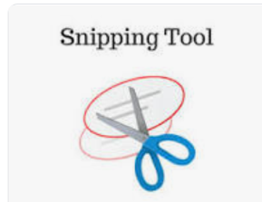

Films, videos, photographs, songs, and written work can be used as evidence or documentation in the portfolio. If evidence or documentation cannot be submitted, the student could write about it. The portfolio should showcase work that they are proud of, show their passion and potential, and show what they are striving to achieve in the future.

The Student Portfolio

Achievement/Accomplishments in the following subjects | Please place documentation/evidence here (e.g., photo)  One item per box only | Please give a brief description of the photo
Science

Math

English

Social Studies

Extracurricular activities (optional)

Experience of working independently

Experience of being a team player

THIS IS THE END OF THE PORTFOLIO

