What media teach kids about gender can have lasting effects, report says
By Caroline Knorr, Common Sense Media
Updated 7:36 AM ET, Thu June 29, 2017
Does Hollywood have a gender problem? 01:58

Story highlights: Gender stereotypes are incredibly effective at teaching boys and girls what the culture expects. Luckily, parents can assert control over the messages that Hollywood dishes out.

Gender stereotypes are messing with your kid.
It's not just one movie. It's not just one TV show. It's constant exposure to the same dated concepts in the media over and over, starting before preschool and lasting a lifetime -- concepts like: Boys are smarter than girls; certain jobs are best for men and others for women; and even that girls are responsible for their own sexual assaults.
If you thought this stuff went out with Leave It to Beaver, the new Common Sense Media report, Watching Gender: How Stereotypes in Movies and on TV Impact Kids' Development, will put you right back in June Cleaver's kitchen.
According to the report, which analyzed more than 150 articles, interviews, books, and other social-scientific research, gender stereotypes in movies and on TV shows are more than persistent; they're incredibly effective at teaching kids what the culture expects of boys and girls.
What makes these messages stick -- and harder for parents to counteract -- is that they're timed for the precise moment in kids' development when they're most receptive to their influence.

Girls feel less 'smart' than boys by age 6, research says
Think of preschoolers who are just beginning to identify as boys or girls. The characters they see on TV and in movies often have an obvious masculine or feminine appearance, such as a superhero's big muscles or a princess' long hair. These characteristics also are often associated with specific traits -- for example, being strong and brave or fearful and meek.
Fast-forward to the tween and teen years, when characters begin to wrestle with relationships, sex, and job prospects. That "strong and brave" superhero becomes aggressive and hostile. That "fearful and meek" princess become submissive and weak.
For young audiences who absorb ideas from the media on how to behave and what to become, these characterizations can lead to false assumptions and harmful conclusions.
These oversimplified characterizations play out in many ways over and over. According to the report, a lifetime of viewing stereotypical media becomes so ingrained it can ultimately affect kids' career choices, self-worth, relationships, and ability to achieve their full potential.
Media to support your kid's gender identity

Challenging what it means to 'dress like a boy'
And lots of parents are concerned about these issues, too. We polled nearly 1,000 parents across the country and found that they believe the media has a significant influence on their kids, from how girls should look and behave to how seeing violence can affect boys' beliefs about themselves.
Luckily, parents can assert control over the messages that Hollywood dishes out. Because, let's face it: Exaggerating the differences between boys and girls is just a ploy to keep audiences entertained. It's not what we really want our kids to emulate.
While there are movies and TV shows that defy gender stereotypes -- and Hollywood is making some progress on this front -- you're not going to be able to prevent your kids from seeing everything that sends the wrong message. And your kids probably like a lot of media that reinforces stereotypes.
Fortunately, the most powerful messages kids absorb are from you. When you actively role-model gender equality, speak out against stereotypes, and challenge outdated ideas, kids will hear that loud and clear.
Also, you have a lot of control over your kids' media -- mostly when they're little, but even as they grow. Choose quality media that reflects your values, and talk to your kids about the movies and TV shows they watch. (Learn more about what to look for in movies and TV to avoid gender stereotypes.) Use these age-based strategies -- from toddlerhood to the teen years -- to reach kids at the exact moment they need to hear them.

Age 2-6
At this age, kids:
- Learn their gender identities (that they're a boy or a girl).
- Learn stereotypes about activities, traits, toys, and skills associated with each gender.
- Begin gender-typed play (girls "clean the kitchen," boys "mow the lawn").
- Need to hear your input in specific, not abstract, terms.
What you can do
Point out people from real life or TV that show there's more than one way to "do" gender. Try a show such as Doc McStuffins and say, "I notice that Doc's mom works full-time to support the family and that her dad stays home and takes care of the kids."

Fitted tees, shorty shorts: Sending the wrong message to girls?
Comment positively on shows that equally value boys and girls. Watch Odd Squad together and say, "Otto and Olive are equal partners and rely on each other to solve cases."
Find shows that aren't hyperpink or super-blue. Or, at least, balance out your kid's preferences with shows such as Julie's Greenroom, which uses a variety of hues, both on the stage sets and in the characters. The show also exposes some of the technical aspects of stage production, which teaches kids that shows are created by people and are only limited by imagination.

Age 7-10
At this age, kids:
- Attribute certain qualities to men and women -- for example, that women are more emotional and affectionate and men are more ambitious and aggressive.
- Associate specific occupations and academic subjects with each gender.
- Self-segregate based on gender -- boys want to play with boys, and girls want to play with girls.
- Want some choice over what they watch but still respect parents' input.
What you can do
Recognize characters who defy gender stereotypes. Check out a movie such as Big Hero 6 and say, "It's OK to show when you're sad -- and boys shouldn't be embarrassed to cry."

Transgender kids: Painful quest to be who they are
Praise characters who are instrumental to the storyline for what they do versus what they look like. Stream Project Mc2 on Netflix and say, "For the girls on Mc2, being good at math and science are more important than their appearance."
Seek out movies and shows with non-stereotyped characters -- for example, female characters with realistic body types and non-aggressive male characters. Try a show such as Andi Mack where the characters wrestle with peer pressure to look and act a certain way to fit in.

Age 11-13
At this age, kids:
- Feel self-conscious about physical changes and feel pressure to conform to cultural gender norms.
- Are intolerant of cross-gender mannerisms and behaviors.
- Are concerned about dating potential.
- Want to pick their own shows -- and they're often shows intended for older kids.
- Are more interested in peers than parents.
What you can do
Emphasize that worth and happiness don't come from appearance (especially important for female characters) or from physical strength (especially important for male characters). Watch a movie such as Arrival and remark on the lead character being a female professor. Or try Billy Elliot, about an Irish boy who wants to be a dancer despite his father's objections. Ask: "How do these characters go against what society expects of them?

Challenging what it means to 'dress like a boy'
Comment positively on healthy, supportive, and fulfilling cross-gender friendships and relationships. Try a movie such as Bridge to Terabithia (or read the book), which features an equal friendship between the boy and girl main characters. Discuss what makes them such good friends and what each one teaches the other.
Talk about how transgender characters in movies and on TV are often the target of bullying. Try a show such as I Am Jazz about a transgender teen. Ask: "How did you feel when Jazz was bullied. If you knew her, would you defend her?"

Age 14-17
At this age, kids:
- Mix with other genders and become more flexible about stereotypes.
- Become preoccupied with their future careers, as well as appearance.
- Want to learn gender-based expectations for how to behave in romantic and sexual situations.
- Choose what they want to watch and are willing to discuss abstract ideas (and don't want to be lectured to).
What you can do
Join the conversation
See the latest news and share your comments with CNN Health on Facebook and Twitter.
Look for shows that feature boys and men expressing their emotions in constructive ways, having diverse interests (other than only sex), and being kind or friendly to non-heterosexual characters.
Check out This Is Us and point out how the fathers are shown as nurturing and thoughtful. Or watch The King's Speech, about King George the VI, who must reveal his biggest vulnerability. Ask, "Can a man, or a boy, be both strong and sensitive?"
Point out when female characters voice their own needs. Watch an ensemble show such as Brooklyn Nine-Nine and note how the female characters don't defer to the men.
Find characters who have non-gender-stereotypical professional aspirations (girls who want to be scientists and boys who want to be nurses). Consider a show like Bones, which features a strong female lead in a traditionally male-dominated profession.

Gender stereotypes are destroying girls, and they're killing boys
Alia E. Dastagir, USA TODAYPublished 2:41 p.m. ET Sept. 21, 2017 | Updated 11:26 a.m. ET Sept. 22, 2017
It doesn't matter where in the world you live. Lessons about gender start early, and they have lifelong consequences.
A new study in the Journal of Adolescent Healthfound many norms around gender, what's expected of boys and girls, become entrenched in adolescence and have negative impacts that carry into adulthood.
We knew some of this already. Existing research shows gender roles can harm both sexes. But the Global Early Adolescent Study — which looked at girls and boys between 10-14 years old in 15 countries with varying income levels — found many of these stereotypes are universal, and they become entrenched before 10 years old.
"We were actually anticipating more differences than similarities, and one of the big findings is that there are still very consistent forms of patriarchy around the world," said Kristin Mmari, an associate professor at Johns Hopkins Bloomberg School of Public Health and the lead qualitative researcher on the study.
The ideas girls and boys have about gender, the study found, form earlier in adolescence than had previously been measured, Mmari said.
"There seems to be a shift as soon as girls and boys enter this stage, where their attitudes and beliefs about the opposite sex change dramatically," she said. "And they talked about how this was not so in childhood. That they could have these friends — opposite sex friends — and they were given equal amounts of freedom. They were treated the same, they thought. But once they began puberty, and their bodies developed, their worlds changed."
The biggest myth perpetuated about gender, researchers found, is that once girls hit puberty, they are vulnerable and in need of protection to preserve their sexual and reproductive health, while boys are seen as strong and independent. It's this myth, Mmari said, that changes how the world sees both sexes during adolescence, and how it continues to treat them throughout their lives.
"How you perceive girls and boys is socially driven," Mmari said. "It's not biologically driven."
Among consequences that the study noted when girls conform to gender stereotypes:
- Depression
- Child marriage
- Leaving school early
- Exposure to violence

And consequences when boys conform to gender stereotypes:
- Engaging in physical violence to a much greater extent than girls
- Dying more frequently from unintentional injuries
- Being more prone to substance abuse and suicide
- Having a shorter life expectancy than women
Mmari said one of the major takeaways from the study is that it's important to challenge gender stereotypes when children are young.
"You can look at it as a window of opportunity to really address these attitudes and beliefs before they become cemented later on," she said.
The next phase of the study, which Mmari said will take about four or five years, will measure how gender norms change over time, what factors influence those changes and how they relate to health-outcomes for boys and girls.
"We need to view gender as more of a system," Mmari said. "One of the problems ... is we typically look at things on an individual level. So we feel like if we just empower girls, make them feel good, then we'll change. But the problem is they go back to their homes where they're given messages from their parents that are contradictory. They go to the schools where they're given messages from their teachers that are contradictory. They look at the media — it's a whole system out there that's transmitting these inequitable norms, and so we have to think of it more on that level."

Sign Me Up

HuffPost PARENTS
09/21/2017 10:26 EDT | Updated 09/21/2017 12:06 EDT

Gender Stereotypes Are Firmly Rooted By Age 10: Global Study

These beliefs can raise the risk of depression and suicide.

Gender stereotypes are firmly rooted in today's youth by age 10, according to a global study Wednesday that warns such beliefs can raise the risk of depression, suicide, violence and HIV.
The investigation, which spanned 15 countries, suggested that vast amounts of money are wasted on stereotype prevention programs for teenagers, because efforts must begin far earlier.
"Adolescent health risks are shaped by behaviours rooted in gender roles that can be well established in kids by the time they are ten or 11 years old," Kristin Mmari, lead researcher for the qualitative research at the Global Early Adolescent Study, a partnership between the World Health Organization and Johns Hopkins University.
"Yet we see billions of dollars around the world invested in adolescent health programs that don't kick in until they are 15, and by then it's probably too late to make a big difference."
The study included 450 early adolescents matched with a parent or guardian.
Interviews were conducted in Bolivia, Belgium, Burkina Faso, China, the Democratic Republic of Congo, Ecuador, Egypt, India, Kenya, Malawi, Nigeria, Scotland, South Africa, the United States and Vietnam.
Researchers found that gender stereotypes which emphasize female passivity can encourage abuse.
These stereotypes "leave girls at greater risk of dropping out of school or suffering physical and sexual violence, child marriage, early pregnancy, HIV and other sexually transmitted infections," said the report.
Boys on the other hand are encouraged to spend time outside of the home, unsupervised, to explore the world.
When it came to relationships, boys were consistently viewed as being the ones allowed to take the first step except in one city — Edinburgh, Scotland.
Meanwhile, girls across the world are taught that their bodies are their key asset.
"In New Delhi, the girls talked about their bodies as a big risk that needs to be covered up, while in Baltimore girls told us their primary asset was their bodies and that they need to look appealing — but not too appealing," Mmari said.
Boys, too suffer from stereotypes that emphasize physical strength and independence, which can make them more susceptible to violence, substance abuse, and homicide.
While there is increasing acceptance for girls who want to dress or act like boys — particularly in Belgium, China, India and the United States — there is "almost zero tolerance for boys" who push back against typical gender roles, said the report.
"Boys who challenge gender norms by their dress or behaviour were by many respondents seen as socially inferior," and were often bullied, teased and beaten, it said.
"We found children at a very early age — from the most conservative to the most liberal societies — quickly internalize this myth that girls are vulnerable and boys are strong and independent," said Robert Blum, director of the Global Early Adolescent Study.
"And this message is being constantly reinforced at almost every turn, by siblings, classmates, teachers, parents, guardians, relatives, clergy and coaches."

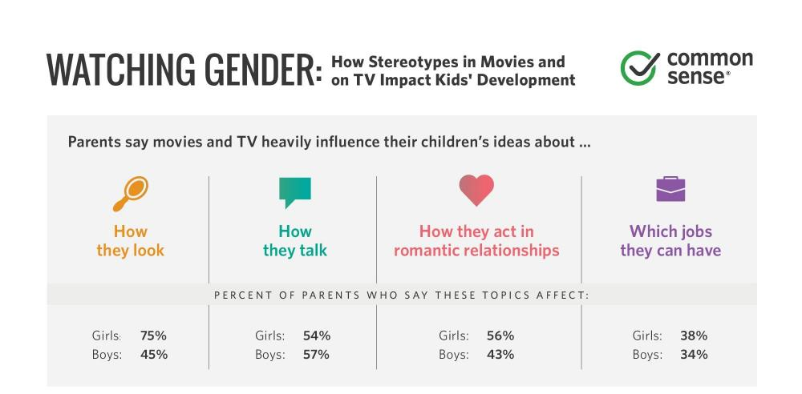

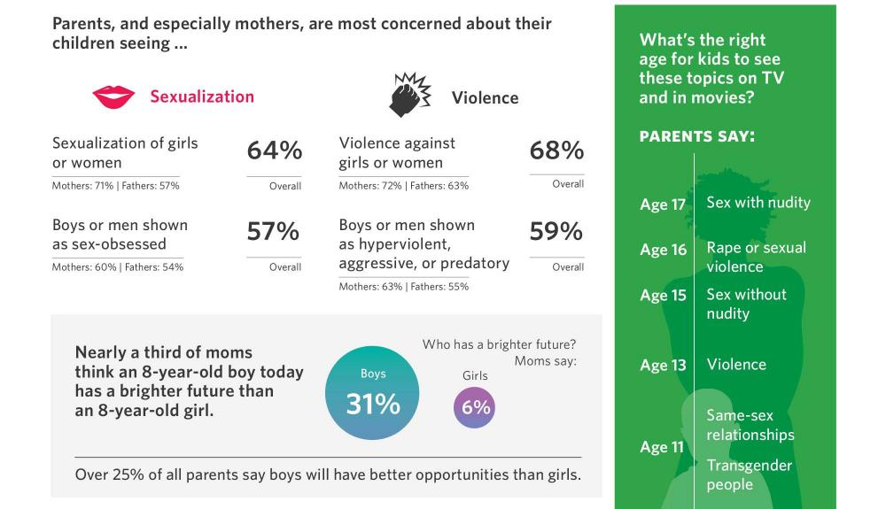
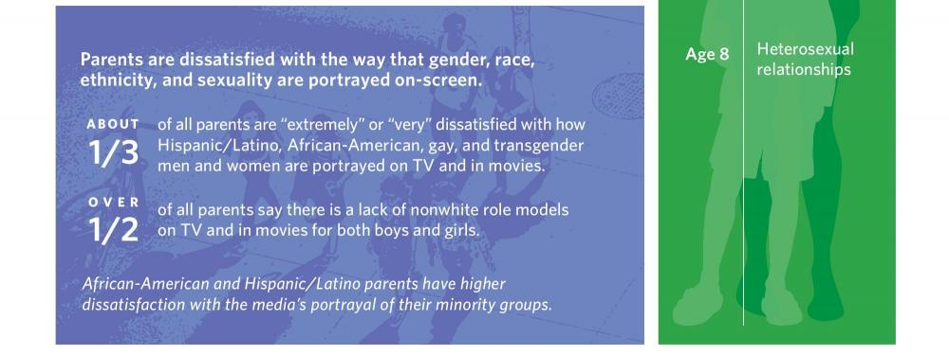
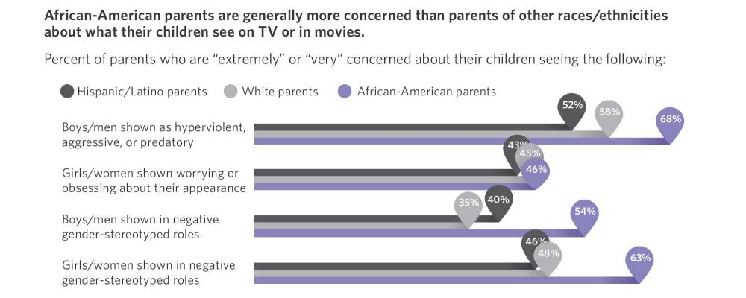
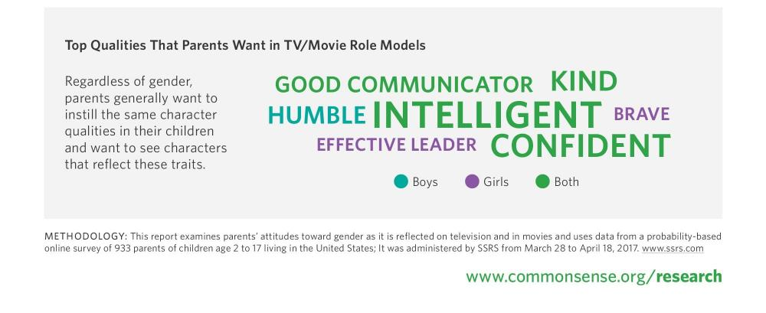

Sexist media scrutiny of women in politics spans decades, study says

'Women are discouraged from seeking leadership roles because of that kind of attention'
By Andrea Ross , CBC News Posted: Dec 17, 2017 2:51 PM MT

Hair, hemlines and husbands — media coverage of women running for federal political leadership in Canada has, historically, been quite different from their male counterparts.
This kind of personal scrutiny persists, and it's dissuading women from running for political leadership, according to a new study from the University of Alberta.
Political scientist Linda Trimble reviewed 2,500 newspaper articles spanning a 37-year period. She found that women who ran for leadership of major Canadian political parties faced scrutiny based on physical appearance or traditional gender roles that was disproportionate in relation to their male opponents.
- The sexist language of politics: Both men and women need to change
- Trudeau names 2 new senators, including Canada's 1st female Indigenous dentist
When Belinda Stronach sought leadership of the Conservative Party in 2004, a lot of media attention centred on her looks and alleged "lack of intellect" and portrayed her as a "puppet for the backroom boys," Trimble told CBC Edmonton's Radio Active.
"Anne McLennan, who was Deputy Prime Minister at the time, said 'This is going to put women off politics,'" Trimble said.
"And certainly women are discouraged from seeking leadership roles because of that kind of attention."

Men's bodies discussed less than women
The first woman who sought the leadership of a national political party in Canada was Rosemary Brown, who ran for the NDP in 1975, Trimble said. Since then, there have been only 13 women who have followed suit — three of them running twice.
That's not very many women, Trimble said.
The women who had a high profile, were competitive to win a race, or were the first to achieve a particular position were often faced with a lot of intensely personal scrutiny and media coverage, she added.
Take Kim Campbell, who ran for leadership of the Progressive Conservative party, becoming Canada's 19th — and only female — Prime Minister in 1993.
- 'I became a target': The difficult tenure of women politicians in Canada
- Record number of women MLAs in Alberta 'changes the game'
"There was a lot of attention to the fact that she was twice divorced, didn't have children, she was called unstable, hysterical, a lot of attention to her body and her sexual allure, she was called a blonde bombshell," Trimble said.
This kind of media coverage suggests leadership performance for women is centered around their bodies and appearances, and that hasn't changed much over the decades, Trimble said.
The study did find a couple of examples of scrutiny toward's men's appearances. Former Prime Ministers Paul Martin and Stephen Harper made headlines for their weight: Martin deemed too heavy, and Harper praised for losing 25 pounds.
"Men's bodies sometimes are discussed, but way less frequently than women," Trimble said.
The downside of the study is that there have been only four women who have won leadership of a national party, the last one being Elizabeth May when she took the reins of the Green Party in 2006. So it doesn't have any examples of "highly visible, highly competitive women" in the last 10 years, Trimble said.
'Men's bodies sometimes are discussed, but way less frequently than women.'- Linda Trimble, political scientist
Trimble is releasing a book called Ms. Prime Minister: Gender, Media and Leadership next year on the topic of representation of women in politics.
She says the media should pay careful attention to how it addresses female politicians, including giving their ideas equal attention.
"If you wouldn't say this sort of thing about a man, if you wouldn't talk about his sexual orientation or his looks or his marriage, would you do the same for a woman?" Trimble said.
"Sometimes women have to work hard to convince people in the press that they do embody strength and fortitude and determination."

Women and the Media

You could go to a film, switch on the TV, tune in to the radio, turn the pages of a magazine, or surf online. Regardless of your choice of media, you’d have a good chance of encountering stereotypes that perpetuate gender discrimination.
Women in all types of media tend to be thin and sexualized. They talk less than men. They have fewer opinions. And they are far less likely, in the entertainment industry, to play roles as leaders or professionals, or even as women who work for a living.
Research spanning more than 100 countries found that 46 per cent of news stories, in print and on radio and television, uphold gender stereotypes. Only 6 per cent highlight gender equality. Behind the scenes, men still occupy 73 per cent of top media management positions, according to another global study spanning 522 news media organizations. While women represent half of the world’s population, less than one thirdof all speaking characters in film are female. Cyberviolence has extended the harassment and stalking of women and girls to the online world.
Twenty years ago, 189 UN Member States recognized the central role of media in shifting the gender stereotypes that influence how we think and act. They made women and media one of 12 critical areas of the Beijing Platform for Action, and called on media everywhere to make a far greater contribution to women’s advancement.

They agreed that the number of women in the media must increase, including in decision-making. More should be done to present women as leaders and role models, and to abandon stereotypes. Encouraging women’s training, adopting professional guidelines to reduce discrimination, and establishing media watch groups for monitoring were among measures to move forward. Women’s involvement in information and communications technologies and media networks, including electronic networks, were also highlighted as a means of strengthening women’s role in democratic processes.
There has been some progress since the Beijing Conference. The percentage of stories reported by women has edged up in most issue areas, and women are among the most active social media users. But even a cursory look at media content shows how far there is to go.
Women have an equal right to participate in public debate, including in the media, and offer insights and ideas that must be heard. Everyone deserves to live free from the burden of harmful gender stereotypes.
The media shapes our world—but so do women, as powerful agents of change in all areas of society. It is time for media to reflect this reality.

The time is now for media to make the future – on-screen and off-screen
By Geena Davis
Date: Monday, May 4, 2015

Academy and Golden Globe Award-winning actor Geena Davis is a long-standing advocate for increased and diverse representation of women in film and within the entertainment industry. She is the Founder and Chair of the Geena Davis Institute on Gender in Media, working with media and entertainment companies through research, education, and advocacy programmes to improve how girls and women are portrayed on-screen. The Institute released the first-ever global study on female characters in popular films in 2014, with support from UN Women and the Rockefeller Foundation.
What do we learn about women and girls when we turn on the television or go to the movies? Around the world, female characters in films and television take far less space than male characters. They do less interesting things. They are judged by their appearance.
We all know that women and girls are slightly more than half the human population. But you would not know this from watching films and television, where there are roughly three male characters for every one female.
Less than a quarter of the on-screen global workforce is female—much lower than in the real world. Women are far less likely to be a judge or doctor or in any other professional or leadership position, and women and girls are twice as likely as men and boys to appear in sexualized attire or nude.
These very enlightening and disturbingly bleak findings were part of the first-ever international study on the portrayal of women in films that my institute on Gender and Media commissioned from the USC Annenberg School of Communication and Journalism, and presented last year with the support of UN Women and the Rockefeller Foundation.
Our data are echoed by research on other types of media. The Global Media Monitoring Project found that only a quarter of the people heard or read about in print, radio and television news are women. Almost half of the stories uphold gender stereotypes.
Twenty years ago, at the Fourth World Conference on Women, the governments of the world committed to media making a far greater contribution to women’s empowerment, recognizing that films, television, newspapers and now online platforms shape the ways we think—and act.
Yet despite this commitment, we still are far from a balanced representation or portrayal in the media. In fact, our research shows that the ratio of male to female characters in film has been exactly the same since 1946.
My colleagues in film and television used to think that the problem of gender equity had been fixed. But there was no data showing them the real picture. When I brought them the research I commissioned – covering a 20 year span – they were absolutely stunned to learn how bereft of female presence the fictitious worlds they were creating were.
I have stressed how important it is for future generations to have more female characters. We know that girls feel less empowered the more TV they watch, while boy’s views become more sexist. There are important ethical questions concerning stereotypes or hypersexual images to young children. No one thinks it is a positive development that, as one recent study found, girls as young as six are seeing themselves through the male gaze.
There is also an economic argument—research shows that films with more women and girls make more money, and are less likely to fail.
Maybe instead of developing unconscious gender biases and having to fix them, we can start from the beginning, as Beijing recognized, by not perpetuating them at all.
To achieve gender equality, we have to work on many issues—laws, education, representation in government—the list is long. But, media needs to be a particular priority because they have such an enormous impact on the ways that women, men, boys and girls think about their roles and their value to society. We cannot wait even one more year for progress. We know the problem, and we have the evidence confirming it.
Think about this: in all of the sectors of society that still have a huge gender disparity, how long will it take to correct, to reach parity? We can't snap our fingers and suddenly half of congress is women. But there's one category where the underrepresentation of women can be fixed TOMORROW: on-screen.
In the time it takes to create a television show or to make a movie, we can change what the future looks like. In other words, we don’t have to wait for society to turn things around, we can create the future now, through what people see. Yes, there are woefully few women CEOs in the world, but lots of them can be women on screen. How long will it take to fix the problem of corporate boards being so unequal? Well, they can be half women tomorrow, in films and on TV.
Here’s a simple solution; cast more women in roles written for men. The time is now for media to make the future – where we have done away with gender bias – a reality today, on-screen.

TV & RADIO
18 JULY 2017 Amelia Tait

Why new rules on gender stereotyping in ads benefit men, too

A new report by the Advertising Standards Authority says a “tougher” stance must be taken on negative gender stereotyping.

Dads don’t go to Iceland. In fact, they can’t. Have you ever seen a dad in Iceland? No! Don’t be stupid. It’s mums that go to Iceland – if they find the time after being magnetically pulled towards that bloke on the beach with a can of Lynx Africa and emptying the Fairy Liquid for their offspring to make a rocket with. Hang on, what’s that her husband’s eating? It’s a Yorkie – you know, for boys. If girls eat them, they die.
Adverts are chock-full of gendered messaging – and obviously it’s not all bad. No one seriously thinks girls can’t handle “man crisps” McCoys or that dads that go to Iceland will be beaten out by Kerry Katona wielding a 24 Piece King Prawn Party Selection. Yet many adverts feature insidious messages that can slowly shape our perception of the world. Are all women supposed to be at the kitchen sink? Is yoghurt really the source of a woman’s orgasm? Are men incapable of looking after their own children and are they all sofa oafs unwilling – nay, unable – to iron a shirt or clean a kitchen tap?
Gender stereotypes like these have a negative impact on both women and men. A new report on gender stereotyping in advertising by the Advertising Standards Authority (ASA) and Committees of Advertising Practice (CAP) argues that gender stereotypes “can lead to mental, physical and social harm which can limit the potential of groups and individuals”. In particular, young children easily internalise the messages they see. The report, entitled Deceptions, Perceptions, and Harm, argues that a “tougher line” needs to be taken on ads with stereotypical gender roles, or ads that mock people for not conforming to gender stereotypes.
Before now, the ASA has regulated adverts that sexualise women or present women who are unhealthily thin. Now, the CAP (who author the UK Advertising Codes) will develop new standards for ads that feature gender stereotypes, and the ASA will enforce these rules.
“Such portrayals can limit how people see themselves, how others see them, and limit the life decisions they take. Tougher standards in the areas we’ve identified will address harms and ensure that modern society is better represented,” explained Ella Smillie, the lead author of the report.
This doesn’t mean you’ll no longer see mums doing the washing or dads mowing the lawn. The regulations haven’t yet been drawn up, but the report has examples of problematic adverts. If a woman is solely responsible for cleaning up while her family make a mess, for example, this could be flagged. In turn, adverts that show men trying and failing to do simple household tasks will be deemed a problem. The ASA isn’t a pre-emptive body, so they won’t go around mercilessly banning these adverts in a way that would make your dad (or mum, or sister) scream “political correctness gone mad!”. Rather, the organisation deals with complaints the public make and then issues sanctions if advertisers break the CAP code.
So, are you beach body ready? This infamous advert was part of the inspiration behind the new report and upcoming regulations. Although complaints about the ad were upheld by the ASA, this was in fact because Protein World, the advertiser, was making false claims about health and nutrition. The sexism in the advert that many objected to was not regulated by the ASA, and thus exposed a gap in its policies.
There are many similar adverts that have prompted complaints about gender stereotyping but that the ASA has not investigated or sanctioned because of this gap in the current regulations. An advert for Aptamil baby milk prompted complaints when it inferred boys could grow up to be rock climbers while girls become ballerinas. The ASA did not find grounds for a formal investigation. Last August, Gap was accused of sexism in adverts where boys were labelled “little scholars” and girls “social butterflies”. The ASA did not investigate after Gap took the adverts down itself following social media backlash.
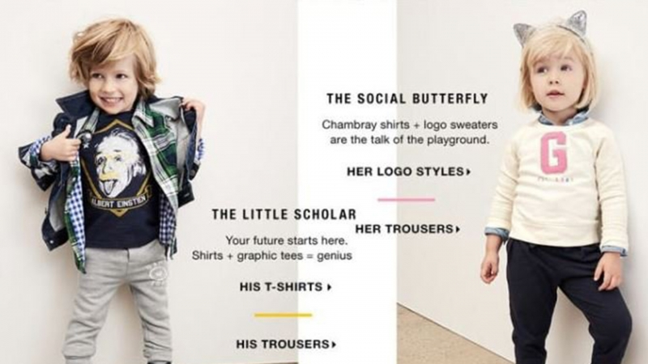

Yet it is not just women who are limited by gender stereotypes in advertising. Between 2015 and 2016, the ASA considered 1,378 complaints related to the depiction of women and men. Of these, 465 cases dealt with the portrayal of men.
The ASA did not uphold complaints against a KFC advert which featured two men arguing about who was more manly. When one man mocked the other for having scented candles, the mocked man replied: “You know those candles help with my anxiety... You're a monster.” Many complaints said the advert equated anxiety with a lack of masculinity, perpetuating the view that men should not admit to mental health issues. Under its old regulations, the ASA did not consider the ad would cause serious or widespread offence, or perpetuate damaging stereotypes. Though it is as yet unclear whether the new rules would see this advert banned, it is encouraging that similar adverts will now be challenged by the regulations.
And that’s the crux of it. Though many blame “feminazis” for narrowing the confines of acceptable and unacceptable media, these regulations should be celebrated even by those who don’t consider themselves feminist. Although a single advert might not make a man feel as though he has to behave or look a certain way, the ASA’s report explains how adverts can cumulatively affect us. Women and men aren’t born thinking they can do this or can’t do that – our media helps to shape this. “While advertising is only one of many factors that contribute to unequal gender outcomes, tougher advertising standards can play an important role in tackling inequalities and improving outcomes for individuals, the economy and society as a whole,” said Guy Parker, chief executive of the ASA.
So if Fairy Liquid, or Iceland, or Yorkie can make little boys and little girls feel that anything is possible – why shouldn’t they? Besides, aren’t we all bored of seeing lazy men and uptight women on TV? Shouldn't adverts be a little more imaginative?
The CAP will report publicly on its progress developing the new rules by the end of 2017, with the new standards coming into force in 2018.

THE BLOG
05/15/2014 01:24 pm ET Updated Jul 15, 2014

Gender Roles in Media

By Allison Lantagne (17 yr old)
Media plays a large role in creating social norms, because various forms of media, including advertisements, television, and film, are present almost everywhere in current culture. Gender roles, as an example, exist solely because society as a whole chooses to accept them, but they are perpetuated by the media. Conspicuous viewers must be aware of what the media is presenting to them, and make sure they’re not actively participating in a culture of oppression.
Even on young children, gender roles are being pushed through advertisements. My search for American advertisements with girls playing with action figures and boys using easy-bake ovens was fruitless, and even when I moved to a gender neutral product, sidewalk chalk, the advertisement was sending different messages towards boys versus girls. The girls were all coloring on the sidewalk, as the one young boy rapped, ending in a short dance routine where it was clear that the only male in the advertisement was the main character. Are consumers of sidewalk chalk actively trying to send this message of submission to their 9-year-old girls? Likely not, but the media is sending them the message without being stopped. However, Tide, a Proctor and Gamble laundry detergent, has taken its advertisement in a better direction, recently showing a clip where the leading male actor proudly proclaims “I’m a stay-at-home dad,” and later goes on to braid his daughter’s hair. By showing a man playing out typically “feminine” behaviors, Tide is promoting a more equal society.
Television is the most pervasive form of media, with 96.7 percent of American families owning a TV, according to The Nielsen Company, which takes TV set ownership into account when it produces ratings. This, of course, means that viewers must carefully examine the content of the programs they choose to watch, and decide if they can ethically support and promote said content.
For example, The Big Bang Theory, in its earlier seasons, had only one consistently present female lead — Penny, played by the lovely Kaley Cuoco-Sweeting. Penny’s character was that of the stereotypical female: the ditzy, attractive neighbor, who existed solely to create sexual tension between herself and one of the show’s leading men, Leonard Hofstadter. As the show progressed, the characters developed and more females were introduced, but Sweeting’s character still exists primarily to create romantic tension.
A better example of female representation in television can be found in the American version of the TV show The Office, which had five consistent female leads — Pam Beesly-Halpert, Angela Martin, Phyllis Lapin-Vance, Meredith Palmer and Kelly Kapoor. There is a strong, working-class female represented in each department of the fictional paper company Dunder Mifflin, and all of these female characters are dynamic. Even though some of them did portray female gender roles, such as the character of Kelly being emotional, the characters were given enough development and background to be more than just stereotypes. The Office worked against the unfortunate statistic that men outnumber women in television two to one, and gave viewers a plethora of strong females in the workplace, helping to move the media to more accurately represent the real world, where women are 51 percent.
Film is less pervasive than television, which means consumers must be even more particular when choosing movies to support. Every $8 movie ticket tells the film industry to produce more movies like the ones viewers have paid to see, which is why it is disappointing that Grown Ups 2, directed by Dennis Dugan, grossed about $200,000,000 more than The Call, directed by Brad Anderson. Only about a quarter of the cast of Grown Ups 2 is female, and the movie doesn’t pass the Bechdel test, a test created by Alison Bechdel, which asks only three questions: Does the piece have two or more female characters? Do they speak to each other? Do they speak of topics other than men? Although the movie has stars such as Maya Rudolph and Salma Hayek, the female characters don’t have a conversation about anything other than men. The Call, starring Halle Berry and Abigail Breslin, features a strong female lead (Halle Berry) who saves a young girl (Abigail Breslin) after being kidnapped by a character played by Michael Eklund, but grossed significantly less. The message consumers are sending to filmmakers is that they should produce more films with women falling into the resigned, quiet, gender role, as opposed to films that break away from these molds.
There’s nothing wrong with accepting gender roles. For example, I want to be a stay-at-home mom, but this is a personal choice, not something that I feel society or tradition is forcing me to do. The problem with gender roles is that they can cross a line and become oppressive. If a young woman wants to become a doctor, and a young man a teacher, it is the rest of the world’s responsibility not to bat an eye. If a doctor can cure the sick, what does gender matter? If a teacher can educate a student, who are we to deny the pupil the right to learn, solely on the grounds of the sex of his or her teacher? If a man wants to cry, let him cry. Men feel just as women do.
Although the media isn’t yet representing either gender void of stereotypes, a societal change will bring about a change in the media. Regardless of this, gender roles are just that, roles. It is up to the individual to decide whether or not they are going to fill them. The best advice that can be given is to make sure, above all else, that you are fulfilling a role you want to be fulfilling, regardless of where it fits in society’s set of theoretical constructs.

THE CLOTHES MAKE THE WOMAN

In 2017, Powerful Women Finally Got the Costumes They Deserved

A survey of the year’s best superhero outfits, from Wonder Woman to the new Doctor—and a peek at what’s in store for 2018.
by
- FARAH JOAN FARD
DECEMBER 28, 2017 12:00 PM
Hey men, what would you wear to fight? Hint: don’t expose your vital organs,” wrote Jessica Chastain on November 14. She was responding to a wry tweet from Melissa Silverstein,founder of Women and Hollywood, that compared the Amazon warrior costumes in Patty Jenkins’s Wonder Woman (designed by Lindy Hemming) to the Amazon warrior costumes in Zack Snyder’s Justice League(designed by Michael Wilkinson, who also created the costumes for Batman v Superman). The former were sturdy, battle-ready combinations of leather and armor; the latter were skimpy outfits that emphasized their wearers’ chests and exposed their washboard abs.
While some might argue that the images shown were cherry-picked, the uproar that ensued highlighted a glaring issue in Hollywood’s depiction of female action heroes: most of the time, they’re not clothed nearly as appropriately as their male counterparts. (Yes, George Clooney’s Batman and Robin costume was decorated with sculpted nipples—but at least his chest was covered.)
Action leads like Xena and Buffy have made great strides in how women are portrayed as warriors, but for years, it seemed that every positive step came with an equal and opposite setback—Halle Berry’s Catwoman; the scrapped 2011 Wonder Woman TV series; films like Sucker Punch in which women attempt to fight in high heels and glorified lingerie. As Cara Delevingne said upon the release of Suicide Squad, another offender: “Generally, though, superhero movies are totally sexist. Female superheroes are normally naked or in bikinis. No one would be able to fight like that.”
But more recently, movies like Wonder Woman and The Force Awakens have laid groundwork for equality in how action stars are presented—and clothed. As Hollywood's post-Weinstein reckoning continues, those efforts matter even more; as Michael Kaplan, costume designer for The Last Jedi, said this month, “There’s wonderful strong women in this film, much more than we’ve seen ever before in a Star Wars film. And I think it’s reflecting what’s going on [in the news].”
What’s more, costume equality in Hollywood is set to reach new heights in 2018—and beyond. For proof, look no further than this survey of 2017’s greatest female action-hero costumes—and the outfits we’re most looking forward to seeing on screens next year.
Wonder Woman and her Amazons, Wonder Woman
Batman v Superman costume designer Michael Wilkinson wanted Wonder Woman to wear something specifically made for battle in the film that introduced the character to the D.C. cinematic universe. Patty Jenkins and Lindy Hemming then upped the ante on his original work in Wonder Woman, drawing inspiration from training armor, ancient cultures, societies run by queens and female warriors, and athletic trends. Hemming wanted her Amazons to be striking and strong, above all else—and she made sure to give them metal breastplates, a nod to mythology, in which Amazons cut off their left breasts to better wield their bow and arrows.
Some of the Amazon warriors can be seen with a special breastplate on their left side, and many also protect themselves with armor on their knees and forearms, as well as metal headdresses. Their skirts are short for the sake of movement, resembling the design of Hoplite soldier wear, or pteruges, leather skirts worn by ancient Greek and Roman soldiers. Wonder Woman herself is no longer the flag-wearing fighter from the years of Lynda Carter but a stunning warrior. Her boots are made to resemble Roman greaves, as others have noted, redesigned from Wilkinson’s original footwear to ensure Diana can move easily in mud and water; her bracelets and tiara now function more as armor as well.
As Gal Gadot’s Wonder Woman herself points out while trying on women’s period clothing in the film, “How can a woman possibly fight in this [a corset]?” She can’t. And so she won’t—not anymore.

Why does sexism persist in the video games industry?
By Kim GittlesonBBC reporter, New York
13 June 2014
Is creating female video game characters too much work?
That might sound like a rhetorical question, but it was actually one of the main topics of discussion at this year's E3 conference - the video game industry's biggest event, which ended on Thursday.

The issue arose after James Therien, technical director at European gamemaker Ubisoft, told trade publication VideoGamer that the latest instalment of Ubisoft hit Assassin's Creed would not feature any playable female characters because it would have "doubled the work".

The reaction was swift - and negative - especially when a former Ubisoft developer questioned how much work would be involved.

"The message from the industry is that men come first," says Jayd Ait-Kaci, a gamer from Canada who started the hashtag #womenaretoohardtoanimate, which was picked up widely.

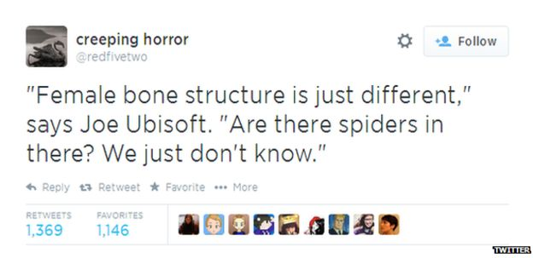
Reaction to Ubisoft's decision on social media was primarily negative:

"#womenaretoohardtoanimate when you throw all your efforts into putting them in situations where their clothes are strategically ripped off" wrote @emilyrwanner.
But what left many scratching their heads was that Ubisoft had already included female assassins in earlier instalments, and that the firm has emphasised diversity, tapping actress and gamer Aisha Tyler as its host at E3.
So what's going on: is the video game industry progressing - or regressing - when it comes to female representation?
Damsels in distress
Of course, the issue of gender ratios in video games is not a new one - but it did seem to be on more observers' minds at E3 this year, with observers tweeting about a lack of female characters in Sony's presentation and videogame site Polygon publishing an article titled "There were more severed heads than women presenters at E3 2014".
Studies have consistently shown that at least since the 1990s, the percentage of female characters in video games has remained steady at around 15%.
"It's amazing how little has changed," says University of Pennsylvania professor, Yasmin Kafai, the co-editor of one of the seminal books on gender in videogames, Beyond Barbie and Mortal Kombat, published in 2008.

Who plays video games in the US?
- Average gamer is 31 years old
- 48% of gamers are female
- 71% of gamers are 18 or older
- 53% of gamers play games on their smartphones

Source: Entertainment Software Association
While there have been exceptions - Lara Croft, in Tomb Raider, or 14-year-old Ellie in The Last of Us - the most recent data found that only 4% of the main characters in the top 25 selling videogames of 2013 were female.
And even when female characters do exist, their representation is generally skewed.
"The research is pretty consistent that there are two types of female characters: the 'damsel in distress' or the 'ultimate warrior'," says Edward Downs, a professor of communications at the University of Minnesota, who notes that most "ultimate warrior" characters are depicted as hyper-sexualised.

Money on the table
The thought for a long time had been that since men were the primary consumers of video games, the gender balance was lamentable but not surprising if firms were simply designing games with their target audience in mind.
But the dynamics of who is gaming has steadily changed in the last five years, as women increasingly flock to video games, with the latest industry figures in the US showing that 48% of gamers are female.

Efforts by pioneers such as Anita Sarkeesian, who runs the website Feminist Frequency, which details sexual dynamics in games, have also brought increasing attention to sexism in games and the industry.

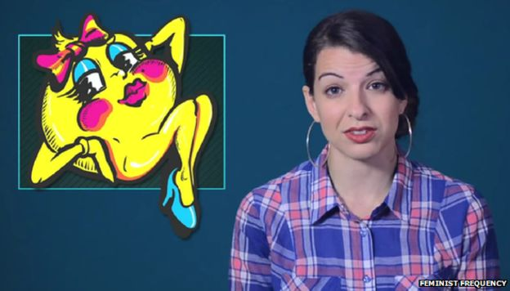
That has put pressure on video game firms like Ubisoft, Sony and Nintendo, among others, to fix the ratio in their games and to change the culture surrounding events like E3, once populated by "booth babes".
Although Ms Sarkeesian was subject to rape and death threats for her efforts, it does feel like "the industry as a culture feels less sexist than it used to," says University of Southern California professor Dmitri Williams.
That is partially because the video game industry realised they were "leaving a lot of money on the table by alienating women," he says.

That has led to some inroads: Borderlands: The Pre-Sequel, Civilization: Beyond Earth, Evolve, and Dead Island 2 were all new releases at E3 that either allowed one to play as a woman or had female protagonists.

Developer crunch
Of course, there are caveats.
While the percentage of female gamers has increased, that has been primarily due to the rise of mobile games, which often do not have characters. For instance, 60% of popular smartphone game Temple Run's players are female (although that game does allow one to play as a female character).
The gender ratio of players of so-called hardcore games, like first-person shooter games such as Halo, is generally disproportionately men, says Prof Williams, who also runs a game analytics firm, NinjaMetrics
It is those games - FPSs, in industry speak - that many observers see the industry regressing, not progressing.
"I think we're starting to see in some cases at least in some genres an even larger gap in the types of players," says Prof Downs.
The need to constantly refresh successful franchises to boost console sales has also put pressure on developers to churn out games at ever faster speeds.
That time crunch is a problem, says New York University professor and game designer Katherine Isbister, because most developers are men.
Developers "tend to create things that are similar to things they're seeing and playing so there's a feedback loop," she says.

Two steps forward
This brings the industry to a bit of a chicken or egg problem, at least when it comes to the hardcore games on consoles.
"Are women not playing hardcore games because they don't like them? Or because they feel alienated?" summarises Prof Williams.
Ubisoft says it is committed to diversity, and in a statement to the BBC did not comment on whether or not the decision to exclude female assassins was an economic choice or one based on user statistics.

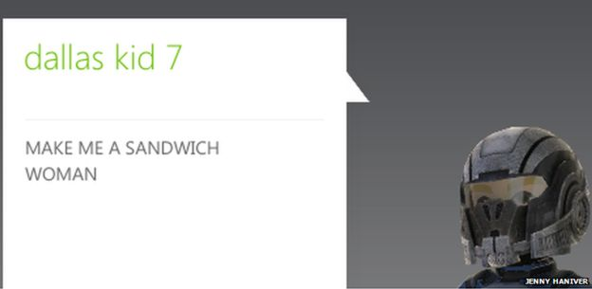
Jenny Haniver posts audio recordings and screenshots of the abuse she receives while playing Call of Duty

But the case of Jenny Haniver could prove instructive.
Ms Haniver plays Call of Duty - a FPS game - daily with her friends, as she has done for years - even though she is often subjected to harassment when men discover that she's a woman, as she told the BBC in 2012.
But, recently, Call of Duty introduced an option to play as a female character.
Now, she says "everyone I know when given the option will play as female characters" - including some men, who have also lobbied for more female characters and a reduction of both hypersexualised female and male characters.
"The more we're normalised and shown as protagonists, the more women are going to want to play games," she says.

TOPICALTOPICAL FEATURES

A Brief History Of Female Representation In Video Games
By Kate Harveston Last updated Jul 4, 2017
The video game industry is booming, but it repeatedly comes under scrutiny for what appears to be the persistent sexualisation of female characters. Many critics have assertively spoken out about how strong female video game characters are rare, with the characters that do appear are often being presented as “prizes.”
But has female representation in video games gotten better as time has passed, or worse?
History indicates that women began appearing in video games around the mid-80s. Sometimes these female characters were barely distinguishable from male characters except for one minor characteristic, such as long eyelashes. Ms. Pac-Man is a good example of that trend. Samus Aran, a heroine in the 1986 Metroid game, is considered the first playable female character, rather than a woman who merely appeared in the background.
In Mario and The Legend of Zelda respectively, Princess Peach and Princess Zelda appear as damsels in distress – and, in many cases, the objective of the game is to rescue them from peril.

Clothing Lara Croft
The introduction of Lara Croft in the 90s presented what is now considered to be one of the first strong female characters not just in video games, but in media in general. However, Croft was depicted in tight pants and midriff-baring tops, and people asserted that this meant the focus was not on her strength, but on her sexuality.
There were also complaints about the character’s unnaturally large breasts. Those reportedly began as a joke shared in the office of her creators, but they were supported since the gaming audience for the Lara Croft series was predominantly male.
A few years after her introduction, the Lara Croft character got a makeover that remains today. She now wears a tank top and pants and firmly represents the role of a strong heroine.
Following Tomb Raider was Grand Theft Auto, an immensely popular series that began in 1997. The game glamorises stealing cars and has been shunned by some gamers for the way it glorifies sexual harassment and the murder of female characters, catering to cisgender males while alienating minority groups.
There is speculation that when individuals see so much violence against women within the game, they won’t feel as shocked by it in real life.
In one version of the game, the goal is to kill as many women as possible. Players are also urged to make a male protagonist grope a female stripper repeatedly before a bouncer discovers his tactics.
Despite these eyebrow-raising activities, the Grand Theft Auto series is perpetually popular. There are currently 11 standalone titles and four expansion packs, which have collectively sold hundreds of millions of copies. Some analysts even say Grand Theft Auto has drastically changed the video game industry.
However, people are understandably worried that such exposure to severe violence against women in extremely realistic video games normalizes it and even causes people to become less empathetic. Studies have suggested these things are true, which is particularly worrisome considering the people who play Grand Theft Auto most often are young males.
There is speculation that when individuals see so much violence against women within the game, they won’t feel as shocked by it in real life. If this is true, Grand Theft Auto could be one of the many things perpetuating violence against females. Some experts say women who work in the sex industry are already at an elevated risk for being harmed by clients, and that Grand Theft Auto isn’t helping that statistic go down.

There were several notable instances of female characters being cast as the antagonists in video games beginning in the early 90s. A small number of these characters, such as SHODAN from the 1994 video game System Shockand Ultimecia from the 1999 title Final Fantasy VIII, have earned particular acclaim from fans and game reviewers, taking their places in video game history as some of the most memorable characters of all time.
Because in most cases, these villains are key characters in the games and not merely given background or subservient roles, this is arguably a major transition that is mostly positive. Although it’s not necessarily a good thing for young girls to see women in games displaying villainous traits, it’s better than them only seeing females as sexual objects.
Teresa Lynch, a media communications researcher at Indiana University, completed a doctoral project where she evaluated 571 playable female characters in video games released from 1989 to 2014. Lynch looked for indicators of hypersexualization such as huge breasts and tiny waists.
She found that the extreme sexualization of women reached its highest point in 1995 and then declined. However, there are still issues with women only being shown in secondary roles and being objectified more than their male counterparts.

Breaking stereotypes
Although there is still a long way to go before women are consistently represented more favorably in video games, some characters have been boldly designed to break the mold. One of them is The Scythian. She’s the protagonist from Sword and Sorcery, a video game for mobile platforms.
The character is not defined by her gender, and she demonstrates that women can be mythical heroes just as effectively as men. She is also an independently existing character and not the family member of a main male character in the game.
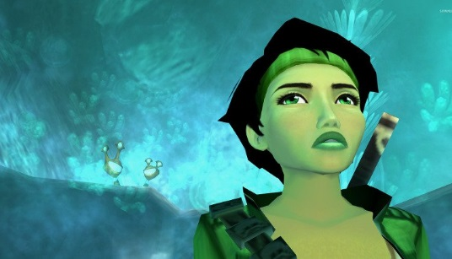
Then there’s Jade, a character from the 2003 title Beyond Good and Evil who represents progress because there were plans to have her defy stereotypes from the start. The character’s creator, Michel Ansel, wanted her to be well rounded and not further the clichés of female characters who act like males.
Fan feedback is one thing that could help gradually increase the number of admirable female characters in the gaming industry. It’s also important that critics keep recognising the clear gender inequality and voicing their opinions that it shouldn’t continue. These measures are necessary to keep moving in a positive direction instead of becoming fixated on females who are objectified or only shown in minor roles.
What will happen in the future remains to be seen, but it’s helpful that women make up such a sizeable chunk of gaming demographics nowadays. If they speak out and say they want changes made in the way female characters are represented in their favourite games, it could have a major impact on the industry.

READS
10/07/2016 4:16 PM AEST | Updated 15/07/2016 12:56 PM AEST

The Slow Evolution Of Women In Video Games

Call Of Duty Black Ops 3 actually features a female soldier.

By Libby-Jane Charleston
A sneak peek at the latest Call of Duty is enough to reinforce the idea that the tide is turning when it comes to female representation in video games. Until very recently, gaming has been almost entirely male dominated. It's not just the players, but the characters in the games too.
Female video game characters of the past were mostly relegated to roles of the 'bag-carrier wearing next-to-nothing' kind. Lara Croft, and her super-tight tank top, was the poster girl for female gaming, like it or not. Game designers have even complained that females were more difficult to animate due to bone structure. Oh, and they're more emotional so there's the challenge of animating a more expressive face.
It's even been suggested they were more difficult to animate due to the female characters' tendency to frequently disrobe. Imagine trying to animate a character who was gradually peeling off her clothing from scene to scene?
Ahem.
Women are also starting to be included in more sporting games, with the announcement by Big Ant Studios that female players and teams will be part of the cricket video game experience, in the upcoming Don Bradman Cricket 17. It's a world first that Big Ant Studios CEO Ross Symons is immensely proud of.
"One thing we decided from early on was that we didn't want to be tokenistic about this; we wanted to ensure that, just as in the men's game, that the women's is as completely true to the sport as is possible," Symons said.
Apart from sexism in video games and under-representation of female characters in games, there is also the sinister world of real-life sexual harassment of women players and those in the gaming industry.
The #GamerGate controversy in 2014 started as an attack against one female developer, which saw her home address and phone number published and a sustained campaign to destroy her public image. Its proponents claimed to want to restore the traditional values of gaming.
Whether times have changed since then is up for debate, but one sure thing is designers have listened to the pleas of the growing band of female gamers. While there are still challenges faced in terms of being a minority in what is still a mostly male dominated industry, statistics show 48 percent of all gamers are female.

Australia's Kayla 'Squizzy' Squires became the first female to qualify for Call of Duty World League in Los Angeles, a video game tournament pitting the world's best gamers against each other. Known as an 'eSports athlete' Squires plays as part of team, Exile5. She is leading the way for professional female gamers in Australia and she's told The Huffington Post Australia the tide has certainly turned in favour of female gamers.
"When I first started playing back in 2012 I didn't know any other female gamers. But things have changed. Not only are there more and more female gamers, who are attracted to the competitiveness of the games, there's much better representation of females in the games. It's come a long way just in the last few years," Squires said.
"The rise of female gamers means that the designers have really had to listen to what we want and it's really pleasing to see some great, strong females in a variety of games."
Video games now attract celebrity fans like Cara Delevingne, who is extremely vocal about her love of the game. She even appeared in the trailer for Call of Duty: Black Ops 3.
But while there has been a lot of progress, there are still grumblings that female representation in video games has not gone far enough and that the games will never feature full gender equality. But there are games like Mass Effect: Andromeda which, as revealed at the recent E3 Expo in LA featured a female lead character. Other Mass Effect games allow players to choose the gender they wish to play by.
Grace is a YouTuber who goes by the name 'I am fall from Grace'. (She prefers not to disclose her surname.) She has more than 100,000 subscribers to her channel and became hooked when introduced to video games by her father at the age of 13.
"My father and I would stay up playing until 2am! It's always been a part of my life and I was very drawn to Call of Duty because, being a first-person shooter game it's my go-to genre. It's a fast game play and it's competitive. I'm attracted to the different game modes, weapons, maps and challenges. And now there are more and more female protagonists so the game is really moving forward in terms of equality," Grace said.
Grace has recently returned from the E3 Expo where she saw a preview of the new Call of Duty: Infinite Warfare game. She's told HuffPost Australia that video game developers have been listening to female gamers when it comes to female representation.
"It's evident in seeing the games progress to what they're like now. In Infinite Warfare the female soldier is a very high ranking officer, who is very respectfully dressed. We've come a long way from Lara Croft with her boobs and skimpy clothing. So I do believe the game developers are taking it on the chin when it comes to designing female protaganists," Grace said.
"I've been involved in gaming from a very young age and gone are the days where female characters are the 'damsel in distress.' There are three leading female characters in Call Of Duty who are all very strong characters. They wear full soldier outfits, they are not masculine but they are as dominant as their male counterparts."
"I'm really hopeful that this will start to be the end of females in video games as the 'damsel in distress. Female gamers sent a strong message that we love gaming too and we want to have strong female characters. We've said, 'Can you please cater to us?' and many of them have listened."

Video games influence sexist attitudes

Date: March 28, 2017
Source: Iowa State University
Summary:
The images and roles of female characters in video games send a powerful message that can influence the underlying attitudes of gamers. Researchers found a link between video game exposure and sexism in a new study of more than 13,000 adolescents.

There are distinct similarities in the way women are portrayed in many popular video games. Female characters are typically attractive, scantily clad, appear in sexually suggestive ways and generally have limited roles.
Douglas Gentile, a professor of psychology at Iowa State University, says these images send a powerful message that can influence the underlying attitudes of gamers. According to a new study of more than 13,000 adolescents, Gentile and a team of French researchers found a link between video game exposure and sexism. The research is published in the journal Frontiers in Psychology.
"Many different aspects of life can influence sexist attitudes. It was surprising to find a small but significant link between game play and sexism. Video games are not intended to teach sexist views, but most people don't realize how attitudes can shift with practice," Gentile said. "Nonetheless, much of our learning is not conscious and we pick up on subtle cues without realizing it."
Researchers did not look solely at video games, but also measured the influence of television and religion. Gentile was not surprised to find the relationship between religion and sexism was three times higher than video games. This is likely because many religions have historically taken a traditional view of gender roles, he said. TV was unrelated to sexism after controlling for religion. Gentile says this may be evidence of the growing number and variety of female character roles on TV compared to 20 years ago.
Practice makes perfect
Repeated exposure to media influences how we perceive and understand social realities, according to George Gerbner's cultivation theory. Gentile says that influence increases with repeated exposure. The 13,520 adolescents, ages 11 to 19, surveyed for the study, spent approximately three hours a day watching TV and nearly two hours playing video games, on average.
Researchers did not measure the level of sexist content in the games played. However, in the paper they cite previous studies that found more than 80 percent of female characters in video game magazines are portrayed as sexualized, scantily clad or a vision of beauty. More than a quarter of the characters fit all three categories.
To measure sexism, researchers asked participants if they agreed or disagreed with the following statement: "A woman is made mainly for making and raising children." Participants who spent more time playing video games were more likely to agree.
"If you repeatedly 'practice' various decisions and choices in games, this practice can influence your attitudes and behaviors outside of the gaming world," Gentile said.
Gentile used the example of the game "Grand Theft Auto," which gives players few options of how to interact with female characters -- "you can pay them for sex, you can look at them or you can kill them," Gentile said. "This is an extremely limited view of the value of women."
Findings true regardless of culture
Researchers controlled for gender and socioeconomics. However, when analyzing the factors separately, sexism was higher among men with a lower socioeconomic status. Participants attended schools in Lyon and Grenoble, France -- two cities in the second largest and wealthiest region of France.
Although cultural differences often influence our attitudes, Gentile says the results are applicable across cultures because this study is focused on learned behaviors, not general cultural beliefs. How we learn and detect cues is the same regardless of culture, he said.
The researchers say it's important to understand that there are many things -- religion, family, education, socioeconomic status -- that influence sexist views. Gentile says video games are not the most important factor, and it is interesting that they are related to sexism at all.

Story Source:
Materials provided by Iowa State University. Note: Content may be edited for style and length.

Journal Reference:
- laurent Bègue, Elisa Sarda, Douglas A. Gentile, Clementine Bry and Sebastian Roche. Video Games Exposure and Sexism in a Representative Sample of Adolescents. Frontiers in Psychology, 2017 DOI: 10.3389/fpsyg.2017.00466

GAMING

Video games tied to sexism in teenagers, says study
A new study published by French and US researchers might give you one more reason to cut down the time your kid spends playing video games.
BY ZOEY CHONG MARCH 20, 2017 5:31 AM PDT
The more time your teen-age boy spends playing video games the more likely he'll be to develop sexist attitudes and gender stereotypes, according to a study released Friday.
French and US researchers who conducted the study surveyed 13,520 French youth between 11 and 19. Participants answered questions related to the amount of time spent on video game play and their attitudes toward women and gender stereotypes.
Results from the study, published in the Frontiers in Psychology journal, showed a positive correlation between game play and attitudes toward women, with levels of sexism higher in males.
Women are generally "underrepresented" in video games, according to the study. When women are included, they are frequently depicted as "characters needing help or holding passive or instrumental role," if not as "sex objects to win."
Researchers did acknowledge several limitations to their research model in identifying the actual causes behind sexist attitudes in teenage video game players, among which includes the possibility that "individuals with sexist orientations spend more time playing video games."
A similar study was published two years ago but generally showed no correlation between long-term gaming and sexist attitudes. In an interview with Kotaku, the researchers suggested that other factors such as family and peer influences contribute more to sexist attitudes than gaming does.

Rape and death threats are terrorizing female gamers. Why haven't men tech spoken out?
By Brianna Wu October 20, 2014
Brianna Wu is a Democratic candidate for Congress in Massachusetts's 8th District and a software engineer.

They’ve taken down women I care about one by one. Now, the vicious mob of the Gamergate movement is coming after me. They’ve threatened to rape me. They’ve threatened to make me choke to death on my husband’s severed genitals. They’ve threatened to murder any children I might have.
This angry horde has been allowed to wage its misogynistic war without penalty for too long. It’s time for the video game industry to stop them.
Gamergate is ostensibly about journalistic ethics. Supporters say they want to address conflicts of interest between the people that make games and the people that support them. In reality, Gamergate is a group of gamers that are willing to destroy the women who have invaded their clubhouse.
The movement is not new. Two years ago, when Anita Sarkeesian tried to crowdfund a series of videos critiquing the hypersexualized female characters of video games, they threatened to kill and rape her. The movement reached fever pitch – and got its name — when a jilted former lover of indie game developer Zoe Quinn published transcripts of her life online. Gamers who were outraged over charges that Quinn’s game Depression Quest had received favorable reviews due to an alleged romantic relationship with a journalist, seized the opportunity to shame and terrify her into hiding. Now, Gamergate is a wildfire that threatens to consume the entire games industry.

The fact that Gamergate supporters went after Quinn and not the journalist says everything you need to know about the movement.
I became Gamergate’s latest target when I tweeted this joke about supporters of the movement:
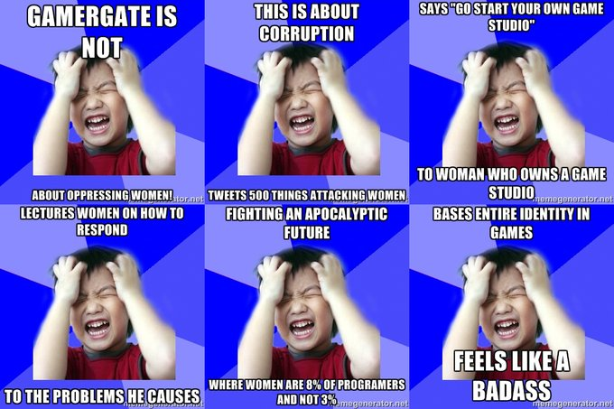

Brianna Wu
✔@Spacekatgal
This was just sent to me, a new meme called Oppressed Gamergater. Love it. http://memegenerator.net/Oppressed-Gamergater/ …
10:39 AM - Oct 9, 2014
Twitter Ads info and privacy
The next day, my Twitter mentions were full of death threats so severe I had to flee my home. They have targeted the financial assets of my company by hacking. They have tried to impersonate me on Twitter. Even as we speak, they are spreading lies to journalists via burner e-mail accounts in an attempt to destroy me professionally.
We’ve lost too many women to this lunatic mob. Good women the industry was lucky to have, such as Jenn Frank, Mattie Bryce and my friend Samantha Allen, one of the most insightful critics in games media. They decided the personal cost was too high, and I don’t know who could blame them.
Every woman I know in the industry is terrified she will be next.
The culture in which women are treated this way by gamers didn’t happen in a vacuum. For 30 years, video games have been designed by men, marketed to men and sold to men. It’s obvious to anyone outside the industry that video games have serious issues with the portrayal of women. It’s not just oversexualized examples, such as Ivy of the Soul Caliber series. Games are still lazily falling on the same outdated tropes involving women. Princess Peach, of Nintendo’s Mario games, has been kidnapped in 12 separate games since 1985. Perhaps the most disturbing of all is the propensity of games to have women thoughtlessly murdered as a motivation for the male hero, such as Watch Dogs.
The consequence of this culture is male gamers have been trained to feel video games are their turf. In stopping Gamergate, the men who dominate it – not just women — must address the culture that created Gamergate.
Some have. But many more have been silent. In the male-dominated video game media, many have chosen to sit by and do nothing as Gamergate picks us off, one by one. IGN has not covered Gamergate. Game Informer has not covered Gamergate. Ironically, the people who most need to hear this message are not hearing it, because of an editorial choice to stay on the sidelines.
There are many straightforward steps we can take to change this.
First, major institutions in video games, which happen to be dominated by men, need to speak up immediately and denounce Gamergate. The dam started to break this week as Patrick Klepek of Giant Bomb broke the silence at their publication on Monday. Last week, the industry’s top trade group, the Entertainment Software Association spoke out against Gamergate, saying “Threats of violence and harassment have to stop. There is no place in the video game community for personal attacks and threats.”

Secondly, I call upon the entire industry to examine its hiring practices at all levels. Women make up half of all gamers, yet we make up only a fraction of this industry. While it’s possible to point to high profile women in the field, the fact remains. Women hold a shockingly disproportionate number of high level positions in game studios, game publishers and particularly in leadership roles. There are just 11 percent of game designers and 3 percent of programmers, according to The Boston Globe.
Game journalism also plays a critical role. It doesn’t matter how many women we get into game production. If the only people evaluating the work we do continue to be men, women’s voices will never be heard.
My friend Quinn told me about a folder on her computer called, “The Ones We’ve Lost.” They are the letters she’s gotten from young girls who dream of being game developers, but are terrified of the environment they see. I nearly broke into tears as I told her I had a folder filled with the same. The truth is, even if we stopped Gamergate tomorrow, it will have already come at too high a cost.

http://www.adstandards.com/en/standards/genderPortrayalGuidelines.aspx

Gender Portrayal Guidelines
When considering consumer complaints about advertising, Standards Councils will be encouraged to refer to the principles expressed in the Gender Portrayal Guidelines with respect to the representation of women and men in advertisements.

Fast Facts
- Stereotyping Guidelines were originally developed by the CRTC Task Force in Sex-role Stereotyping in the Broadcast Media in 1981
- In 1981, Advertising Standards Canada (then the Canadian Advertising Foundation) took over the administration of the guidelines, on behalf of the industry, and extended their purview to all Canadian paid media
- The Stereotyping Guidelines were revised in 1987.
- Renamed the Gender Portrayal Guidelines and revised in 1993

Interpretation Guide
1. Caution should be taken to ensure that the overall impression of an ad does not violate the spirit of gender equality even though the individual elements of the ad may not violate any particular guideline.
2. While the Guidelines pertain to both women and men, some clauses are particularly directed to the portrayal of women. Men and women are not at equal risk of being negatively portrayed and these Guidelines recognize that fact.
3. Humour, works of art and historical settings can all be positive elements in advertising. However, these techniques should not serve as an excuse to stereotype women or men or to portray behaviour which is not acceptable today.
4. The Standards Councils may consider the nature of the media used when assessments are made. Sensitivity should be demonstrated in choosing media vehicles for certain product categories, such as intimate or personal products.

Gender Portrayal Guidelines
1. Authority
Advertising should strive to provide an equal representation of women and men in roles of authority both for the characters within the actual advertising scenario and when representing the advertiser through announcers, voice-overs, experts and on-camera authorities.
2. Decision-Making
Women and men should be portrayed equally as single decision-makers for all purchases including big-ticket items. Where joint decision-making is reflected, men and women should be portrayed as equal participants in the decision-making process whether in the workplace or at home.
3. Sexuality
Advertising should avoid the inappropriate use or exploitation of sexuality of both women and men.
4. Violence
Neither sex should be portrayed as exerting domination over the other by means of overt or implied threats, or actual force.
5. Diversity
Advertising should portray both women and men in the full spectrum of diversity and as equally competent in a wide range of activities both inside and outside the home.
6. Language
Advertising should avoid language that misrepresents, offends or excludes women or men.

StatsCan on gender pay gap: Women earn 87¢ to men's $1

Canadian women still more likely to work in traditionally 'female' occupations
By Solomon Israel, CBC News Posted: Mar 08, 2017 11:21 AM ET Last Updated: Mar 09, 2017 12:19 AM ET

Canadian women earned 87 cents an hour for every dollar made by men in 2015, according to new Statistics Canada data released Wednesday to mark International Women's Day.
The data, which reflects the hourly earnings of Canadians aged 25 to 54, shows the gender wage gap has shrunk by 10 cents since 1981, when female workers earned 77 cents for each dollar earned by men.
- Women urged to go on strike for Intl. Women's Day
- Across Canada, Indigenous women are on the rise
- Push for more female leaders on Wall Street
Statistics Canada says that ratio has improved, in part, due to rising educational attainment by women. In 2015, 35.1 per cent of Canadian women had university degrees, compared to 13.7 per cent in 1990.
But even education doesn't completely erase that earnings gap.
"Even when they had a university degree above the bachelor's level, women earned an average of 90 cents for every dollar earned by men in 2015," wrote Statistics Canada analyst Melissa Moyser in her report.
"The gender pay gap partly owes to the differential allocation of female and male workers across occupations," wrote Moyser. "Women are overrepresented in low-paying occupations and underrepresented in high-paying ones."

Women's work
Canadian women are still more likely to work in traditionally "female" fields like teaching, nursing, social work, sales, service or administration, according to the report. In 2015, 56.1 per cent of women worked in those fields, compared to 17.1 per cent of men. That's not much different from 1987, when those figures were 59.2 per cent and 15.7 per cent respectively.
In professional science jobs, 75.6 per cent of workers were men in 2015, reflecting significant gender imbalances in fields like computer and information systems and engineering.
Gender parity has been reached in the public sector, however. In 2015, women comprised 54 per cent of legislators and senior government managers, which the report attributes in part to employment equity laws for public servants.
In the private sector, women made up just 25.6 per cent of senior managers in the same year.

Responsibilities outside workplace
Canadian women remain less likely to be employed than Canadian men (77.5 per cent for women and 85.3 per cent for men in 2015). Women are also more likely to work part time (18.9 per cent for women and 5.5 per cent for men), often because they're caring for children.
That means women worked fewer hours per week in 2015, and were more likely to be away from work during the week. When women took involuntary time off from work, they were more likely than men to cite illness, disability, personal reasons, or parental leave.
The disparity in hours worked, wrote Moyer, means annual wages can be "a problematic measure of gender-based pay inequality."
"While annual earnings reflect both the price of labour and its quantity, the hourly wages of full-time workers reflect only the price of labour, and they are therefore closer to the issue of gender-based discrimination," wrote Moyer.
When measured by annual wages, women earned 74 cents for every dollar earned by men in 2015.

Another look at labour trends by gender
Research released today by RBC Economics tells a similar story: The gender pay gap has shrunk, but still exists, women are more likely to work part-time and perform unpaid labour, and are still more likely to work in traditionally "female" professions.
But the paper from RBC economist Laura Cooper also casts light on some improving trends for women in the workplace.
Women comprised the majority of Canadian employment gains in 2015 and 2016, a reversal of the trend for 2013 and 2014, wrote Cooper.
Also, the labour force participation rates of older Canadian women have increased, with a record 32 per cent of women aged 55 and older taking part in the labour force in 2016. In 2000, that figure was 19 per cent.
As the working population ages over the next two decades, improving female labour force participation rates "could act to partially offset the projected slowdown in economic growth," wrote Cooper.
Like Statistics Canada's report, the RBC Economics dispatch shows that women are underrepresented in private sector leadership roles in Canada. Just 2.6 per cent of women were in charge of incorporated businesses in 2014, compared to 6.5 per cent of men. That still puts Canada second among G7 countries in this metric, after Italy and ahead of Germany, France, the U.K., U.S. and Japan.

