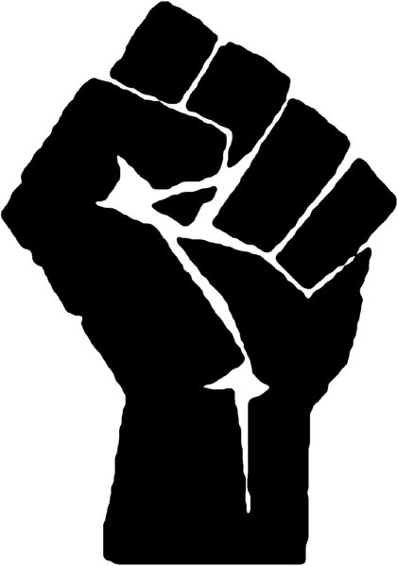TO KILL A MOCKINGBIRD 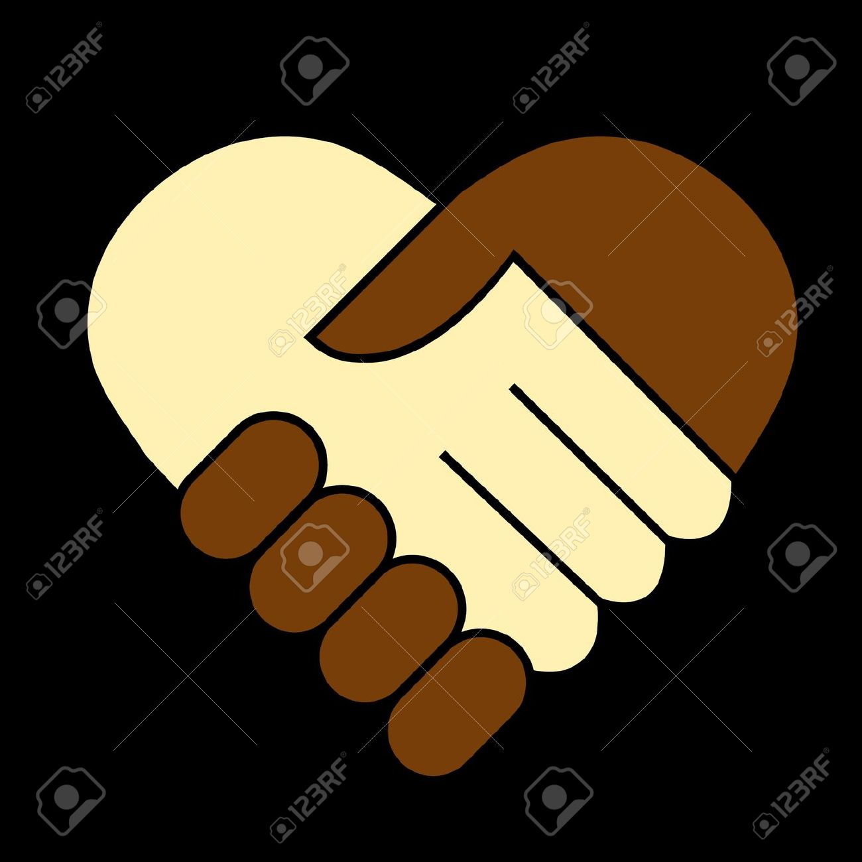
SOCIAL CONTEXT PRESENTATIONS

Harper Lee’s 1960 book To Kill a Mockingbird is a classic novel that takes place during the Great Depression (1930s) in the American South. The story is narrated by Jean Louise “Scout” Finch which allows the reader to see the prejudiced world of the 1930s from the innocent eyes of a 6-8 year old girl. In order to understand the depth of the novel’s themes and the many historical references, it is important to understand the social context of when it was written and when it takes place. For this, you will be preparing a short, but powerful and informative presentation on the topics listed.
OBJECTIVES:
- To provide information on the social context of the novel: setting, conflict, history, major events, society & culture, etc.
- To see & feel what racial discrimination was like in the USA especially in the 1930s-1960s
- To better understand the history and thus be able to make connections to current race & discrimination issues

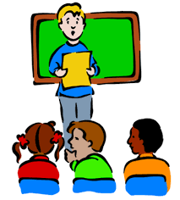 PRESENTATION: each digital presentation must include/be -

- Min 2 mins & max 3 mins in length – movie or video
- Mostly key visuals/video with 5Ws + H
- Some important headings or text to provide context or key information
- A voiceover narrator that provides the majority of the information
- Background music used strategically to help create mood

INFORMATION:
- 5 W’s & H for your topic(s):
  - Who – was involved
  - What – it is, happened
  - When – it happened/person lived & died
  - Where – it happened
  - Why- it’s/he/she is important
  - How- it’s connected to racism/racial divide/race issues in USA/Canada

YOUR GOAL IS TO GET US TO KNOW A LITTLE MORE & TO MAKE US FEEL A LOT MORE!
PRESENTATION TOPICS: Must be presented in chronological order. This is the list of presenters. If there are 2 names, the first is block 1.1 & the second 1.2. The topics in BLUE are still open to both classes for those who don’t have a topic. Purple indicates a topic only taken by block 1.1 & Green indicates a topic only taken by block 1.2.
Students who do not yet have an assigned topic: Block 1.1 - Raman, Sanjey, Savina, Gabriel R. Block 1.2 – Erah
As stated above, the order of presentation is CHRONOLOGICAL – in time/numerical order. So please note your topic number, where your topic falls, and who is presenting before you so you can know when you will be presenting. In other words, Kevin & Ashely you will be presenting first in each of your classes, followed by Amrit & Anmol, etc,
- Slavery & the Slave Trade ** - Kevin/Ashley
- Fugitive Slave Act, Dredd Scott Case, Black Codes – Amrit/Anmol
- Activists: Harriet Tubman & the Underground Railroad – Eula/Tania
- Abolitionists: 1 male, 1 female, 1 other (must have 1 Black and 1 White person)- Claire
- African-Canadians Activist: Viola Desmond & 2 others
- Emancipation Proclamation & the 13th, 14th, 15th Amendments **- Raphael
- Lynching, “Strange Fruit”, Billie Holiday ** - Frida/Ghielene
- Ku Klux Klan & Governor George Wallace ** - Katelyn
- Jim Crow Laws & Segregation ** - Kareena/Chanpreet
- Events: Plessy v Ferguson & Brown v Board of Education & Little Rock Nine - Naous
- W.E.B. DuBois, Booker T. Washington, Ida B. Wells
- NAACP & 3 major achievements -Shawn
- Harlem Renaissance, Langston Hughes & Zola Neale Hurston
- Tuskegee Airmen & “Hidden Figures”– Katherine Johnson, Mary Jackson, Dorothy Vaughan – Lauren/NO NAME – Zain??
- Influential Athletes: Jackie Robinson, Jessie Owens, Harry Jerome, Joe Louis, Muhammad Ali, Tommie Smith & John Carlos – Josh C.
- Influential Musicians: Muddy Waters, Louis Armstrong, Marian Anderson – Jeremiah/Gabriel
- Events: Emmett Till & Scottsboro Boys Case ** - Jersey/Jasmine
- Activist: Rosa Parks & the Montgomery Bus Boycott – Navneet/Alyssa
- Activists: SNCC & CORE – Lunch counter sit-ins & Freedom Riders - Elias
- Events: Birmingham Church Bombing & “The Ballad of Birmingham” – Chelsea/Harleen
- Activists: Martin Luther King Jr., March on Washington, “I Have a Dream” speech – Princess/Jenny
- Politicians: John F. Kennedy, Robert F. Kennedy, Civil Rights Act – Kyle/ Sandeep
- Events: SCLC, Selma to Montgomery March - “Bloody Sunday” – Reneandro/Jared
- Activist: Malcolm X, Black Power Movement, Black Panthers – Arjun/Haseeb
- Leaders: Fredrick Douglas, Shirley Chisholm, Jesse Jackson, Thurgood Marshall, Barrack Obama
- Influential Writers: Maya Angelou, Toni Morrison, Alice Walker, Alex Haley
- Rodney King, the Million Man March, Jena Six – Josh S.
- Black Lives Matter founders, Trayvon Martin, Michael Brown, Freddie Gray, Eric Garner, Philando Castile, Alton Sterling ** - Romlyne
- Current Artist-Activists: Kendrick Lamar “Alright”, J. Cole “Be Free”, Beyoncé “Freedom”, Macklemore & Ryan Lewis “White Privilege II” - Angelo/Armin
- Current Artist-Activists: Miguel “How Many”, Lauryn Hill “Black Rage, Joe Budden “Freedom Freestyle”, Jesse Williams BET 2016 Speech – Rommiel/Jaskirit

