NARRATIVE ELEMENTS

- SETTING:

      - Time - when the story takes place; specific date/time or
general (ex. 3:30pm, summer, past)
      - Place - where the story takes place; geographical location
      - Mood - the feeling the reader has from the story; atmosphere
      - Tone - the writer’s attitude

- CHARACTER:

TYPES OF CHARACTERS:

      - Protagonist - the main character in a story

      - Antagonist - the character or force that works or competes
against the protagonist
      - Round Character
- a well developed character
- complex
- reader learns a lot about this type of character
      - Flat Character - NOT well developed
- the reader does NOT learn a lot about
this type of character
      - Static Character
- the character does NOT undergo
significant changes throughout the story
- the opinions, attitudes, and actions do NOT change
      - Dynamic Character
- the character DOES undergo significant
changes throughout the story
- the opinions, attitudes & actions DO CHANGE

      - Stock/Stereotyped Character - totally predictable, one dimensional, often
seen as a type ex. the jock, the nerd, etc.

      - Character Foil - attitudes, behaviours, opinions contrast with protagonist
- the contrast helps reader understand protagonist better

PRESENTATION OF CHARACTERS:

      - Direct Presentation
- the author TELLS what a character is like
- the author may have the narrator or some other character in the story TELL us what a character is like

      - Indirect Presentation
- the author does not tell us about the character
- the author SHOWS us what the character is like through his/her actions, thoughts, words or what others think of the character

- PLOT:

      - Introduction - the start of a story
(exposition) - setting and characters are presented

1.2 - INITIATING EVENT- first main event of the story, causes the rest of (Inciting Incident) the action

      - Rising Action - a series of events that lead up to the climax
(complication) - conflict is introduced

      - Climax - the highest point in the story
- the point of highest emotional intensity
- the turning point in the story

- ANTI- CLIMAX - a sudden shift from a serious mood to a
comical/trivial mood

      - Falling Action - the final events of the story
(resolution) - the conflict is decided or resolved

      - Conclusion - the ending of the story; denouement
- the impact of the resolution becomes clear

BASIC PLOT DIAGRAM

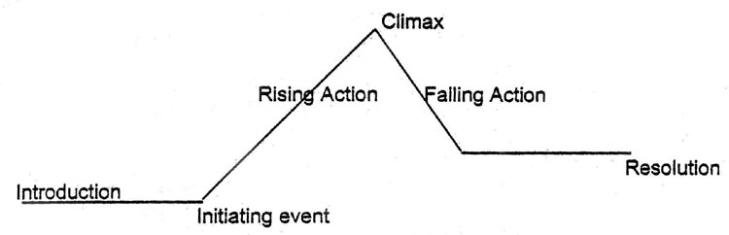

- CONFLICT:

      - Person vs. self - internal struggle; conflict of the mind
- centers around the protagonist’s struggle to overcome
issues within him/herself
- protagonist’s dilemma

      - Person vs. person – external conflict; between the protagonist and
another character (antagonist)
- usually in the form of a physical fight or argument

      - Person vs. society – external conflict; between one character & larger
group
- the protagonist against the pressures of society
(ex. Racism, sexism, etc.)

      - Person vs. nature - external conflict; between a character and
animals, weather, or another force of nature

      - Person vs. supernatural – external conflict; between a character and a
supernatural being or force
- something beyond humanity (ex. Ghost)

      - Person vs. technology – external conflict; between a character and some
form of technology ex.robot, internet, etc.

- POINT OF VIEW:

      - First Person - when one of the characters tells the story
- the pronoun “I” is used

      - Omniscient - the narrator relates the thoughts and feelings of
ALL the characters: 3rd person
- “god-like” narrator

      - Limited Omniscient -- the narrator relates the thoughts and feelings of only
one or a few characters: 3rd person
      - Objective - narrator has no special knowledge; story is factually
presented; 3rd person
- like viewing photographs of an event

- THEME:
        - the message or lesson that the author is trying to convey
        - a universal message about life (can apply to all)
        - is a complete statement (not one word)

- TONE:

      - Tone - the attitude/mood a writer takes toward the subject,
characters & readers or a literary work
        - can be humorous, romantic, mocking, bitter, etc.

      - Satire - the use of irony, sarcasm or ridicule, to denounce or
expose people or ideas; often criticizes society or politics

      - Irony - using words or phrases to mean the exact opposite of its
literal or normal meaning
        - when the opposite of what is expected occurs

There are 3 types of irony:

- Verbal Irony - occurs when the literal words are opposite
to the intended meaning; similar to sarcasm

- Situational Irony - an outcome is the opposite of what one would expect

- Dramatic Irony - the reader/audience knows key information that the character(s) doesn’t

- IMAGERY:

- Imagery - vivid language, details and figures of speech that help the reader form a mental image of the writing; helps the reader “see” & “feel” what’s being read

- Simile - a comparison between two unlike things using like or as

- Metaphor - a direct comparison between two unlike things

- Personification - giving human qualities to plants, animals, objects, etc.

- OTHER:

- Allusion - a reference to a person, place or event from
history, literature, or mythology

- Epiphany - a moment of significant realization/insight

- Flashback - a switch in plot from the present to the past

- Foreshadowing - hints or warns of events to happen later in story

- Symbolism - using something concrete to represent something abstract (ex. a heart to represent love)

