NARRATIVE ELEMENTS

- SETTING:

      - Time - when the story takes place; specific date/time or
general (ex. 3:30pm, summer, past)
      - Place - where the story takes place; geographical location
      - Mood - the feeling the reader has from the story; atmosphere
      - Tone - the writer’s attitude

- CHARACTER:

Types of characters:

      - Protagonist - the main character in a story

      - Antagonist - the character or force that works or competes
against the protagonist

      - Round Character - a well developed character
- complex
- reader learns a lot about this type of character

      - Flat Character - NOT well developed
- the reader does NOT learn a lot about this type
of character

      - Static Character - the character does NOT undergo significant changes throughout the story
- the opinions, attitudes, and actions
do NOT really change

      - Dynamic Character - the character DOES undergo significant
changes throughout the story
- the opinions, attitudes, and actions DO CHANGE

- PLOT:

      - Introduction - the start of a story
- setting and characters are presented
- also called the exposition

1.2- INITIATING EVENT/ Inciting Moment- first main conflict; causes rest of action

      - Rising Action - a series of events that lead up to the climax
- conflict is introduced
- also called the complication

      - Climax - the highest point in the story
- the point of highest emotional intensity
- the turning point in the story

      - Falling Action - the final events of the story
- the conflict is decided or resolved
- also called the dénouement

      - Conclusion/ - the ending of the story
Resolution - the impact of the resolution becomes clear

BASIC PLOT DIAGRAM

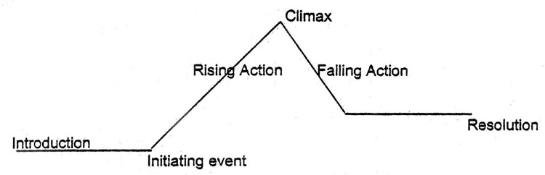

- CONFLICT:

      - Person vs. self - conflict of the mind
- centers around the protagonist’s struggle
to overcome issues within him/herself
- protagonist’s DILEMMA

      - Person vs. person – conflict between the protagonist and
another character (antagonist)
- usually in the form of a physical fight or
argument

      - Person vs. society – conflict between one character and a
larger group
- the protagonist against the pressures of
society (ex. Racism, sexism, etc.)

      - Person vs. nature - conflict between a character and
animals, weather, or another force of
nature

      - Person vs. supernatural – conflict between a character and a
supernatural being or force
- something beyond humanity (ex.ghost)

      - Person vs. technology – conflict between a character and some
form of technology (computer, robot,etc.)

- POINT OF VIEW:

      - First Person - when one of the characters tells the story
- the pronoun “I” is used

      - Omniscient - the narrator relates the thoughts and feelings of
ALL the characters
- “god-like” narrator

      - Limited Omniscient - the narrator relates the thoughts and
feelings of only one or a few characters

- THEME: - the message/lesson that the author is trying to tell
- a universal message/truth about life (can apply to all)
- is a complete statement (not one word)
- OTHER:

1. Flashback - giving information about an event or situation in the past

2. Foreshadowing - giving hints or clues about events that will happen in the future of the story

3. Symbol/ – when an abstract ideas is represented by symbolism something concrete

4. Irony - when the opposite of what is expected occurs

