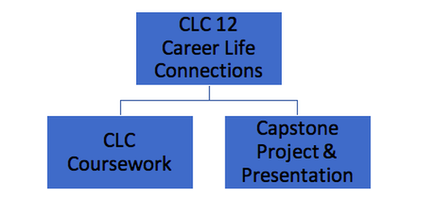
Capstone Project
A Person’s Career is Considered Their “Journey” Through Life.
For most people, career-life planning will not be a matter of making one major decision and living with it for a lifetime. Rather it will consist of learning through study, experiential learning, community networking, flexible planning for post-graduation and reflection on skills and interests. CLC & Capstone is designed to be one component in helping you manage this journey towards a meaningful and preferred future as you prepare to exit the school system.
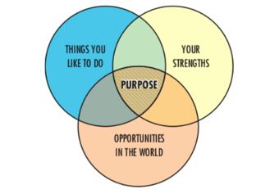
What exactly is Capstone?
The capstone is a rigorous year-long learning opportunity that allows students to reflect and share their learning journey in a culminating presentation / project. Capstone is a requirement of Career-Life Connections and for graduation.
- Capstone is a passion project
- Capstone allows you to demonstrate your interest in learning about a particular topic.
- Ideally, your focus would be in an area you are passionate about and could possibly be pursuing after graduation.
- Your Capstone Project should be a topic that you are passionate (interested) in learning more about.
- You will present your Capstone in early to mid April
What is the purpose of Capstone?
The purpose of the Capstone is for students to demonstrate the knowledge, competencies, and passion(s) that they can offer the world, as they integrate personal interests and strengths with preferred future possibilities. It is a representation of the student’s learning journey and provides an opportunity to reflect and synthesize as well as showcase and celebrate. By going through this process, students are able to advance toward who and how they want to be in the world.
What does Capstone consist of?
The Capstone project consists of three components that include the following:
1. Proposal
Select a project area and develop a Capstone Proposal (see Proposal Format). It is recommended that you should review the proposal with parent(s)/guardian(s) and Teacher Mentor prior to the submission to Mr. Birt through the Google Classroom. The proposal will be reviewed and approved by Mr. Birt before any work may begin.
2. Execution of Capstone
The main idea of the Capstone is that you are engaged in a meaningful project and that you will be experiencing real-life relevant learning. You will conduct research and maintain a collection of work product evidence for use later in the Capstone presentation.
3. Presentation
In the final step of the Capstone process, you will deliver a 7-10 minute presentation (see Presentation Guidelines). The presentation should incorporate components of the project, including evidence of your learning and be displayed in a way that suits your project (the portfolio).

