The DT (adapted) Rules of Tchoukball
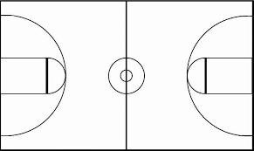
- Begin with a jump ball. A point is scored for rebounding the ball off the net and having a teammate catch it.
- There is a crease around the net that no one is allowed to enter unless a player needs to retrieve a ball from behind the net.
- Players with the ball may only take three steps or take three seconds (just like handball).
- Defensive players may not contact offensive players and vice versa.
- Defense is similar to handball.(Shadow)
- After scoring a point, the offensive team passes ball to defensive team and the defensive team touches the back wall before passing ball out.
- Plenty of adaptations exist but these tend to get the most out of the students and allow them to experience some basics of the game.
- See this link for official rules. ttps://www.ldcsb.ca/Programs/recreation/tchoukball/Documents/Tchoukball%20Rules.pdf
- Using other balls will also work such as a basketball or a volleyball.
- Safety Concerns: not a lot except for the tchoukball’s themselves are quite hard and can hurt if struck in the face.

