Volleyball
Serving
-If the ball hits the net on the serve it is NOT considered a fault, and play shall continue as if it was a regular serve.
-A serve may happen anywhere behind the base line and within the free zone.

Scoring

-A team scores a point:
o By successfully grounding the ball on the opponent’s court;
o When the opponent team commits a fault;
o When the opponent team receives a penalty.
-If the serving team wins a rally, it scores a point and continues to serve.
-If the receiving team wins a rally, it scores a point and it must serve next.

Rules

-The team is entitled to a maximum of three (3) hits, in addition to blocking
-A hand or hands passing over the net to affect a block is NOT a fault provided that you do not interfere with the opponents play

Badminton

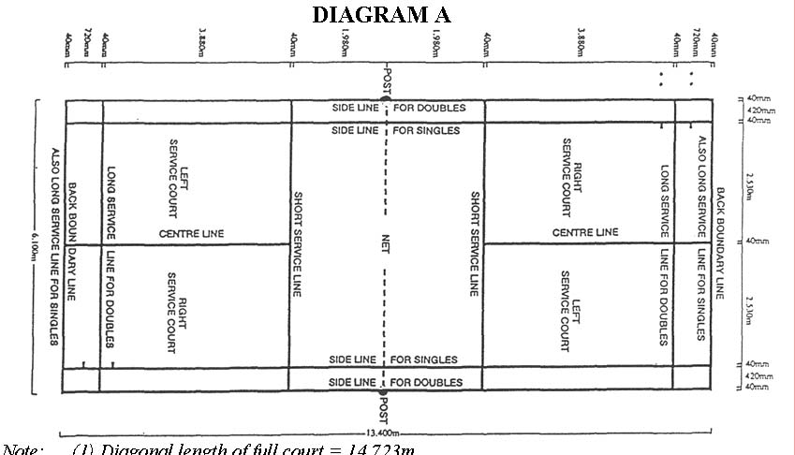
Service
A shuttle on the line is "in". The server and receiver stand in the diagonally opposite service courts (always right hand at the start of the game) but therefore players may move anywhere on their side of the net. The server must obey laws designed to force underhand delivery of the serve, and the receiver must stand still until the service is struck.
Scoring
If the serving side wins a rally, it scores a point, and serves again but from the alternate service court. If the receiving side wins the rally, the score remains unchanged and the service passes to the next player in turn. In singles, this is the opponent: in double it's either the partner or, if both players have just had a turn of serving, one of the opponents
Rules
-A rally is won when a shuttle is hit over the net and onto the floor of the opponent's court. –
-A rally is lost if the shuttle is hit into the net, or over the net but outside of the opponent's court. A rally is also lost if the shuttle touches the player's clothing or body, or if it is hit before it crosses over the net.

