Racquet Games
Outdoor
Tennis
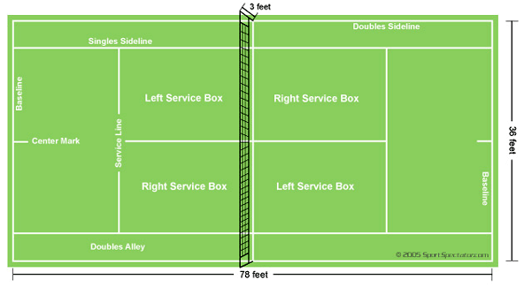
- Rules
- Service:
  - serve each point from alternative sides on base line
  - If the server fails to get first serve in they can use their second serve, failing to complete the second serve the point will be lost
  - If the server clips the net but the ball goes in the service area it is legal
- Miscellaneous:
  - If player touches net, distracts his opponent or impedes in anyway then they automatically lose the point
  - The ball can hit any part of the line for the point to be called in, outside the line and the ball is out
- Scoring
- Each set:
- 4 points to win the game (1st point – 15, 2nd point – 30, 3rd point – 40, 4th point – game)
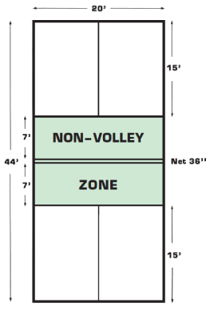
- 40 – 40 results as a deuce (player must win by a clear of 2 points)
- Each game:
  - best out of so many sets (out of 3 – women, out of 5 – men)
  - clearly win by 2 sets (i.e. 7-5 sets to win)
- Court Diagram

Indoor
Pickle Ball
- Rules
- Service:
  - Serves are made diagonally, starting with the right-hand service-square and alternating each serve
  - Server must clear the seven-foot non-volley-zone in front of the net and land in the diagonal service court
  - Serves should be done underhand with the paddle below the waist
  - Server must keep both feet behind the back line when serving
  - The ball should be hit into the air without being bounced
  - Serving side will continue to serve until there is a fault on the service
- Scoring
- First side scoring eleven points and leading by at least two points wins
- Players can only score a point if they are serving
- Teams switch sides when they receive a point

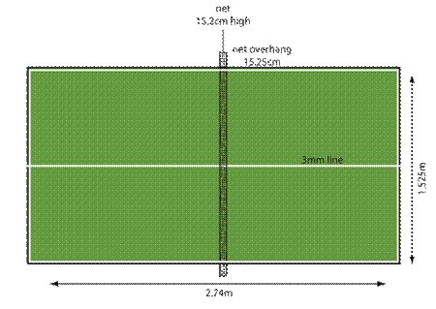
Table Tennis
a. Rules
- Service:
- Performed from area behind the table and between the side edges
- Toss ball up, strike while it’s in the air, first bounce should be on the server’s court, passes over the net bouncing on receiver’s court
- NOTE: if server misses the ball completely, the receiver scores 1 point
- Returning the ball:
  - Ball must be struck after it bounces on your court (if hit before hitting your court its considered a volley – illegal), then hitting it directly over the net into the receivers court
  - IF the ball hits the net and goes over, it is legal
  - Ball cannot physically touch the empty hand (non-racquet hand)
  - If the ball strikes the top surface or top edges or corners it is legal, but aide edges are out of bounds
b. Scoring
- Points (if your opponent):
- Fails to make a good serve
- Fails to make a legal return
- Touches the net in any way with racquet, clothing, or body
- Volley the ball at anytime
- Ball touches clothing or body

