Unit: Grade 8/9 Volleyball

Lesson #2 – (Bump) Underhand Pass Adapted
- prior to teaching lesson, students are given a series of you-tube video clips that proper technique. <https://www.youtube.com/watch?v=O9mQNIUMpIY>

- http://volleyball.about.com/od/glossary/ - Students provided with link to this website that contains images and definitions to aid in the understanding of the game of volleyball.

- Pair ELL students with student who speaks English and native language (i.e. Tagalag)
- Instruct helper to translate instruction if ELL student seems confused

Warm Up: Dynamic Physical Activity to ready the legs and arms.

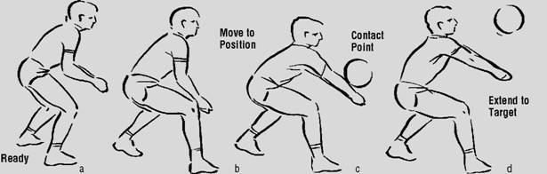
- Demonstrate proper technique for bump

- In partners have students toss ball to partner and return with the bump. Switch after a minute.

- Students form groups of 5 where they will practice their bump skills by trying to keep the ball in the air as long as possible.

- In their same groups, students will play an elimination game where they are eliminated if they cannot successfully keep ball in the air using an underhand pass. Groups continue until only one student remains. Since these activities are very visual, ELL students will be instructed to repeat what they have seen in order to demonstrate understanding and ability.

- Class will then be instructed to line-up behind me and we will walk the lines of the volleyball court in order to show them what the court looks like and where players must position themselves.

- Students will then participate in a short game that uses no serves and only underhand passing.

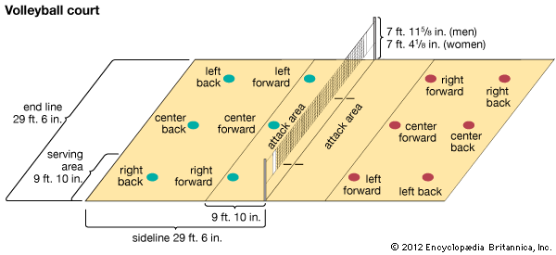

Check for understanding.

- Students must demonstrate:

-Legs
-Arms
-Movement

