Volleyball

Rules
- 6 players on court
- 3 hits to return the ball
- Rotate clockwise after every time their teams wins back the service
- Only 3 players in net position can jump, spike or block
- Backcourt players can only hit the ball over the net if they are behind the attack line
- Ball hits net and goes over it is legal
- When hitting:
  - Bump/ forearm pass clasping hands and using your forearm to pass the ball
  - Volley motion of sending ball back and forward from the net
  - Spike slamming the ball over the net aggressively and effectively
  - NO carrying the ball
Scoring
- Rally point system
- Best out of 5 sets (first 4 sets are played to 25 points, 5th set is played to 15 points)
- Must win a set with a two point advantage

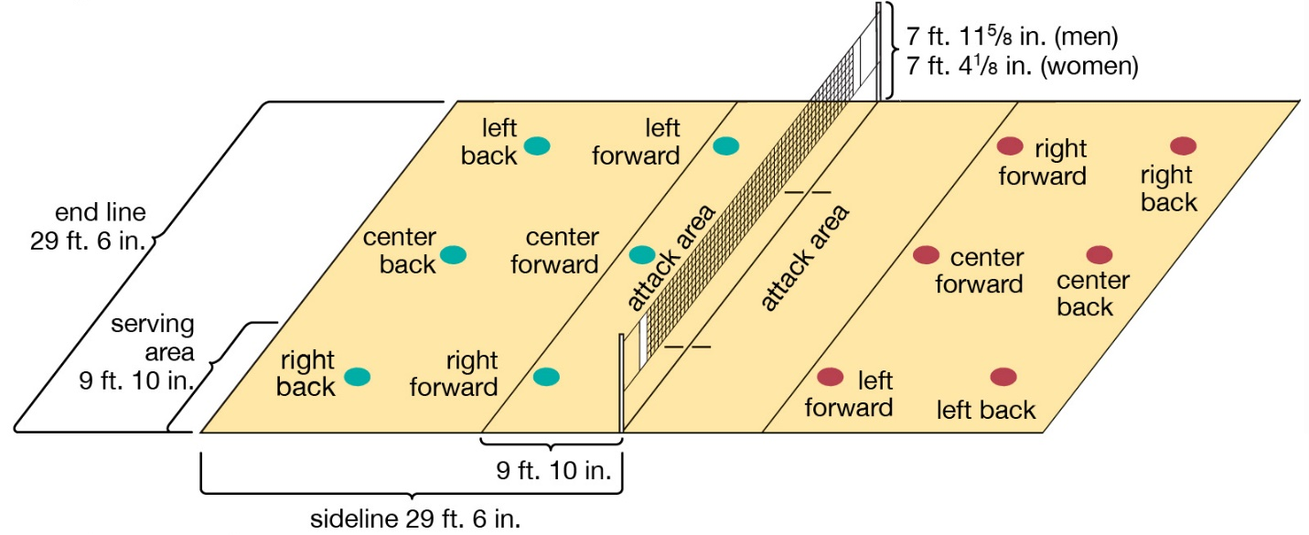
Court Diagram

