PE 8
Soccer Skills Name: ___________________

Kicking the Ball – Match the diagram with the correct terminology.
A. 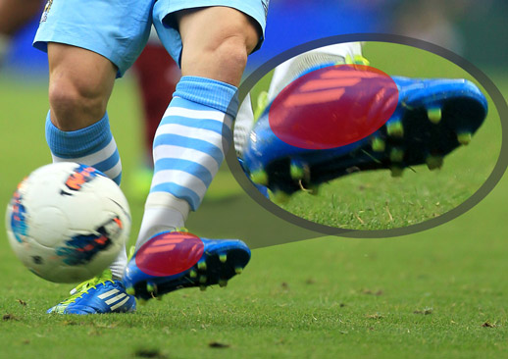 B. 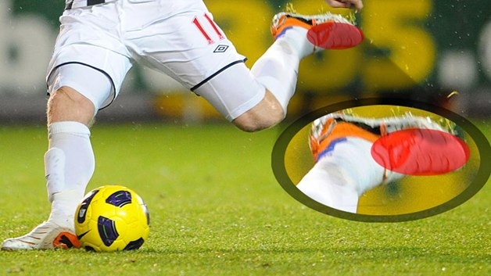
Passing on the ground: _______
Raising the ball into the air: _______

Rules of the game – Read the following rules before completing the questions on the back.
THROW IN
- A throw in is taken along the touch line at the point where the ball went out of play.
- It is awarded against the team that last touched it before it went out of play.
- The ball must be thrown into play with both hands, from behind and over the head.
- The thrower must face the play and, as the ball is released, part of each food must be on the ground either behind or on the touch line.
- A goal may not be scored directly from a throw in and the thrower may not play the ball again until it has been touched by another player.
GOAL KICK:
- awarded to the defending team when the ball crosses its goal line (without passing between the goal posts) after having been last touched by an opponent
CORNER KICK:
- awarded to the attacking team if the ball crosses the goal line (without passing between the goal posts) having been last played by one of the defending team
FREE KICKS:
- awarded to a team for an offense committed by an opponent
PENALTY KICK:
- awarded to the opposing team when a defending player within his own penalty area commits a major foul which would normally be penalized by a direct free kick

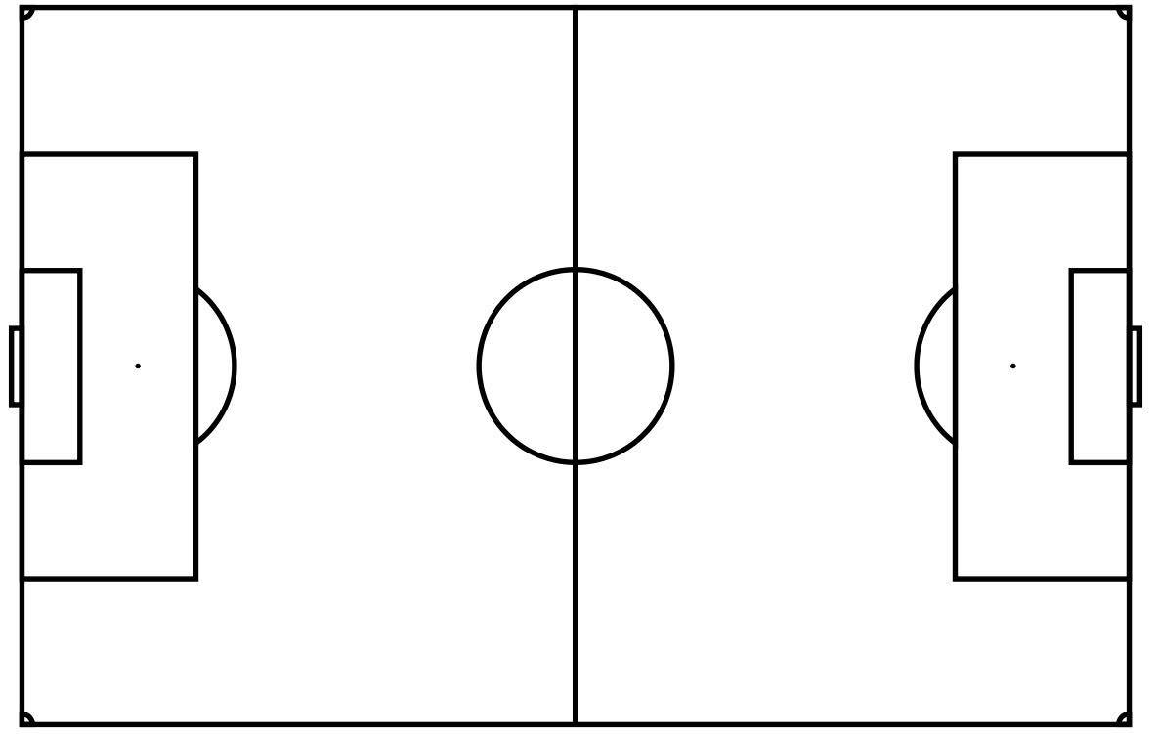
A B

C D

Fill in the blanks.
Match the following terms with correct location in the diagram above.
Word Bank:
Corner Kick Goal Kick
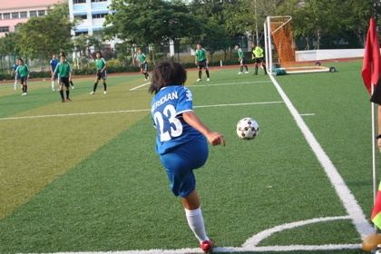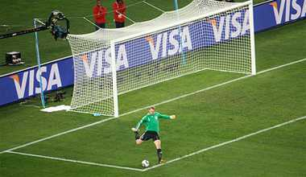

Penalty Kick Throw In
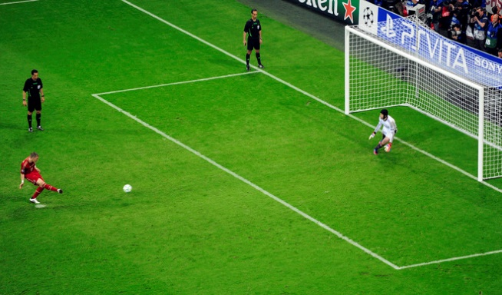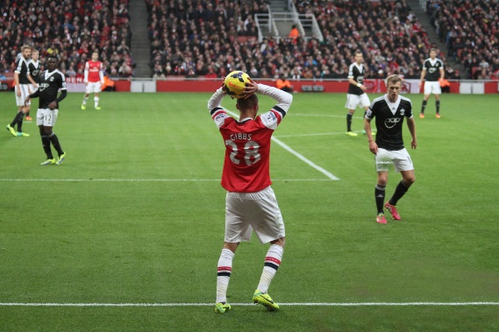

A. ____________________
B. ____________________
C. ____________________
D. ____________________

