PE 8
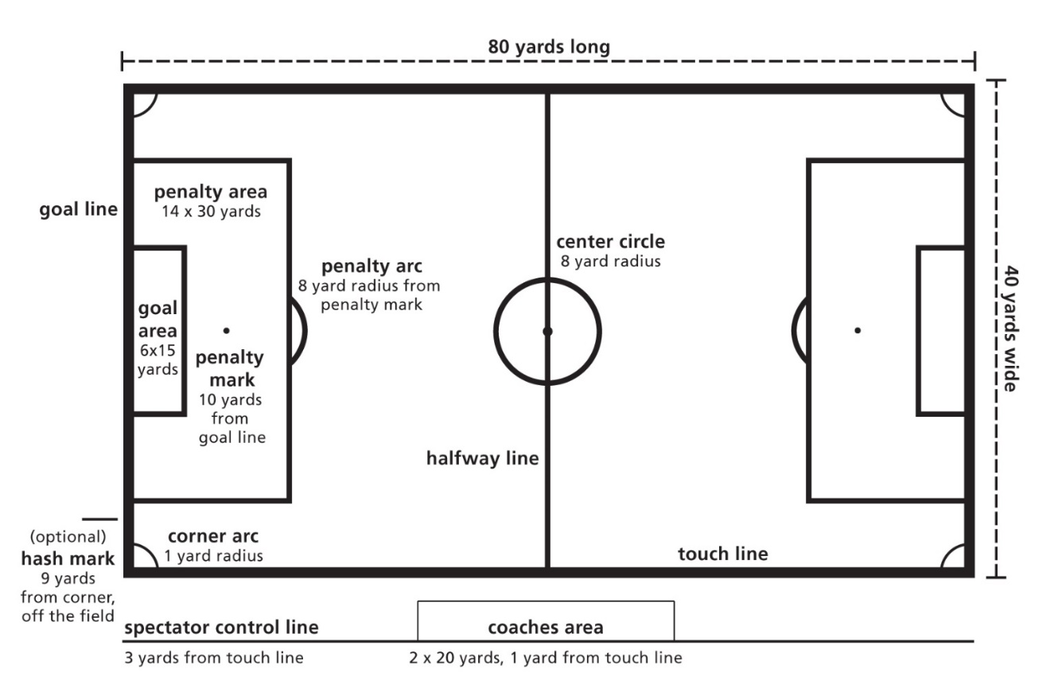
SOCCER

RULES OF PLAY
SUBSTITUTIONS
- Substitutions may only be made with the referee’s permission and only during a stoppage in play.
PLAYING THE BALL
- Except when throwing in, a player other than the goalkeeper is not allowed to play the ball with his hands or arms. A goalkeeper may play the ball with his hands and arms only when inside his own penalty area.
- All players are permitted to use any other part of the body in order to stop, control, or pass the ball, move with it, or score.
OUT OF PLAY
- The ball is out of play when it completely crosses the boundaries of the field. Play is restarted by a throw in when the ball has crossed the touch line, or by either a goal kick or a corner kick when it has crossed the goal line.
THROW IN
- A throw in is taken along the touch line at the point where the ball went out of play.
- It is awarded against the team that last touched it before it went out of play.
- The ball must be thrown into play with both hands, from behind and over the head.
- The thrower must face the play and, as the ball is released, part of each food must be on the ground either behind or on the touch line.
- A goal may not be scored directly from a throw in and the thrower may not play the ball again until it has been touched by another player.
CAUTIONS
- A referee will caution (yellow card) a player who:
  - Enters or leaves the game without the referee’s permission
  - Continually breaks the laws
  - Shows dissent from any of the referee’s decisions
  - Is guilty of unsportsmanlike conduct
- Play is resumed with an indirect free kick unless the cautioned player has committed an offense which results in a direct kick.
VOCABULARY
GOAL KICK:
- awarded to the defending team when the ball crosses its goal line (without passing between the goal posts) after having been last touched by an opponent
CORNER KICK:
- awarded to the attacking team if the ball crosses the goal line (without passing between the goal posts) having been last played by one of the defending team
FREE KICKS:
- awarded to a team for an offense committed by an opponent
PENALTY KICK:
- awarded to the opposing team when a defending player within his own penalty area commits a major foul which would normally be penalized by a direct free kick
THE OFFSIDE RULE
OFFSIDE
- An attacking player is offside if, at the time the ball is played forward by one of his own team, he is nearer the opponent’s goal line than at least two opponents and the ball, except when:
  - he is in his own half of the field of play -or-
  - he receives the ball direct from a goal kick, corner kick, or throw in
- A player shall not be penalized for being offside if, in the referee’s opinion, he is not interfering with the play unless he is seeking to gain an advantage by being in such a position.

