Basketball Terms
Instructions: Match the correct basketball terms from the word bank to the images below.
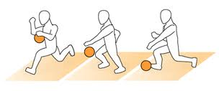  1.____________________________ | 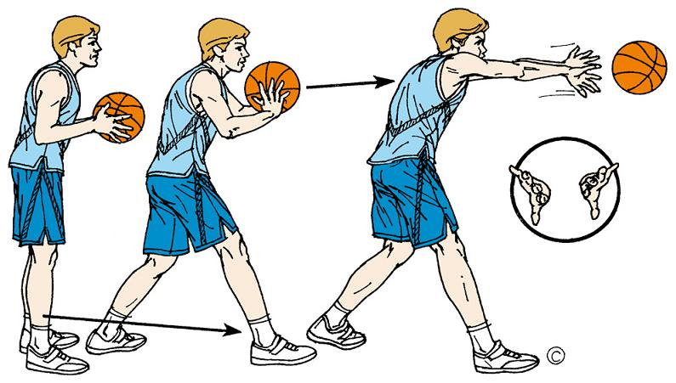  2._________________________________
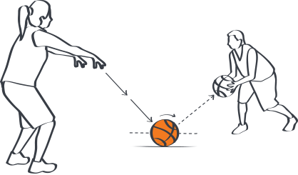  3.___________________________ | 4. _________________________________
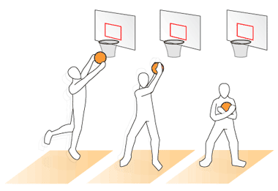  5. _______________________________ | 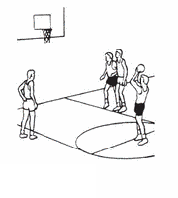6._______________________________
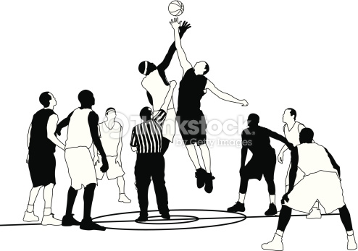  7.____________________________ | 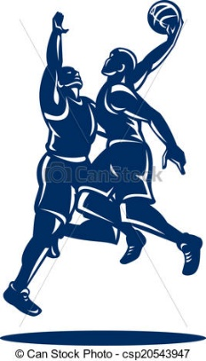  8. ______________________________
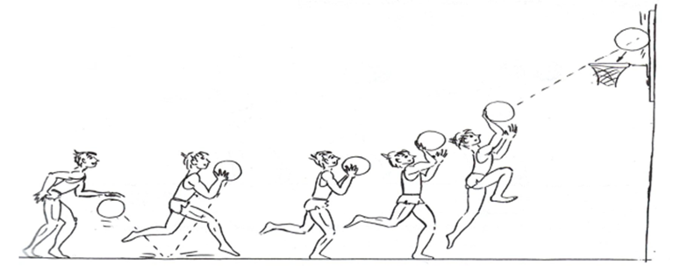
9. ___________________________________

Word Bank
- Bounce pass
- Chest pass
- Overhead pass
- Free throw
- Lay-up
- Jump ball
- Rebound
- Blocked shot
- Dribbling

