PE 9 Boyes
Badminton, the game of….

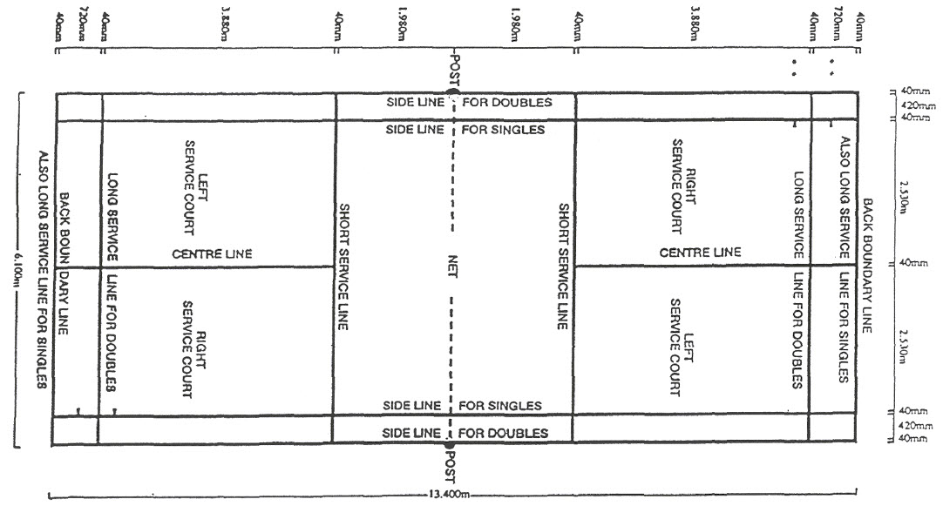
The Court
Scoring
- Rally Point Scoring: one team scores a point at the end of each rally, regardless of which team served
- Game is played to 21 points (must win by 2 points, if ties at 20-all)
- If tied at 29 points, the first to 30 points is the winner

Server Must
- Keep both feet on the floor
- Hit the base of the shuttle first
- Hit the shuttle below waist level
- Have the racquet move continuously forward

Faults During Play
- Shuttle landing outside the court boundaries
- A players racquet or clothing is touching the net during play
- Shuttle is hit with two strokes on one side
- Shuttle was carried on the racquet or thrown over
- Shuttle hitting the ceiling, player or player’s clothing
- If the receiver’s partner hits the serve
*Note – A shuttle hitting the net on the serve and going over is good provided it lands in the correct service court*
Strokes
- Overhead Clear – used to hit the bird high and deep into the other court very close to the back boundary line. The bird is contacted high over your head.
- Backhand Clear – similar to overhead clear except using other side of the racquet and body position on court is adjusted to do so
- Overhead Drop – used to hit the shuttle so that it will barely go over the net and land close to the net. Contact is overhead and slightly in front.
- Backhand Drop – similar to overhead drop, but using other side of racquet
- Smash – used to hit the shuttle down hard and with accuracy into the other court
- Forehand Net Clear – similar to the high deep serve. The bird is hit underhand hard so that it travels high enough to clear your opponents racquet and land near the back of the boundary line
- Backhand Net Clear – Similar to forehand net clear, but using other side of racquet
- Forehand Net Drop – aka. “Hairpin drop” Contact the bird near the net and 4-6 inches underneath the tape of the net. The bird is lifted over the net and lands near the net on the other court.
- Backhand Net Drop – similar to Forehand Net Drop, but using the other side of the racquet

