PE 8 Boyes
Active Health
The Human Body
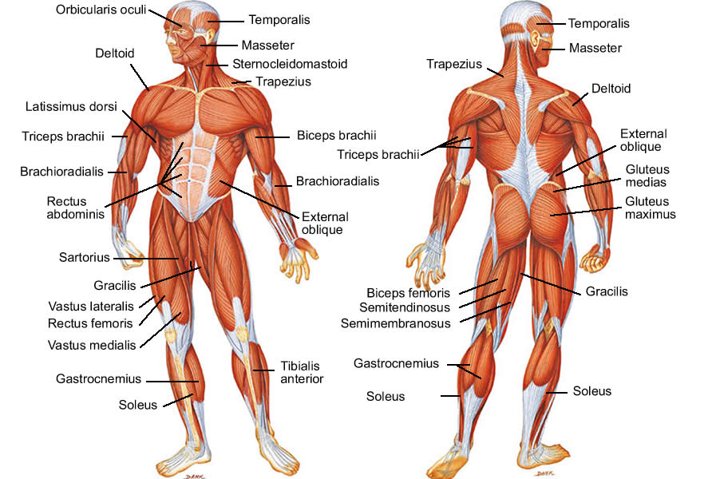
Muscle Groups
- External oblique (obliques)
- Gastrocnemius (calves)
- Gluteus maximus (glutes)
- Gluteus medius (glutes)
- Brachioradialis (forearm)
- Tibialis anterior
- Quadriceps femoris (quadriceps, quads)

- Rectus abdominis (abs)
- Biceps brachii (biceps)
- Biceps femoris
- Triceps brachii (triceps)
- Deltoid (delt)
- Trapezius (traps)
- Pectoralis (pecs)
- Latissimus dorsi
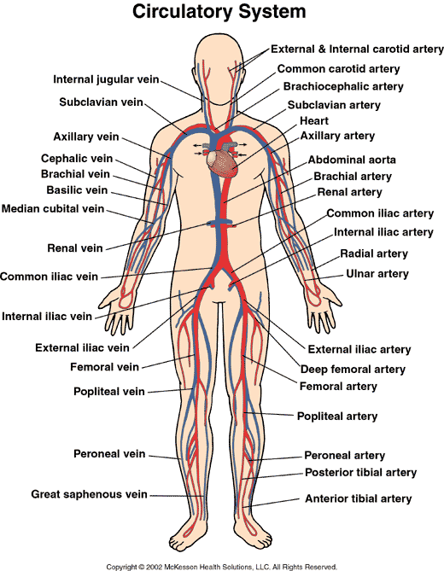

The circulatory system, also known as the cardiovascular system, is a network of tubes that assist in blood circulation by carrying blood from the heart out to the body and back to the heart. The heart’s job is to pump out blood to the lungs and all the body tissues. Arteries carry blood out to the body, while veins carry blood back to the heart. Arteries and veins are connected by tiny blood vessels called capillaries. The blood carried out to the body drops off oxygen and food, and returns with carbon dioxide and other waste products. Carbon dioxide is then dropped off in the lungs, and the waste products in the kidneys. The cardiovascular system also transports nutrients, hormones, and blood cells to and from the parts of the body.
Concepts of Physical Fitness
- Cardiovascular Endurance
This is the measure of how efficiently your heart, lungs, and blood vessels provide oxygen to your body tissues during physical activity over a period of time.

b) Muscular Endurance
The ability of a muscle or group of muscles to exert force repeatedly against resistance over a period of time.

c) Muscular Strength
The ability of a muscle to exert a maximal or near maximal force against an object and help reduce injuries.

d) Muscular Power
The ability to produces as much force possible, as quickly as possible.

Weight Training

a) Target (What is your goal????)
- Speed: The rate at which you are able to move/operate.
  - Do sprints with full recovery (5-50m).
- Power: The amount of work performed per unit of time.
  - Do heavy bench or incline bench presses
- Strength: The ability of a muscle or muscle group to overcome the most resistance in one effort.
  - Do jump squats with weights (loaded barbell as you would for a regular set of squats) to increase the strength of your legs.
- Size: How big your muscles are.
  - Increase your calorie intake. Ease up on the cardio. Lower number of reps; instead, use heavier weights.
- Definition (tone): How defined your muscles are.
  - Focus on form and movement of reps. Muscles should stay under tension during sets.

- Reps: The number of times you perform a specific exercise.
  - Ex) 15 reps of a bench press.
- Sets: The number of cycles of reps that you complete.
  - Ex) One set of 15 reps (of bench press).

Diet & Calorie Intake
- Calories: Units of heat energy; the approximate amount of energy required to raise the temperature of one gram of water by one degree Celsius. Wow, that was confusing! A calorie is a unit of measurement for the energy your body needs to function.

- Carbohydrates: Groups of organic compounds found in foods and living tissues that consist of sugars, starches, and cellulose. The breaking down of carbohydrates provide energy for our bodies.
  - Simple- Composed of one or two sugar molecules that can be quickly digested, and thus a quick source of energy.
  - Complex- Made up of a chain of sugar molecules, these are rich in fiber and high in vitamins and minerals.

- Proteins: Essential nutrients for the human body that each play different critical roles such as assisting in structure, function, and regulation of the body’s tissues and organs. Protein is most commonly associated with muscle growth and development.

