THE ECONOMICS OF TICKET SCALPING

Introduction: Many states have laws related to ticket resale for sporting events and concerts. These laws are commonly referred to as anti-scalping laws. While their intention is to protect ticket buyers from fraud and high prices, you will recognize these laws as price ceilings. The same supply and demand analysis conducted on other forms of price ceilings can be applied to the world of sports (concert) tickets.
Review: A price ceiling is a maximum price that can be charged for a good, set by law. Well know price ceilings are rent controls. When price ceilings are set below equilibrium, it results in increased quantity demanded but decreased quantity supplied and a shortage occurs.
Read the following quote: from a past USA Today sports section, “Care to pay $1,000 for a No. 2 lead pencil? How about $550 for a key chain, or $51 for an unused coaster? Did we mention that we’ll throw in free tickets to Saturday’s Big Ten football showdown between Ohio State and Michigan?
- Explain why this strange situation (above) sometimes occurs outside major sporting events?

- Define ticket scalping and list examples of ticket scalping that you may have encountered in your own lives.

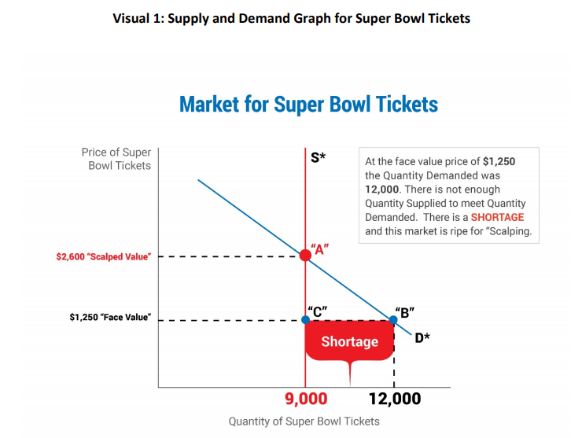

- Why would someone pay more than the face value for a ticket? Refer to Visual 1 to help with your response.

- Is the face value of a ticket the same as the market price for a ticket? a)Think about “big” games – like super Bowl or a World Series game. b) What about games with little demand – like when both teams are bad?

Some communities have developed anti-scalping laws. These laws do not allow fans to sell tickets to other people for more than the face value—no scalping allowed! A 1931 law in Michigan (Michigan Compiled Laws § 750.465) makes it illegal to resell a ticket above its face value price without the written consent of the event operator and venue operator. According to that same law, it is illegal to resell season tickets if they have the ticket holder’s name on them and the tickets state they are non-transferable. This article provides a summary of anti-scalping laws in the US. https://seatgeek.com/tba/articles/ticket-resale-laws/

- Predict what the effects of such a law might have on the buyers and sellers of tickets. Construct a supply and demand graph which shows the effect of such a law. Hint: In effect, this law imposes a price ceiling.

Conclusion: When a scalper and ticket-buyer come together to make a transaction, both parties benefit (that is, utility is enhanced for the buyer and the seller) because the scalper valued the money to be received more than the ticket, and the ticket buyer valued the ticket more than the money they had to pay for the ticket. Anti-scalping laws in some states mitigate the extent to which these mutually-beneficial exchanges can occur.
Ticket scalping can be a controversial practice. Selling tickets to sporting events, on a secondary market for more than face value, is often seen as an exploitive practice. However, from an economic perspective, the scalping of tickets can be viewed as mutually beneficial trade. In other words, those that sell the tickets value the money more than the tickets and those that buy the tickets value the tickets more than the money, hence both gain from the transaction. Some communities have passed laws designed to stop ticket scalping. From an economic perspective, these laws can be viewed as price ceilings. Price ceilings cause shortages and, in the sports and entertainment ticket markets, frequently cause a black market to occur.

MULTIPLE CHOICE QUESTIONS
- A negative aspect of anti-scalping laws is that:
  - They hurt ticket agencies.
  - They prevent sell-outs.
  - They cause people to pay more than they are willing to get tickets.
  - They prevent the market from matching willing buyers and sellers.
- An anti-scalping law is an example of a:
  - Price floor
  - Price ceiling
  - Equilibrium price
  - Market clearing price

- The face value of a sports ticket:
  - Is always higher than the market price.
  - Is always lower than the market price.
  - Can be higher or lower than the market price.
  - Is always zero.

