PMATH 12 – CHAPTER 2 – ABSOLUTE VALUE AND RECIPROCAL FUNCTIONS
2.1 Absolute Value Functions
The absolute value of any number is its distance from the origin on a number line.
$$\left|5\right|=5 \left|-7\right|=7$$
In general, $\left|a\right|=\{ a if a≥0 OR -a if a <0\}$

Ex 1 Evaluate
- $\left|4\right|- \left|-6\right|$ b) $5-3\left|2-7\right|$

Absolute Value Function y = $\left|f(x)\right|$ (f(x) can be ANY function)
eg. y = $\left|2x+1\right|$
graph of the basic abs. val. y = $\left|x\right|$ 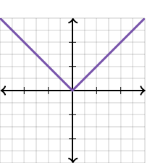
Once again x-intercepts are CRITICAL POINTS since the graph changes directions.

Ex 2 Sketch the graph y = $\left|3x+6\right|$
Process
- if y = 3x + 6, the x-int = -2
- create a table with points on either side of -2
- plot the points and connect
x | y = 3x + 6 | y = $\left|3x+6\right|$
-2
-3
-4
-1
0

Domain
Range

Homework – p86 #3-7 and multiple choice

