**Percent and Fraction Changes**

Percent to fraction Fraction to percent

75% =  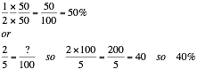

Change each of the following to a fraction or mixed number in simplest form.

a b c

1. 25% 45% 160%

2. 65% 120% 24%

3. 78% 55% 260%

4. 70% 144% 86%

5. 95% 40% 180%

Change the following to a percent.

a b c

6.   

7.   

8.   

9.   

10.   