Objective: Propaganda is selling us something; an idea, a product, a belief. Using graphics and phrases, that piece of propaganda is promoting or persuading us to join a cause or contribute to something. It will be your job to create a piece of propaganda.
Your task: create a propaganda poster that is pro-Patriot or pro-Loyalist! Essentially, you need to pick whether you are trying to convince people to join the American side (Patriots), or the British side (Loyalists) of the revolutionary war. Look at the examples I have provided to get an idea of what a propaganda poster looks like.
If you are making a Loyalist poster you should include images and indicators that make it clear you are a loyalist (maybe a British flag, a slogan with the word loyalist in it, asking people to join the British cause, saying something about the mother country, much more!!)
If you are making a Patriot poster you should include images and indicators that make it clear you are a Patriot (George Washington, joining the rebellion, fight for independence, fight for representation, anti-British, much more!!!)

Requirements:
- A clear and convincing graphic that persuades and convinces the person viewing the poster
- A slogan (one word or more!) that pulls in the reader and persuades them to join the Loyalist or Patriot cause
- Graphics and color that make the poster eye catching and interesting
- It is clear to tell what side you are on (Patriot or Loyalist)
- Clear that the student put in their best effort
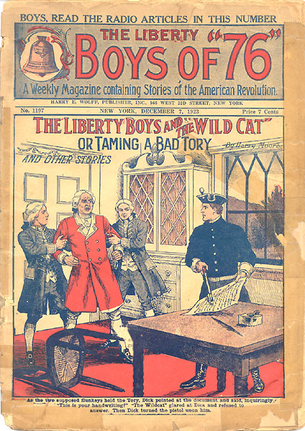
- Poster does not have any grammar or spelling errors
Total: /25
