The Flying Shuttle
- Invented by John Kay in 1733
- Made weaving much faster!
- Only needed one person to operate the machine
- The invention used springs and levers shoot the shuttle across the loom and then pull it back after it had crossed all of the threads
- This made weaving on a very large loom much faster and you could create much more cloth
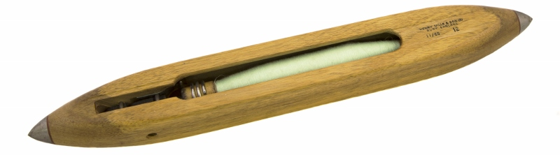

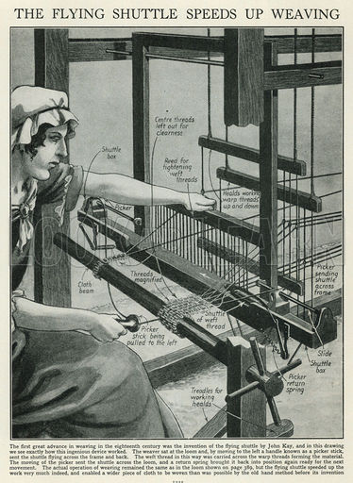

The Spinning Jenny
- Invented by James Hargreaves in 1764
- He named the invention after his wife, Jenny
- The Spinning Jenny was a device that was powered by a hand-cranked wheel – it allowed a spinner to spin many threads at the same time
- This meant that one spinner could now do the work of many spinners – business owners did not have to hire as many people, so now they made more money!
- At first, Hargreaves tried to keep his invention a secret so he could sell his cloth to make lots of money – but the secret got out quickly and other people found out about the invention
- People were so angry he tried to hide it that a mob came to his house and destroyed his original spinning jenny
- Hargreaves had to move away, and he ended up creating a spinning factory of his own
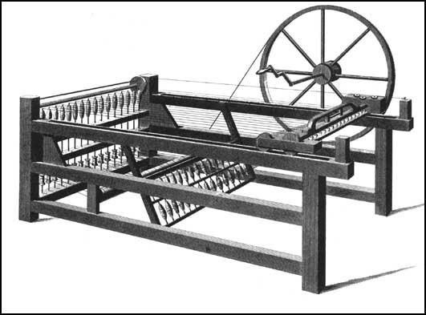
- The spinning jenny was an incredibly important improvement for the textile industry – it produced spun yarn at a faster rate than ever before and allowed for the textile industry, and factories, to grow very quickly.

The Water Frame
- Invented by Richard Arkwright in 1768
- A machine that spun cotton using water power that would spin the wheels that spun the cotton
- Water power was much more powerful than human power
- The machine improved the strength of the cotton thread that was spun
- The machine was even faster than the spinning jenny!
- It reduced the amount of people needed to spin cotton – having to pay less people means making more money for factory owners.
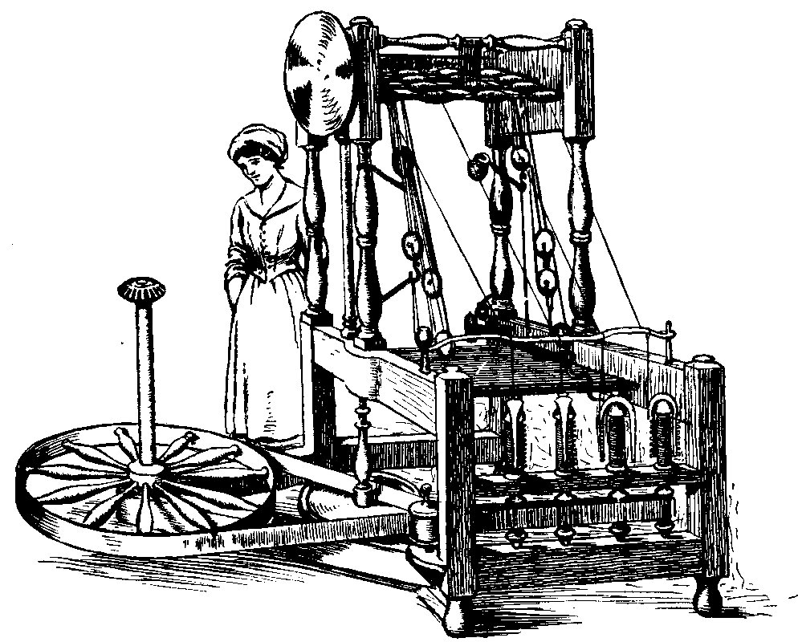

The Power Loom
- Invented by Edward Cartwright in 1785
- A mechanized version of a loom – that means it used POWER to operate.
- Remember, a loom is a device where you are able to weave your thread to make cloth – a power loom used power to weave the threads together and make cloth
- It produced cloth at an extremely fast rate!
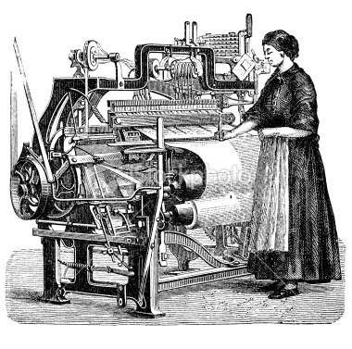
- An updated version of it is still used today to make clothes.

These machines were very large and no longer powered by humans. They needed to be in factories and needed to be run by POWER. At this point, the textile industry became dependent on POWER. But, how do you make/create power? You burn coal (a type of rock), to create really hot heat – the heat was able to power these machines!
The Steam Engine
- First version was invented by Thomas Newcomen in 1712
- He created it so that he could pump water out of coal mines – they needed coal to power the textile machines, as well as to power the steam engine!
- The machine would burn coal to create heat. This heat would boil water, and the boiling water would create steam.
- The steam that was created would be pushed together, which created POWER!
- This power would run the steam engine
- Newcomen’s steam engine did NOT work very well. It was only the first step into creating something better.
- James Watt figured out how to make the steam engine better in 1781
- James Watt’s new steam engine created much more power, with much less waste.
- It was first used to pump water out of mines, but then Watt made it possible for the steam engine to provide power to textile machines
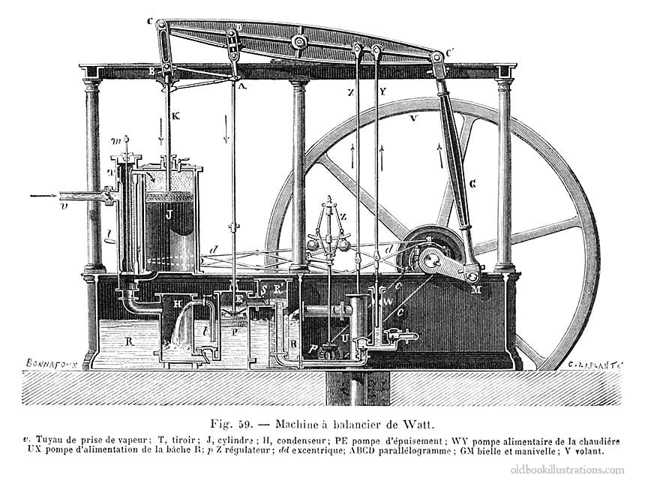
- Eventually, the steam engine was used to power TRAINS!

