Mount Pleasant Library Collection
Residential School System Resources
Annotated Bibliography

PICTURE BOOKS

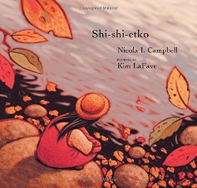 | Shi-shi-etko, by Nicola Campbell (E CAM)  Shi-shi-etko is a young girl who has four days before she leaves home for residential school. Her family has many teachings to share with her, about her culture and the land. Campbell's story — and illustrations by Kim LaFave — follow Shi-shi-etko as she absorbs the world around her and collects a 'bag of memories' at the instruction of her grandmother. But she doesn't take the memories with her. Instead she buries them under a tree, for safekeeping while she is gone.  http://www.cbc.ca/news/indigenous/10-books-about-residential-schools-to-read-with-your-kids-1.3208021
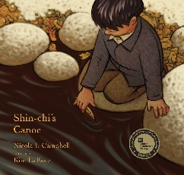 | Shin-chi's Canoe, by Nicola Campbell (E CAM)  This award-winning book tells the story of six-year-old Shin-chi as he heads to residential school for the first time with his older sister. It is the sequel to Campbell's Shi-shi-etko. As the children are driven away in the back of a cattle truck, Shin-chi's sister tells him all the things they must remember about home. Shin-chi knows it will be a long time before he sees his family, not until the sockeye salmon return. Shin-chi endures a long year of hard work, hunger and loneliness before returning home to his family with his sister.  http://www.cbc.ca/news/indigenous/10-books-about-residential-schools-to-read-with-your-kids-1.3208021
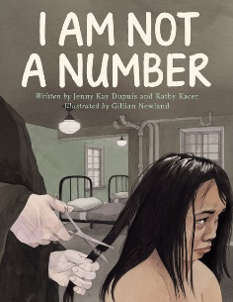 | I Am Not a Number by Jenny Kay Dupuis and Kathy Kacer (E DUP)  When eight-year-old Irene is removed from her First Nations family to live in a residential school she is confused, frightened, and terribly homesick. She tries to remember who she is and where she came from, despite the efforts of the nuns who are in charge at the school and who tell her that she is not to use her own name but instead use the number they have assigned to her. When she goes home for summer holidays, Irene's parents decide never to send her and her brothers away again. But where will they hide? And what will happen when her parents disobey the law? https://secondstorypress.ca/kids/i-am-not-a-number
Missing Nimama by Melanie Florence (E FLO)
A free-verse intergenerational story of separation, loss, and daughter-mother connection amid the ongoing crisis of missing First Nations girls and women.
Kateri wakes up from a dream, realizing that her nimâmâ (mother) is no longer there. The girl asks her nôhkom (grandmother) where her mother is and is told, “She’s one of the lost women, kamâmakos.” Through the trajectory of her life—going to school, falling in love, getting married, attending a march for missing indigenous women, Kateri learns how to cope with the sudden loss of her beloved mother. On each page, Cree author Florence presents two narratives: Kateri’s and her missing nimâmâ’s. By juxtaposing the daughter’s and mother’s thoughts and feelings in complementary verse, Florence provides them the opportunity to experience life together from their respective points of view and to talk to each other from a distance. Thisdale’s soft-edged, wistful artwork enriches the heartfelt story, strongly capturing the passage of time and Kateri’s emotional journey. An afterword is appended, offering simple and relevant information as well as statistics of missing and murdered indigenous girls and women; together with the story, it should help to begin a conversation with young readers.
A solid debut picture book that works as a record of voices that are usually unheard, ignored, and forgotten. (glossary of Cree terms) (Picture book. 7-10)
https://www.kirkusreviews.com/book-reviews/melanie-florence/missing-nimama/
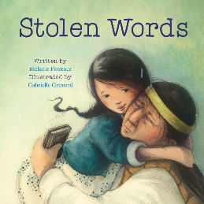 | Stolen Words by Melanie Florence (E FLO)  A little girl helps her grandfather regain the language taken from him as a child.  The story of the beautiful relationship between a little girl and her grandfather. When she asks her grandfather how to say something in his language – Cree – he admits that his language was stolen from him when he was a boy. The little girl then sets out to help her grandfather find his language again. This sensitive and warmly illustrated picture book explores the intergenerational impact of the residential school system that separated young Indigenous children from their families. The story recognizes the pain of those whose culture and language were taken from them, how that pain is passed down, and how healing can also be shared.  https://secondstorypress.ca/kids/stolen-words
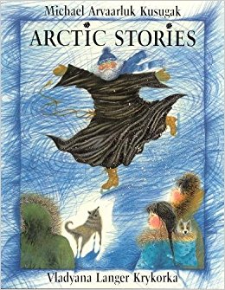
Arctic Stories, by Michael Kusugak (PB KUS Ages 4-8)

This trio of stories about a 10-year-old girl named Agatha is based on the childhood experiences of beloved Inuit author Michael Kusugak. The book begins with a tale of Agatha 'saving' her community from a monstrous flying object. The book also includes the story of Agatha being sent away for school, "The nuns did not make very good mothers and the priests, who were called fathers, did not make very good fathers," Kusugak writes.
http://www.cbc.ca/news/indigenous/10-books-about-residential-schools-to-read-with-your-kids-1.3208021

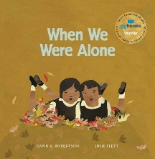 | When We Were Alone, by David A. Robertson (E ROB)  When a young girl helps tend to her grandmother’s garden, she begins to notice things that make her curious. Why does her grandmother have long, braided hair and beautifully coloured clothing? Why does she speak another language and spend so much time with her family? As she asks her grandmother about these things, she is told about life in a residential school a long time ago, where all of these things were taken away. When We Were Alone is a story about a difficult time in history, and, ultimately, one of empowerment and strength.  https://www.portageandmainpress.com/product/when-we-were-alone/
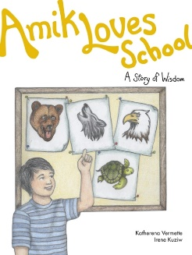 | Amik Loves School, by Katherena Vermette (E VER Paperback)  Amik tells Moshoom about his wonderful school. Then his grandfather tells him about the residential school he went to, so different from Amik's school, so Amik has an idea... The Seven Teaching of the Anishinaabe -- love, wisdom, humility, courage, respect, honesty, and truth -- are revealed in these seven stories for children. Set in an urban landscape with Indigenous children as the central characters, these stories about home and family will look familiar to all young readers.  https://www.portageandmainpress.com/product/amik-loves-school/
When I Was Eight by Christy Jordan-Fenton and Margaret Pokiak-Fenton (371.829 JOR)
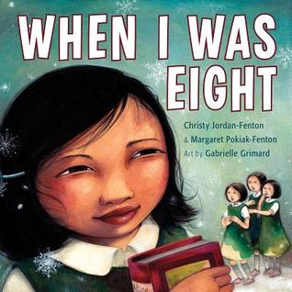
Olemaun is eight and knows a lot of things. But she does not know how to read. Ignoring her father’s warnings, she travels far from her Arctic home to the outsiders’ school to learn.
The nuns at the school call her Margaret. They cut off her long hair and force her to do menial chores, but she remains undaunted. Her tenacity draws the attention of a black-cloaked nun who tries to break her spirit at every turn. But the young girl is more determined than ever to learn how to read.
Based on the true story of Margaret Pokiak-Fenton, and complemented by stunning illustrations, When I Was Eight makes the bestselling Fatty Legs accessible to younger readers. Now they, too, can meet this remarkable girl who reminds us what power we hold when we can read.
http://www.annickpress.com/When-I-Was-Eight

Not My Girl by Christy Jordan-Fenton and Margaret Pokiak-Fenton (371.829 JOR)

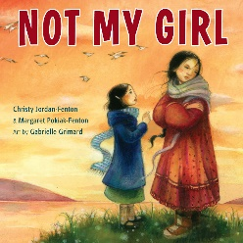
Two years ago, Margaret left her Arctic home for the outsiders' school. Now she has returned and can barely contain her excitement as she rushes towards her waiting family -- but her mother stands still as a stone. This strange, skinny child, with her hair cropped short, can't be her daughter. "Not my girl!" she says angrily. Margaret's years at school have changed her. Now ten years old, she has forgotten her language and the skills to hunt and fish. She can't even stomach her mother's food. Her only comfort is in the books she learned to read at school. webcat.vsb.bc.ca

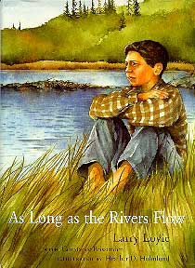 | As long as the Rivers Flow, by Larry Loyie (921 LOY Ages 9-12)  Cree author Larry Loyie writes about his last summer with his family before going to residential school, in Northern Alberta in 1944.Lawrence learns things like how to care for a baby owl, and how to gather medicinal plants with his Kokom. Loyie's story highlights how his education at home was disrupted by the residential school system.  http://www.cbc.ca/news/indigenous/10-books-about-residential-schools-to-read-with-your-kids-1.3208021

FICTION BOOKS

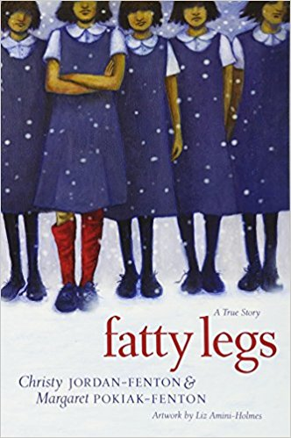 | Fatty Legs: A True Story by Christy Jordan-Fenton and Margaret Pokiak-Fenton (371.829 JOR)  Eight-year-old Margaret Pokiak has set her sights on learning to read, even though it means leaving her village in the high Arctic. Faced with unceasing pressure, her father finally agrees to let her make the five-day journey to attend school, but he warns Margaret of the terrors of residential schools.  At school Margaret soon encounters the Raven, a black-cloaked nun with a hooked nose and bony fingers that resemble claws. She immediately dislikes the strong-willed young Margaret. Intending to humiliate her, the heartless Raven gives gray stockings to all the girls — all except Margaret, who gets red ones. In an instant Margaret is the laughingstock of the entire school.  In the face of such cruelty, Margaret refuses to be intimidated and bravely gets rid of the stockings. Although a sympathetic nun stands up for Margaret, in the end it is this brave young girl who gives the Raven a lesson in the power of human dignity.  http://www.annickpress.com/Fatty-Legs
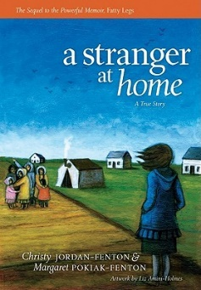 | A Stranger at Home: A True Story, by Christy Jordan-Fenton and Margaret Pokiak-Fenton  (371.829 JOR Ages 9-12)  In this sequel to Fatty Legs, Margaret Pokiak is now 10 years old and can hardly wait to return home from residential school. But her homecoming is not what she hopes for. "Not my girl," is what her mother says when she arrives. The story follows Margaret as she moves through feelings of rejection and tries to reconnect with her family, language and culture.  http://www.cbc.ca/news/indigenous/10-books-about-residential-schools-to-read-with-your-kids-1.3208021
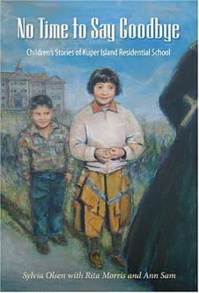 | No Time to Say Goodbye: Children's Stories of Kuper Island Residential School, by Sylvia Olsen  (F OLS Ages 9-12)  This collection of fictional stories of five children sent to residential school is based on real life experiences recounted by members of the Tsartlip First Nation in B.C. The children cope as best they can at Kuper Island Residential School but it's a far cry from the life they're used to. The book is described as sometimes funny, sometimes sad.  http://www.cbc.ca/news/indigenous/10-books-about-residential-schools-to-read-with-your-kids-1.3208021
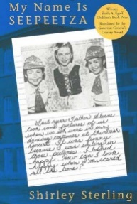 | My Name is Seepeetza, by Shirley Sterling (F STE Ages 9-12)  Written in the form of a diary, My Name is Seepeetza recounts the story of a young girl taken from home to attend the Kamloops Indian Residential School in the 1950s. Sterling's award-winning book has been described as an honest, inside look at the residential school experience - one that highlights the resilience of a child in a place governed by strict nuns, and arbitrary rules.  http://www.cbc.ca/news/indigenous/10-books-about-residential-schools-to-read-with-your-kids-1.3208021
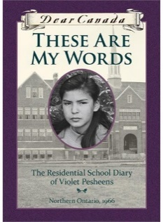 | These Are My Words: The Residential School Diary of Violet Pesheens by Ruby Slipperjack  Twelve-year-old Violet Pesheens is taken away to Residential School in 1966. The diary recounts her experiences of travelling there, the first day, and first months, focusing on the everyday life she experiences--the school routine, battles with Cree girls, being quarantined over Christmas, getting home at Easter and reuniting with her family. When the time comes to gather at the train station for the trip back to the residential school, her mother looks her in the eye and asks, "Do you want to go back, or come with us to the trapline?" Violet knows the choice she must make. (webcat.vsb.bc.ca)
Red Wolf by Jennifer Dance (F DAN Upper Intermediate)
Life is changing for Canada's Anishnaabek Nation and for the wolf packs that share their territory. In the late 1800s, both Native people and wolves are being forced from the land. Starving and lonely, an orphaned timber wolf is befriended by a boy named Red Wolf. But under the Indian Act, Red Wolf is forced to attend a residential school far from the life he knows, and the wolf is alone once more. Courage, love and fate reunite the pair, and they embark on a perilous journey home. But with winter closing in, will Red Wolf and Crooked Ear survive? And if they do, what will they find? webcat.vsb.bc.ca

GRAPHIC NOVELS

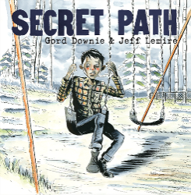 | Secret Path (GRAPHIC NOVEL)  "Secret Path is a ten song album by Gord Downie with a graphic novel by illustrator Jeff Lemire that tells the story of Chanie “Charlie” Wenjack, a twelve-year-old boy who died in flight from the Cecilia Jeffrey Indian Residential School fifty years ago. Chanie, misnamed Charlie by his teachers, was a young boy who died on October 22, 1966, walking the railroad tracks, trying to escape from the Cecilia Jeffrey Indian Residential School to return home. Chanie’s home was 400 miles away. He didn’t know that. He didn’t know where it was, nor how to find it, but, like so many kids—more than anyone will be able to imagine—he tried. Chanie’s story is Canada’s story. We are not the country we thought we were. History will be re-written. We are all accountable. Secret Path acknowledges a dark part of Canada’s history—the long suppressed mistreatment of Indigenous children and families by the residential school system—with the hope of starting our country on a road to reconciliation. Every year as we remember Chanie Wenjack, the hope for Secret Path is that it educates all Canadians young and old on this omitted part of our history, urging our entire nation to play an active role in the preservation of Indigenous lives and culture in Canada. The next hundred years are going to be painful as we come to know Chanie Wenjack and thousands like him—as we find out about ourselves, about all of us—but only when we do can we truly call ourselves, 'Canada'"--Back cover. (webcat.vsb.bc.ca)
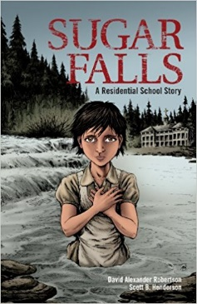 | Sugar Falls: A Residential School Story (GRAPHIC NOVEL)  A school assignment to interview a residential-school survivor leads Daniel to Betsy, his friend’s grandmother, who tells him her story. Abandoned as a young child, Betsy was soon adopted into a loving family. A few short years later, at the age of 8, everything changed. Betsy was taken away to a residential school. There she was forced to endure abuse and indignity, but Betsy recalled the words her father spoke to her at Sugar Falls — words that gave her the resilience, strength, and determination to survive.  Sugar Falls is based on the true story of Betty Ross, Elder from Cross Lake First Nation. We wish to acknowledge, with the utmost gratitude, Betty’s generosity in sharing her story.  http://www.darobertson.ca/publications/sugar-falls/
NON-FICTION

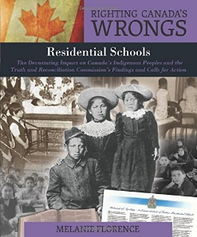 | Residential schools : the devastating impact on Canada's indigenous peoples and the Truth and Reconciliation Commission's findings and calls for action by Melanie Florence. (371.829 FLO)  Canada's residential school system for aboriginal young people is now recognized as a grievous historic wrong committed against First Nations, Metis, and Inuit peoples. This book documents this subject in a format that will give all young people access to this painful part of Canadian history.

