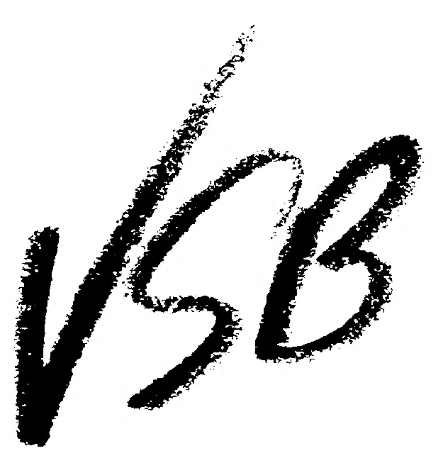
K-7 Classroom Family Diversity, Gender Diversity and LGBT2SQ+ Workshops

Booking information: Stephanie Lofquist, VSB Diversity Mentor/Counsellor (pride@vsb.b.ca)

Curricular connections: http://www.sogieducation.org/sogi3/

VSB book and video list: http://blogs.vsb.bc.ca/pride/vsb-pink-day-books-and-videos-elementary/

Follow-up lessons:
http://www.welcomingschools.org/
http://www.sogieducation.org/sogi3/
http://blogs.vsb.bc.ca/pride/
http://pridenet.ca/wp-content/uploads/the-gender-spectrum.pdf
https://www.glsen.org/sites/default/files/GLSEN%20Ready%20Set%20Respect%202016.pdf

Family Diversity

(K-3, 25min.) Every student will see their family reflected in “The Great Big Book of Families,” by Mary Hoffman. This book shows families with a diversity of compositions, homes, celebrations, schools and pets, feelings and more. After reading this book, we will discuss the common basis of all families: caring, helping one another and love. To wrap-up, we will think about what it means to be kind and respectful of family diversity using the VSB “All Families Welcome” poster as a visual prompt.

Pre-lesson preparation (optional): classroom viewing of the video, “That’s a Family: a film for kids about family diversity” (available in some school libraries and by request: pride@vsb.bc.ca).

(4-6, 45min.) Students will have the opportunity to learn about the diversity of families and vocabulary for describing families. Using photos of families, students will describe and identify families based on composition. Through discussion, we will explore how family diversity is reflected in books and popular culture.

Pre-lesson preparation (optional): classroom viewing of the video, “That’s a Family: a film for kids about family diversity”(available in some school libraries and by request: pride@vsb.bc.ca) or “Apples and Oranges, “ (available online at NFB).

(6-7, 60min.) Diverse Identities: Sexual Orientation and Gender Identities

This is a film-based workshop that explores stories of youth who identify as LGBT2SQ+. In this workshop students will learn terminology for describing identities and how to be an ally or upstander.

Out in Schools films and curriculum: http://outinschools.com/resources/ (contact pride@vsb.bc.ca for membership access to films).

Gender Diversity (K-3)

(K-5, 45min.) Gender Expression and Gender Stereotypes

Students will participate in an interactive activity exploring gender stereotypes. We will then read a story about a child who challenges gender stereotypes to encourage empathy and understanding. Drawing on story events, students will share what they can do and say to create welcoming schools that allow all children to be themselves and explore their interests.

(K-5, 25 min.) Gender Rainbow

In this workshop, students will learn about gender diversity. We will read a book about a transgender child and have a discussion about creating welcoming schools for all.

Gender Diversity (6-7)

Students will explore the gender spectrum through film and discussion. Students will be introduced to terminology and take part in interactive activities to think about inclusion in their school. We will discuss discrimination and the role of allies and upstanders.

Staff Workshops

Lunch, afterschool and pro-d workshops are available on these topics:
- gender diversity and school support for transgender and gender creative students
- resources for teaching about family and gender diversity and LGBT2SQ+ identities
- creating inclusive classrooms/schools for LGBT2SQ+ students
- VSB’s Sexual Orientation and Gender Identities policy
- addressing homophobia and transphobia
- another topics determined by your school

Booking information: Stephanie Lofquist, VSB Diversity Mentor/Counsellor (pride@vsb.b.ca)

