John Oliver Secondary School

530 East 41st Avenue, Vancouver, B.C., V5W 1P3

Connecting with your School Counsellor
& Mental Health Resources while school is closed

Dear Students,
During this uncertain and unprecedented time, your Counsellors are here to support you. If you would like to book an appointment for Counselling or ask a question, please email us your questions or concerns and we will set up a time to see you either by phone, email, or on MS Teams (link to download MS Teams below). Please email your Counsellor first to set up a time and method of communication.

****If you get a call from a Private or No Caller ID phone number ***
please answer as it may be your Counsellor.

Counsellor Assignments
Mrs. Alvares aalvares@vsb.bc.ca Grade 8, Grade 12 (Last name A-D)
Mrs. Birkenhead sbirkenhea@vsb.bc.ca Grade 9, Grade 12 (Last Name E-R)
Mr. Steinruck asteinruck@vsb.bc.ca Grade 10, Grade 12 (Last Name S-Z)
Mr. Edge redge@vsb.bc.ca Grade 11, Take a Hike Program
Download MS Teams:
https://office365.vsb.bc.ca/for-students
Use your student email (STUDENTNUMBER@learn.vsb.bc.ca) and login information to set up your account
If you need to reset your password, go to https://studentpass.vsb.bc.ca/
You will need to know your PEN# & Date of Birth
If you continue to have trouble email your Counsellor or teacher
Attached is a list of helpful resources in the meantime.
Take good care of yourselves and reach out for help if you need it.
HELPFUL SITES TO SUPPORT WELLNESS
CRISIS CENTER
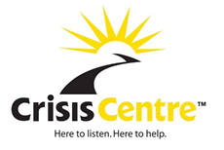
The Crisis Centre values the importance of community, connection and support during this current health situation. To support your mental health and wellbeing, they are expanding their mindfulness-based programs online for youth and adults.
Anywhere in BC 1-800-SUICIDE: 1-800-784-2433
Mental Health Support Line:604 310-6789
Youth Chat https://youthinbc.com/

KIDS HELP PHONE
Kids Help Phone is Canada’s only 24/7, national support service. They offer professional counselling, information and referrals and volunteer-led, text-based support to young people in both English and French.
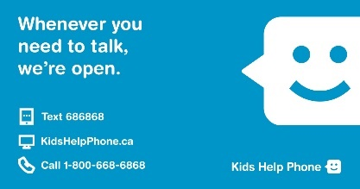
Phone counsellor 24/7 at 1-800-668-6868.
Live Chat 12:00am-7:00am https://kidshelpphone.ca/live-chat
Text CONNECT to 686868
Download the App

FOUNDRY BC
Foundry offers young people ages 12-24 health and wellness resources, services and supports – online and through integrated service centres in communities across BC.
https://foundrybc.ca/

KELTY MENTAL HEALTH
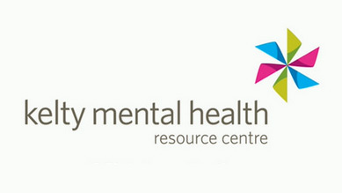
Living through mental health challenges is hard. Whether you are going through struggles yourself, or supporting a friend or loved one, the Kelty Mental Health Resource Centre is here for you. Their website includes information, tools and supports for yourself or a friend. If you want to talk to someone who might be able to understand what you’re going through, our youth peer support workers have their own lived experience with mental health challenges and are here to support you through your struggles.
All of our services are free of charge, and you can reach us over the phone (1-800-665-1822), in person or by email (keltycentre@cw.bc.ca).
https://keltymentalhealth.ca/youth-young-adults

APPS or ONLINE RESOURCES AVAILABLE
- Mindshift CBT
- Breathr
- Calm
- Spotify (search: meditation, body scan, etc)

QMUNITY

Qmunity is what happens when queer, trans, and Two-Spirit folks looking for a sense of community come together. They provide personal support for queer, trans, and Two-Spirit people of all ages to live healthier, happier lives.

https://qmunity.ca/get-support/youth/
Reach out to our Youth Specialist, Han youth@qmunity.ca, or Facebook chat, through the GAB Youth Facebook group or reach out to our Social Worker, Jennie at jennie.mw@qmunity.ca

VCH Vancouver Child and Youth Mental Health & Substance Use (CYMHSU)
Remote Intake Clinics and Specialized Programs Response Plan for COVID-19

Due to the current COVID19 Pandemic, CYMHSU operations are being modified with new Remote Intake times being offered. Remote services (e.g. Zoom or phone) are available for ages 6 to 18 out of the following Vancouver CYMHSU locations. Please call for details at:
Pacific Spirit
2110 W. 43rd Ave., 3rd Floor
Phone: 604-267-3970; Fax: 604-675-3909
Days/Hours:
REMOTE APPOINTMENTS SCHEDULED TUESDAY & THURSDAY:
9:00am to 3:30pm

Northeast
355-2750 E. Hastings St.
Phone: 604-675-3895; Fax: 604-675-3909
Days/Hours:
REMOTE APPOINTMENTS SCHEDULED MONDAY & WEDNESDAY:
9:00am to 3:30pm

Raven Song
2450 Ontario St. 3rd Floor
Phone: 604-872-8441
Fax: 604-675-3909

NO REMOTE INTAKES OCCURING OUT OF THIS LOCATION
.
West End
101-1128 Hornby St.
Phone: 604-331-8908
Fax: 604-675-3909

NO REMOTE INTAKES OCCURING OUT OF THIS LOCATION

Please Note Intake appointments will be conducted remotely.
Alan Cashmore Centre Infant Mental Health (0-5 years old)
(604) 675-3996 Intake by appointment only

Child and Adolescent Response Team (CART)
(604) 874-2300 Appointment Required

Youth Outreach
Call office directly at 604-688-0551 or fax referral to 604-688-0553

