MATH 10: UNIT 9.1: FINANCE - SIMPLE AND COMPOUND INTEREST

A) What is 'simple interest'?

-let's review some vocabulary:

i) principal:

ii) interest:

iii) annual interest rate:

iv) time:

So, 'simple interest' is the interest (or extra) money you earn or pay on your principal

B) What is the formula for 'simple interest'?

Ex: go to https://www.scotiabank.com/ca/en/0,,2,00.html, click on 'rates and prices' and then 'savings accounts'.

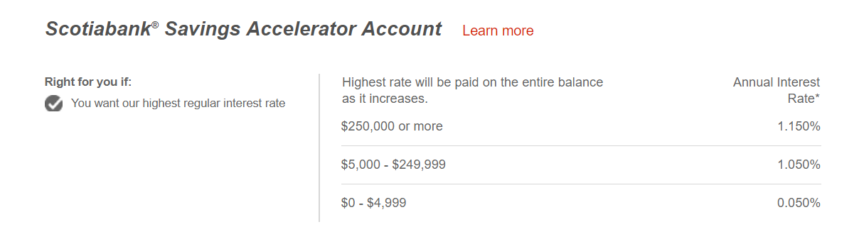

i) If I had $6000 in this account, how much interest would I earn in 2 years? How much money would I have in total after the 2 years?

ii) How much interest after 3 years? How much in total after 3 years?

Ex:
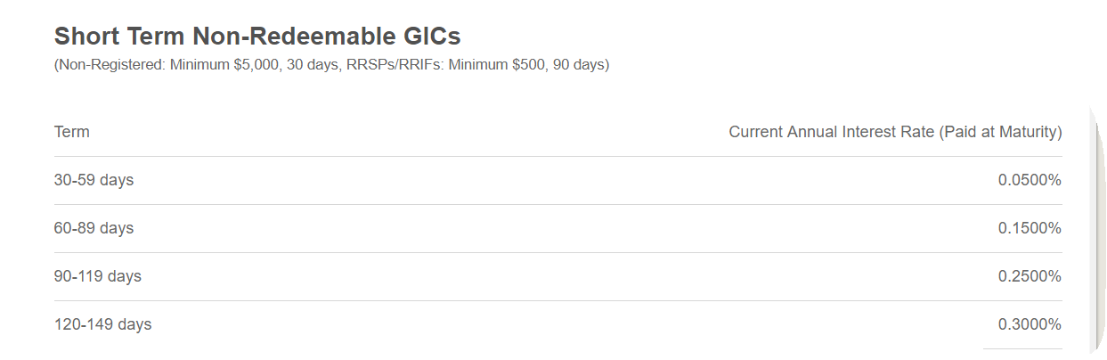

i) how much interest did I earn on $5000 if I bought a 60-89 day GIC?

B) Other types of 'simple interest' questions:

i) Peter Parker borrows $15,000 from Tony Stark to make new web fluid. Peter paid back $16,200 after 3 years.
-How much interest did Peter Parker pay back?

-what was the interest rate that Peter paid?

Try:
1) Borrowed $35,000 to buy a new Acura MDX. The dealership charges 2% interest per year. You pay off the loan in 5 years.
a) How much interest did the dealership earn?

b) How much did you pay for the MDX in total?

2) Berserker, a soldier from Fortnite, wants to upgrade the power of the grenade. Berserker checked his bank account and realized he earned $27 in 2 years at an interest rate of 3%.
a) How much money did he have originally?

b) It will cost $476 to upgrade the power of his frag grenade. Does he have enough money in his account?

C) What is 'compound interest?

-let’s compare how the interest accumulates between simple and compound interest:

SIMPLE INTEREST COMPOUND INTEREST
principal | % | Interest amount | Total amount | time | principal | % | Interest amount | Total amount | time

D) What is the 'compound interest' formula?

P=
r =

t =

n =

Note: semi-annually means n =
quarterly n =
monthly n=
bi-monthly n =
weekly n =
bi-weekly n =
daily n =

E) How to do 'compound interest' questions?

Ex: you borrowed $6500 at 5% compounded semi-annually for 5 years.
i) what was the total amount you paid back?

ii) what was the interest?

Ex: Isla is 14 years old. She wants $1,000,000 by the time she is 65. She invests in dividend paying blue chip stocks that have historically returned 5% annually. How much does she need to start with to reach her goal?

E) What is the ‘rule of 72’?
-

WB pg 281 #1, 2, 4-11

Math 10: unit 9.2B: gross and net pay

A) What is 'gross pay'?

-refers to all the money (ex: overtime, bonuses, reimbursements, tips, commission, etc) your employers pays you BEFORE deductions (ex: income tax, medical insurance, employment insurance, retirement plans, etc)

Ex: i) Tim works at Sportchek. He earns $13.50 per hour. If he worked 8 hours on Saturday, what is his gross pay for the day?

ii) Harry Potter works for the Ministry of Magic. He earns $56 per hour. On holidays, like Voldemort Day, he earns time and a half. If Harry worked 30 hours, and an additional 5 hours on Voldemort Day, calculate his gross pay.

iii) Katniss also earns a commission based on her sales. If Katniss sold $2000 worth of goods on Saturday, and earns 5% commission on the sales, what is her new gross pay?

iv) Black Panther earns a commission based on his sales of Vibranium: 2% on the first $1000, 4% on the $1001-$3000, and 6% on sales over $3001. How much would he earn if he sold:
- $900 worth of Vibranium?

- $1200 worth of Vibranium?

- $8500 worth of Vibranium?

v) Arya earns money based on the number of swords and axes she makes. She earns $500 for 25 swords and $300 for 60 axes. If Arya made 600 swords and 1200 axes for the Night’s Watch, how much money did she earn?

B) What is 'net pay'?

net pay = gross pay - deductions

Ex: Astrid earns $75,000 gross pay as a computer programmer. She has deductions of $10,500 in taxes, $2600 in CPP, $800 in EI, and MSP of $1100. What is her net pay?

Ex: LeBron James earns $36,000,000. The income tax for California is 13%. What is his net pay?

Ex: Luke Skywalker earns 15% in tips in the cantina. If his tables charged a total of $5000, how much in tips does Luke earn?

ii) From his tips, Luke pays out 2% to the cooks. How much do the cooks earn from Luke? What is Luke's net pay?

Do:
-handout
-WB: pg 286 #1, 2ace, 3-7 (look at example 3 from the workbook for extra help)

Math 10: unit 9.2A: types of income
A) How do we earn income?

-most people earn income via 4 ways:

i) wages

ii) salary

iii) commission

iv) piecework

Do: handouts

Math 10 Unit 9.3: tax rates

  - What is a 'tax'?
-according to Oxford dictionary (https://en.oxforddictionaries.com/definition/tax), a tax is:
"A compulsory contribution to state revenue, levied by the government on workers' income and business profits, or added to the cost of some goods, services, and transactions"

  - Describe the 3 main types of tax systems and give an example of each:

i) regressive:
-assesses tax as a percentage of the value of the asset that a taxpayer purchases or owns. This type of tax has no correlation with an individual's earnings or income level
-Regressive taxes tend to have a greater impact on low-income individuals than they do on high-income earners

Ex: sales tax: GST is 5% and can be considered a 'regressive tax' as it impacts lower income earners more than high income earners
ie: Iphone XR: $1000. 5% GST on the phone is $_________. The ______has more impact on someone earning $30,000 than on another person earning $1,000,000.

ii) proportional:
-usually refers to a 'flat tax' when talking about income tax
-everyone pays the same income tax rate, no matter the income level.

Ex: if the proportional tax is 8%, person earning income of $30,000 pays ________ income tax. A person earning $1,000,000 pays ________income tax.

iii) progressive:
-increasing tax rates based on income.

Ex: Federal tax rates for 2019 (Canada):

  - 15% on the first $47,630 of taxable income, plus
  - 20.5% on the next $47,629 of taxable income (on the portion of taxable income over 47,630 up to $95,259),plus
  - 26% on the next $52,408 of taxable income (on the portion of taxable income over $95,259 up to $147,667),plus
  - 29% on the next $62,704 of taxable income (on the portion of taxable income over 147,667 up to $210,371), plus
  - 33% of taxable income over $210,371

From <https://www.canada.ca/en/revenue-agency/services/tax/individuals/frequently-asked-questions-individuals/canadian-income-tax-rates-individuals-current-previous-years.html>

Ex: for BC:
Taxable Income - 2019 Brackets | Tax Rate
$0 to $40,707 | 5.06%
$40,707.01 to $81,416 | 7.70%
$81,416.01 to $93,476 | 10.50%
$93,476.01 to $113,506 | 12.29%
$113,506.01 to $153,900 | 14.70%
Over $153,900 | 16.80%

From <https://www2.gov.bc.ca/gov/content/taxes/income-taxes/personal/tax-rates>

  - What do we do with these tax rates?
-used to calculate the amount of income tax that goes to the federal government and the provincial government.

-let us use WB pg 289:

Ex: Mr. Chan earns $70000 a year. How much total income tax did he pay?
Step 1: Calculate the federal income tax paid:

…so: federal taxable income = gross income -federal basic amount - CPP - EI

=

step 2: Calculate his BC provincial income tax paid:

…so provincial taxable income = gross income - BC basic amount - CPP - EI

=

step 3: Calculate the total income tax paid:

…so total income tax paid = federal income tax + provincial income tax

Ex: BC premier earns $200000 per year. Calculate the total income tax paid.
step 1) calculate the federal income tax

step 2) calculate the BC provincial income tax

step 3: total tax paid

-do WB pg 291 #1-2: left, 3: all
-WB pg 296 #1-4

