M8E: unit 5.5: dividing polynomials
January 2, 2016
5:01 PM

To divide polynomials by a monomial, separate each polynomial term by the common denominator monomial.

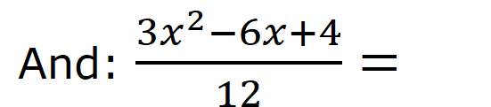

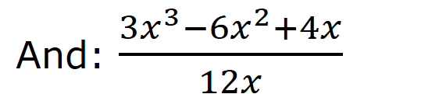

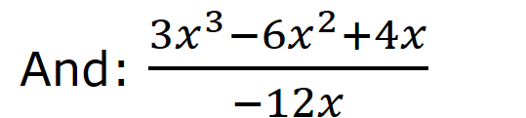

Try:

-WB: pg 187 #1-3 (left column), 6, 7, 10 (left column)
-extra practice if you want: MMS9 pg 247 #13, 16, 23; pg 255 #10, 11, 16, 21

•

C

