Math 10: Unit 2.3: Squares and Square Roots

  - Some definitions
  - Power:
2³

ii) What is a 'square number'?

x²

Ex: 7²=

iii) describe 'square root'

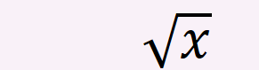

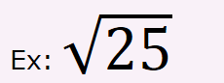

-numbers like are NOT rational square roots.

B)But there is a problem:

  - Know: 5x5=25
  - But (-5)(-5) = 25 also,

  - How to find square roots?

  - Use prime roots (like finding GCF earlier)

  - Can we do square roots of negative numbers?

  - Not in grade 10.

  - What are 'cubes'?

i) what are 'cube roots'?

ii) how to do 'cube roots'?

  - Same method as finding square roots…but now want 3 of the same numbers.

Ex:

Ex:

  - Can we do cubic roots of negative numbers?
-yes

Ex:

Pg 78 #1-4( left column), 5-10
-quiz next day on GCF, LCM, square roots

