A&W MATH 11: ANALYZING AND ADJUSTING YOUR BUDGET

A) -though many people make a budget, they find it difficult to stay on it, or they find that their situation changes and they have to make adjustments to their budget.
-part of the problem is that people often pay bills first, and then anything left over goes into savings. A better idea is to pay yourself first, by putting a certain amount in savings, and then adjusting what you spend.
-a suggested Canadian spending guideline:
savings | 10% | clothing | 2-5%
housing | 25-35% | recreation | 5-10%
utilities | 5-10% | Health care | 5-10%
food | 10-15%
transporation | 10-15%
-it is hard to see and compare how much each takes up from a family budget and income. It is sometimes better to use a circle graph to compare expenses and expenditures:
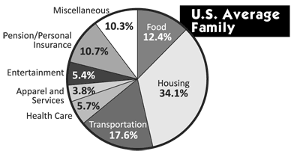
-spreadsheets can make it easier to adjust you spending and can help you make a circle graph for visual comparisons of your spending.

B) Questions:
1) Jamie earns $500 a week.
i) He wants to save 12% of his earnings. How much does he save?

ii) Jamie gets a 3% raise, but continues to save 12% of his earnings. How much does he save now?

2) Sukhman saves $3000 a year, or 8% of his income.
i) What is Sukhman’s annual income?

ii) He wants to increase his savings to 10% of his annual income. How much does he save now?

iii) How much does he earn per month?

iv) This is his monthly budget:
income | Expenses
Monthly pay | Mortgage $1300
 | Food $550
 | Transportation $200
 | Clothing $250
 | Utilities $375
 | savings
Total income | Total expenses

v) draw a circle graph of his spending:

-pg 355 #1, pg 363 #1-3, 4a

