Science 10 : Comic Physics Project
Have you ever wondered what you favourite cartoon character would be thinking if they were physicist?  “Here is a famous world war one flying ace about to defy the forces of gravity.  If I leave the ground at 7am and travel at a fixed velocity of 100 miles an hour, when will I reach the front lines which are 600 kilometers away? What about my acceleration? How can this dog house defy the laws of gravity? “  Your mission is to select five physics situations from the following list:  Moving with a fixed velocity  - Going up  - Going down  - Going fast  - Going slow  - Going forward  - Going Backwards  - Staying in one place  Acceleration  - Speeding up  - Slowing down  - Going upward  - Going downward  - Fixed velocity  - Due to Gravity | The famous world war one flying takes to the sky’s above Europe in search of the dreaded Red Baron
Part One
- From this list of 13 options select five examples that you want to show as a physics graph and as a cartoon.
- For example
Snoopy is taking off to fight the Red Baron
Make a graph to show lifting of the ground as a velocity verses time line.

Physics Explanation  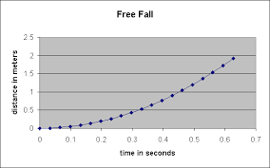  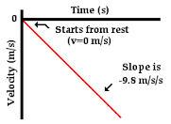 | Cartoon Situation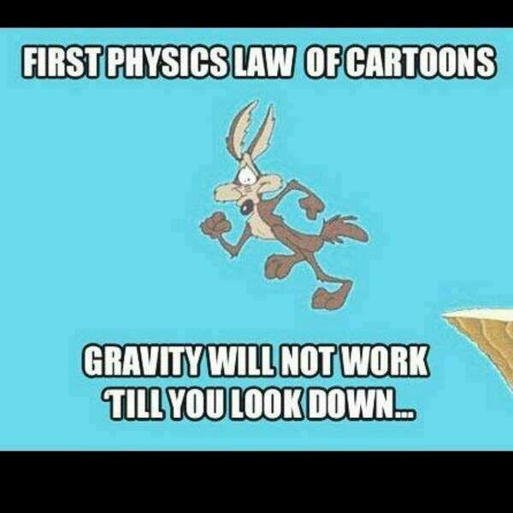
Formulas and Theories  Gravity is a force that takes affect as soon as the object starts to move. As the object falls the velocity of the object changes so there is acceleration.  From the first graph, we notice that in less than a few seconds the distance travelled by the object is rapidly increasing. The formula for determining the velocity of a falling object after a time of t seconds is  v_{f} = g * t  Example Calculations:  At t = 6 s  v_{f} = (9.8 m/s²) * (6 s) = 58.8 m/s  At t = 8 s  v_{f} = (9.8 m/s²) * (8 s) = 78.4 m/s | In the Cartoon shown Wile E Coyote remains frozen in space until he looks down.  The longer he does not look down the less likely the force of gravity apply  Though cartoon physics is funny, it does not Even

