French Immersion Social Studies 10 | Mr. Lukas Morel  lmorel@vsb.bc.ca
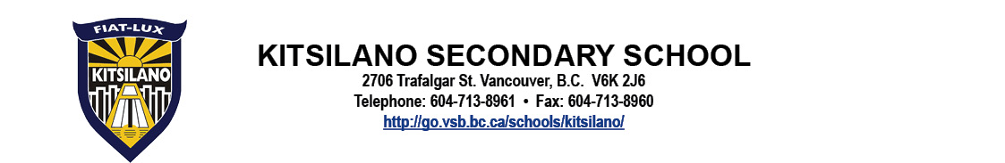
Goals
The emphasis in any Social Studies should go far beyond rote memorization. Accordingly, as the “Big Ideas” in the curriculum indicate, students are expected make connections between the facts of history and their greater meaning in society (see Course Content below)
https://curriculum.gov.bc.ca/curriculum/social-studies/10/courses.

Course Content
All areas of Curriculum Learning are based on the “Know-Do-Understand” model to support a concept-based, competency-driven approach to learning. The three elements work together to support deeper learning:
Know = Content Learning Standards
Do = Curricular Competency Learning Standards
Understand = Big Idea
In FSCH 9, there are 4 “Big Ideas”:
- Global and regional conflicts have been a powerful force in shaping our contemporary world and identities.
- The development of political institutions is influenced by economic, social, ideological, and geographic factors.
- Worldviews lead to different perspectives and ideas about developments in Canadian society.
- Historical and contemporary injustices challenge the narrative and identity of Canada as an inclusive, multicultural society.
FSCH 10 focuses on global events that happen between 1914 and now. Some examples of units that we will cover include the impacts of the World War I, the Great Depression, and the events surrounding World War II.
All courses also emphasize the Core Competencies, a set of intellectual, personal, rand social and emotional proficiencies that all students need to develop to engage in deep and life-long learning. The three core competencies are:
Communication
Thinking
Personal and Social

Assessment & Evaluation
As learning is an individual journey, assessment and evaluation is cumulative. The emphasis is on supporting students to achieve competency.

For details on how assessment will be structured in this course, please see the attached document “Parent Letter – Grading for Sciences Humaines 10”.

Marks for Each Report
All points have the same value, regardless of the type of activity. Larger, more “important” types of assessments will have inherently larger point values and will have a larger impact on the final grade.

Term and end-of-year Reports
The year is calculated cumulatively. This means that each successive term does not start again at “0”. Instead, it is a continuation of the previous one. The “Term” grade in the MyEd BC Parent portal is incorrect. The mark that will appear on the report card is the “Cumulative grade”, which is a “year-to-date” sum of all work completed since September. Accordingly, the year’s Final grade will be the cumulative mark for the year, NOT an average of the three terms.

Equipment and Materials
- Binder with loose-leaf paper
- Pencil, pen, pencil crayons, ruler

Supplemental Fee(s)
- None
Policies and Procedures

Cell Phones
Unless students are given specific permission to use a cell phone for an activity, cell phones are STRICTLY FORBIDDEN in class. Cell phones used without permission will be confiscated. First offenses will have phones confiscated until the end of the period, and repeat offences may see phones the day, overnight, and/or may only be returned in person to a parent/guardian.

Attendance
Attendance is recorded and reported for each class. Chronic absenteeism can significantly impact student learning and progress.
Please refer to the Student Agenda for detailed Attendance Policies.

Tardiness
Students must be in their classroom before the beginning of each period or they will be marked late. Students who are frequently late may be required to make up the time at the teacher’s discretion.

Academic Integrity Policy
On First Offence
-The student will receive “0” for that particular work.
-The incident will be recorded on the student’s discipline file.
-The parents/guardians will be informed.
-The student will not be eligible for Honour Roll recognition.

On Second Offence
-In addition to all first offence consequences:
-The student will not be eligible for school-based scholarships.
-The student will be referred to Grade Administrator.

Assignments & Tests
Please hand assignments in on the date assigned. Due to the type of assessment used in this class, students will have the opportunity to correct/redo assignments and/or tests if they wish. Please see documents available at http://blogs.vsb.bc.ca/lmorel.

Extra Help
Available by appointment and during tutorial time every morning.

Please sign the following form and present to the subject teacher.
_______________________________________________________________________________________
KITSILANO SECONDARY SCHOOL

I, ___________________________________________ have read and understand the above course expectations.
(Print full name of student)

Signature of Student: ______________________________________ Course: ___________________________

Signature of Parent/Guardian: _______________________________ Teacher: __________________________

Date: ___________________________________________________ Block: ____________________________

