JR. LINKS Remote Learning Guide
Week 12 – JUNE 15 – 19, 2020 (LAST WEEK OF INSTRUCTION)
ACTIVITY | MONDAY – JUNE 15 | TUESDAY – JUNE 16 | WEDNESDAY – JUNE 17 |  | THURSDAY – JUNE 18 | FRIDAY – JUNE 19  LAST DAY OF INSTRUCTION
 | Day 2 | Day 1 | Day 2 |  | Day 1 | Day 2
Block 2-4 LINKS | Block 2-4 LINKS  Check TEAMS and Email, school website for OPTIONAL on-site learning opportunities for Jr. LINKs and ELECTIVES classes.  CHECK WHICH SESSION YOU ARE ABLE TO ATTEND DEPENDING ON YOUR LAST NAME and Block. | Block 1-4 LINKS  - What in the World Level 1 - Issue 7 - COVID-19 AND THE ECONOMY PG 19-24 | Block 2-4 LINKS  - Work on your Math Packages. (Drive Through Math or Money Matters) |  | Block 1-4 LINKS  - Write Me a Note Lesson 13 Post Cards pg. 37-43 | Block 2-4 LINKS  - Work on your Math Packages. (Drive Through Math or Money Matters)
Nutrition Beak - 15 minutes
- Jr. LINKS  30 minutes | Block 2-3 LINKS  Go to Jr. LINKS Teams, click on ATTENDANCE Channel, and complete attendance.  Log into office.com and check your @learn.vsb.bc.ca email.  Log in and Teams on the Check all your TEAMS classes for meetings, attendance link, assignments, messages, etc.… | Block 1-3 LINKS  - What in the World Level 1 - Issue 7 - COVID-19 AND THE ECONOMY PG 19-24 (cont’d)  - Nature Scavenger Hunt (optional) | Block 2-3 LINKS  - mod_covid_crossword  - mod_covid_connect_dots |  | Block 1-3 LINKS  - What in the World Level 1 - Issue 7 - COVID-19 BACKGROUNDER PG. 25-33 | Block 2-3 LINKS  - Your choice of:  Coolmathgames.com  Mathisfun.com  raz-kids.com (free trial)  Typingclub.com, iPad games Educational apps
LUNCH - 60 minutes (pick-up free lunch at school 11:30-1PM)
- Electives  30 minutes | Block 2-2 ELECTIVES  Participate in 2- 2 electives class. “Like,” comment or complete attendance assignments in ELECTIVES Teams classes. You must once per week for attendance participate/interact purposes. | Block 1-2 ELECTIVES  Participate in 1-2 electives class. “Like,” comment or complete attendance assignments in ELECTIVES Teams classes. You must participate/interact once per week for attendance purposes. | Block 2-2 ELECTIVES  Participate in 2-2 electives class. |  | Block 1-2 ELECTIVES  Participate in 1- 2 electives class. | Block 2-2 ELECTIVES  Participate in 2-2 electives class.
Silent Reading - 20 minutes - Enjoy reading a book/magazine of your choosing.
- Electives  30 minutes | Block 2-1 ELECTIVES  Participate in 2-1 electives class. “Like,” comment or complete attendance assignments in ELECTIVES Teams classes. You must participate/interact once per week for attendance purposes. | Block 1-1 LINKS  - 1-1 Self Assessment of Core Competencies June 2020  - School Wide, all students must complete this activity during 1-1 Block and share results with parents. | Block 2-1 ELECTIVES  Participate in 2-1 electives class. | Block 1-1 LINKS  - What in the World Level 1 - Issue 7 - COVID-19 BACKGROUNDER PG. 25-33 (cont’d)  Or  - Teams Tutorial -  Contact Ms. Shen on Teams or your Electives Teachers for help with Teams and homework. I will also be contacting students this block. |  | Block 2-1 ELECTIVES  Participate in 2-1 electives class.
- Chore Time  30 | In collaboration with your parent/guardian, choose an age appropriate household chore to complete.
- Afternoon Fresh Air  30 minutes | Bike, walk the dog, play outside …Pay attention to Covid-19 protocols for Safe Distancing.
- June 15-19th, 2020 Optional On-site schedule for Ms. Shen.
- SSA Leigh, will have her own schedule, please connect with her directly for details (lcrawford@vsb.bc.ca or on TEAMS).
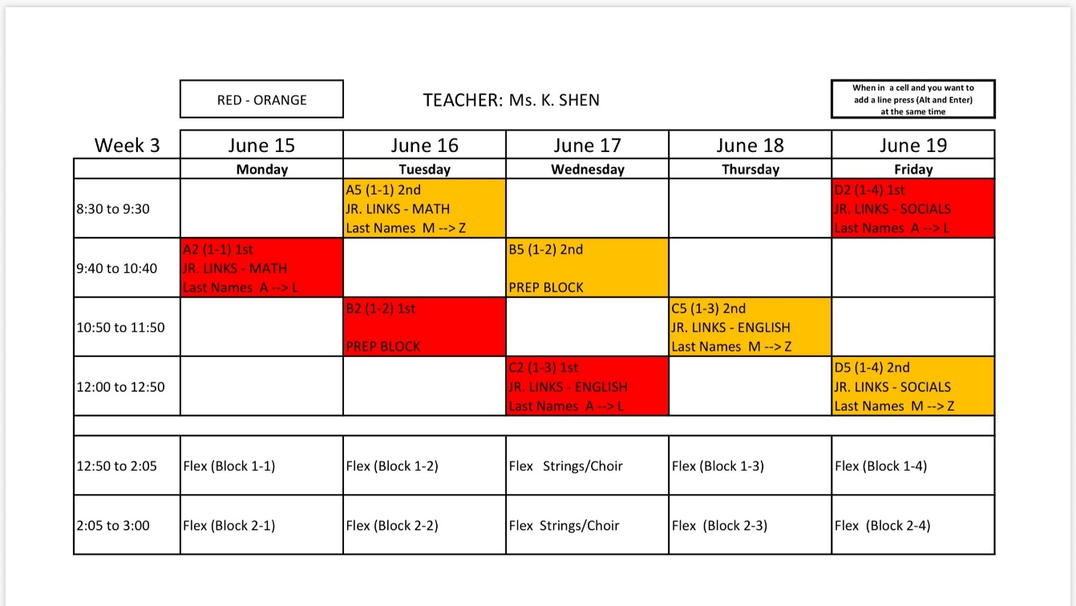
- June 22-25 Year End Schedule:
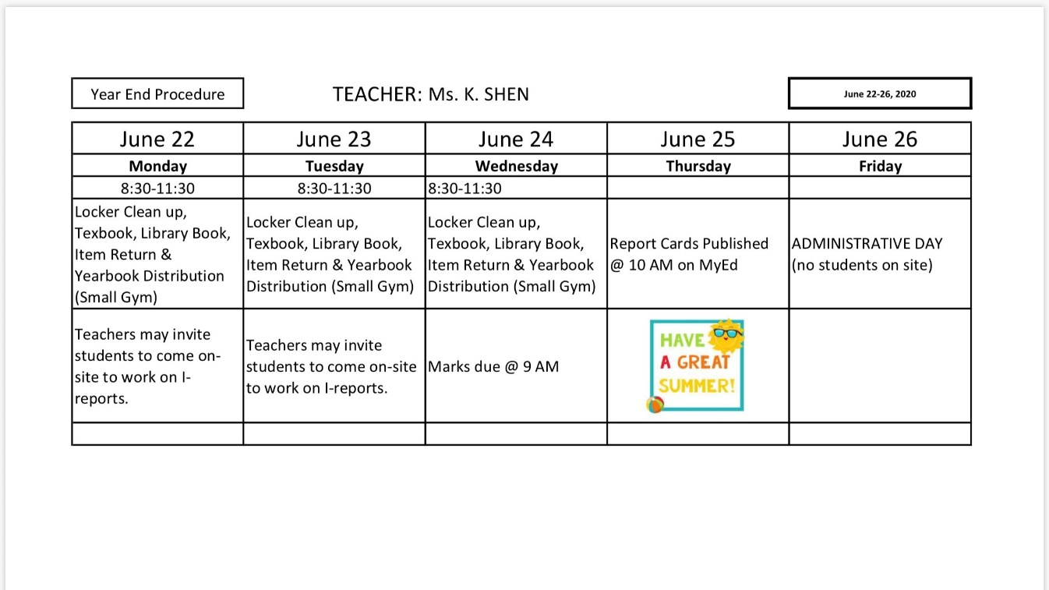
REMINDERS:
- June 15-19 is the last week of formal instruction for all classes. If you got an I-report make sure you complete the plan to get a passing mark.
- This week please come by during your on-site schedule to RETURN LIBRARY BOOKS, TEXT BOOKS AND ANY BORROWED ITEMS from Jr. LINKS, the Library or your electives teachers. Also please bring home all personal belongings and projects left in 311 and lockers.
- Any projects not picked up by June 19, 2020. Any items not picked up by this time will be donated or recycled.

Weekly Attendance:
- Complete your weekly JR. LINKS attendance by logging into TEAMS-->Attendance channel. MONDAY/TUESDAY each week.
- ALL other ELECTIVEs classes will mark student for “Engagement” you must interact with your teachers at least ONCE PER WEEK to be marked “P – for present”, if you do not participate you will get a “D – for disengaged” and counsellors and ADMIN will have to follow up. Please Check with Electives teachers in by Thursday/Friday @ 3PM.
THIS WEEK’S RESOURCES:
- Ms. Shen’s Blog - https://blogs.vsb.bc.ca/kshen
- Week 12 – JUNE 15 – 19, 2020 OPTIONAL ON-SITE SCHEDULE (MS. SHEN) (LAST WEEK OF INSTRUCTION)
- June 22-25 Year End Schedule
- Money Matter Math Package (most students are on this package)
- Drive Through Math Package (JT and NC are on this package, menu on pg.30)
- Write Me a Note Lesson 13 Post Cards pg. 37-43
- mod_covid_crossword
- mod_covid_connect_dots
- What in the World Level 1 - Issue 7 - COVID-19 AND THE ECONOMY PG 19-24
- What in the World Level 1 - Issue 7 - COVID-19 BACKGROUNDER PG. 25-33
- 1-1 Self-Assessment of Core Competencies June 2020

