Section 1: General Introduction

- Define “risk factor”: _______________________________________________________________________________________________________________________
Things you didn’t know about risk factors:

Section 2: Risk Factors You Can Control

Risk Factor | - General information  - How does it damage your cardiovascular system?

Section 3: Risk Factors You Can’t Control

Risk Factor | - General information  - How does it damage your cardiovascular system?

Section 4: Emerging Risk Factors

Risk Factor | - General information

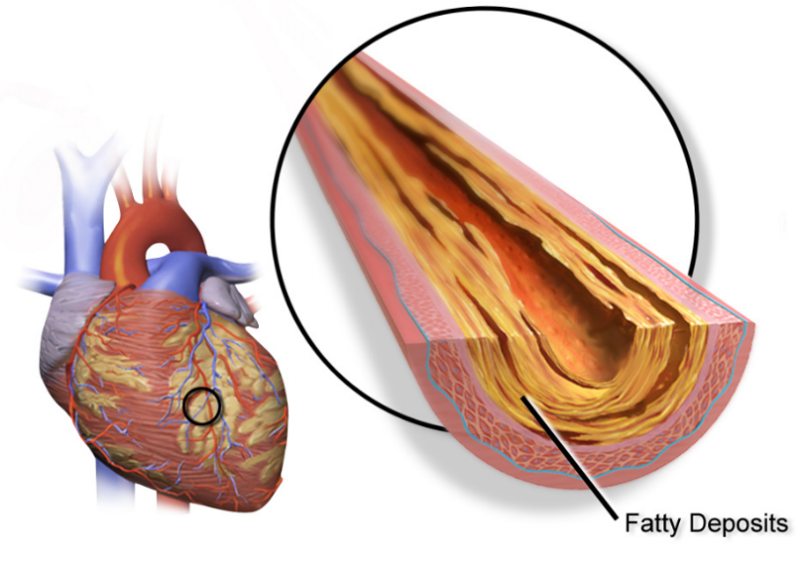
Image: BruceBlaus, Wikimedia Commons (CC BY 3.0)

