Drosophila questions – Read the Catalyst article on Drosophila melanogaster by Nigel Collins (November 2006) and the handout on drosophila handling and sexing.
The catalyst article can be accessed at https://www.stem.org.uk/system/files/elibrary-resources/legacy_files_migrated/8649-catalyst_17_2_382.pdf
Answer the following questions from the readings.
- In hot weather, the Drosophila life cycle may take ___________________ days.
- Adults may live _______________ days and may lay _______________ eggs in their lifetime.
- Larvae live in the _________________ or food source, burrowing and feeding.
- The forked tube at one end of the pupa is used for ___________________________.
- Research began on Drosophila about ____________ years ago, when biologist Thomas ______________________ discovered a white-_________ mutant.
- Morgan won the Nobel Prize in ________________.
- Drosophila has been one of the most important organisms used in ___________________ research, including in terms of patterns of ___________________, as well as on understanding _____________ and protein __________________, as well as understanding how ___________ organisms can develop from simple fertilised eggs.
- The Drosophila genome was __________________ in 2000, meaning that the exact order of DNA ___________________________ was determined.
- 50% of the ____________________ acid sequences in fruit flies have matching sequences in ____________________________.
- ____________ % of known human diseases have matches in the fruit fly genome.
- Drosophila has been very useful in studying human diseases caused by _______________ genes, including _______________________, Huntington’s, ____________________, diabetes and ___________________.
- Drosophila can be easily kept in small ____________, with a food source and a foam ________________ that prevents them from __________________ while allowing for air to move in and out of the bottle.
- Drosophila will develop from _____________ to adult in about _________ days at 25ºC, and the life cycle can be completed within __________ weeks.
- Large___________________ of Drosophila can be easily and inexpensively cultured in the lab.
- Many _____________________ strains of Drosophila have been found and are used in genetic experiments.
- Drosophila has also been useful in learning about how _________________ is inherited, the system for which is shared by humans and fruit flies.
- Genes that are considered sex-linked occur on the _____ and _____ chromosomes, responsible for gender.
- Females have two X chromosomes (XX) while males have one X and one Y ( ___ ).
- If a gene is located on the X chromosome, it may have no matching gene on the ___ chromosome.
- See the image below of the X and Y chromosomes in humans (http://ib.bioninja.com.au/standard-level/topic-3-genetics/34-inheritance/sex-linked-genes.html). Notice that the Y chromosome is much ______________________ than the X chromosome.
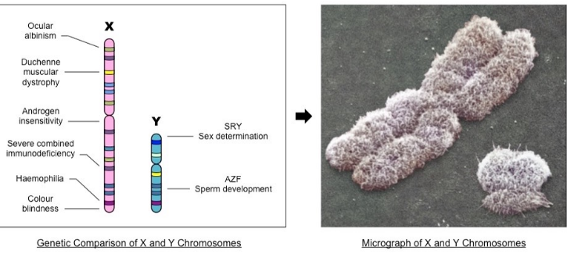
- The diagram below explains how sex-linked disorders occur (http://slideplayer.com/slide/8515983/):
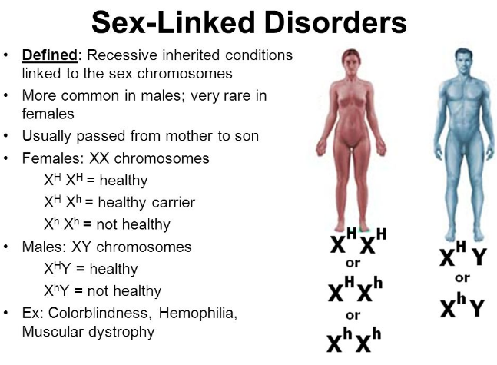
- In Drosophila, the ______________ - eyed fly showed sex-linked ______________________. This is because the eye colour gene in Drosophila Is located on the X chromosome, with no __________________ position on the Y chromosome. This means that if the recessive allele for ________________ eyes occurs on the X chromosome, the male will have no second ________________ and therefore will have white eyes. The same is true for the ______________________ sex-linked diseases shown above.
- In sex-linked genes, _______________________ may carry a recessive allele but still be ________________________, whereas this is not true for the males, hence the higher incidence of sex-linked conditions in _________________.
- Distinguishing male from female Drosophila:
  - Males have ________ abdominal segments, while females have _____.
  - Males have a dark-coloured sex __________ on the foreleg (front leg), which is a small ____________________ of about 10 black ________________ .
  - Males have darkened posterior ______________________ on the abdomen.
  - Females have a more _____________________ abdomen than males.
  - Females have several dark stripes on the _______________ , while males have _______.
  - Males have dark _______________________ while female genitalia is more pale in colour, and _________________.
- Wild type (normal or typical) Drosophila are denotes with the “___” symbol, while mutations are given letter symbols.
- The symbol for the mutant ebony is ______________.
- The symbol for the mutant garnet is ______________.

