**JO PAC Meeting – April 13, 2016**

***Present:*** Anne Montgomery – PAC Chair, Tracey Santos – Treasurer, Ramandeep Kaurminhas and   
Jo-Ann Gordon – Co-Secretaries, Tim McGeer – Principal, and 8 parents

The meeting began at 7:00 p.m.

***1. VSB Budget Proposal:***

Lara Spence is attending and speaking at the meeting tonight on behalf of the JO PAC (see attached letter).

New proposal reduced numbers of Teachers, Vice-Principals and Support Workers being cut. Result for JO is that some classes (Gr. 11 and Gr. 12) will go over 30 students. In the Mini school the Gr. 11 and 12’s will have blended classes. We would lose Michelle Batkin and so Administration would have to pick up her job.

To voice your concerns, email:

budget2016\_2017@vsb.bc.ca

[premier@gov.bc.ca](mailto:premier@gov.bc.ca) (Christy Clark)

[educ.minister@gov.bc.ca](mailto:educ.minister@gov.bc.ca) (Mike Bernier)

***2. VSB 2021 Strategic Plan***

In Phase 2 now – complete final survey online (April 11 – May 1). The following links were taken from the VSB website (https://www.vsb.bc.ca/vsb2021)

[We have now completed a Phase 1 Engagement Report, sharing the process and findings so far.](http://www.vsb.bc.ca/sites/default/files/publications/vsb-phase1-report-20160411-interactive.pdf)

Phase 2, titled “**Setting Direction, Making Choices**”, is now underway, and will create the core content of the new plan. Four “key themes” have been drafted, along with a set of “directional statements” to ensure action on each, but these are for your discussion and comment until May 6th. There are three ways to provide input:

### *Group Discussion:*Download and complete a small-group discussion guide, working with some of your friends and colleagues to provide detailed feedback on the two themes you think are most important. Take notes by hand or in the PDF itself, and turn in the completed discussion guide by May 6th.

[Download the pdf »](http://www.vsb.bc.ca/sites/default/files/publications/VSB-Phase2-discussionguides-20160406-readerenabled.pdf)

(please ensure to right click and save the document. You can open the document in a [pdf reader program](https://get.adobe.com/reader/))

### *****SURVEY #2:***** Online from April 11 to May 1st, this short survey covers the same draft content (“key themes and directional statements”) as the guides offered above, but does not go into deep discussion.

[Take the survey »](http://fluidsurveys.com/surveys/dfergusson/vsb2021-phase-2-survey/" \t "_blank)

### *****Workshop:***** We are hosting a discussion-based workshop at Templeton Secondary School (727 Templeton Drive) on April 21st from 7:00 to 8:30 pm. Small-group discussions on the same “key themes and directional statements” will start promptly at 7:15. Don’t be late!

[Workshop Agenda »](http://www.vsb.bc.ca/sites/default/files/publications/Workshop-agenda.pdf)

***3. VSB Long Range Facilities Plan***

The design process is completed and the VSB is now asking for public input before they decide which schools will be closed and/or made into swing schools, etc. As John Oliver Sec. has not been seismically upgraded it could be slated for closure. Please attend any or all of the following public meetings to let them know the John Oliver community is thriving and the 1,100 students at JO want to remain in their school (taken from the <https://vsbengagement.wordpress.com/how-to-get-involved/> website).

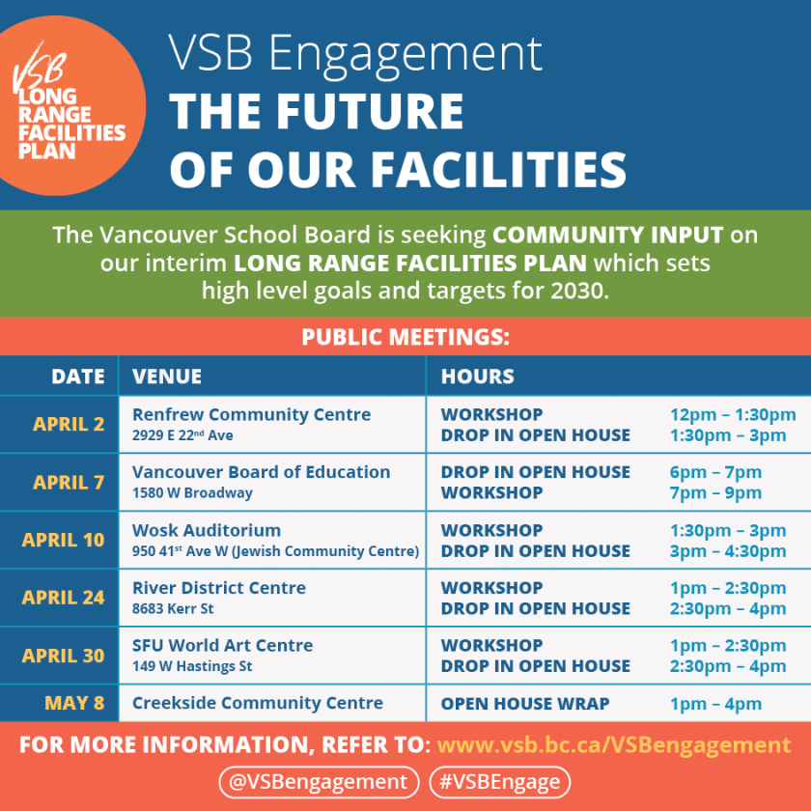

***Principal’s Announcements: Tim McGeer***

***VSB Long Range Facilities Plan*** – Tim to invite either David Nelson or Chris Atkinson to attend the final JO PAC meeting May 18th to talk about the plan and answer questions.

***Indoor Track Meet, Math Jr. Olympics, Mini School Seattle Trip*** (next week).

***Filming at John Oliver*** – Riverdale (Archie comics) filmed over March break, earning $7,000 for John Oliver. There is talk it may become a series, which would mean more money for JO as they would rent the Barn and use the grounds. Paramount will be filming in August “Death Note” at JO.

***Rotary Gala*** – raised $5,000 for John Oliver, to support literacy.

***New Curriculum*** – will roll out in September, with teachers creating content. CP time will help generate the new lessons.

***April 28 Festival*** – Gr. 6 & 7 feeder school classes will come to JO and participate in 8 different stations of First Nation activities. JO students have learned enough about the different activities (Medicine Wheel, BC button blanket, cedar weaving, bone game, storytelling, etc.) to lead the students.

***PAC Treasurer’s Report:***

Gaming Commission gave an additional $2,000 to JO PAC.

Bank of Montreal offer – 65 accounts were opened, providing $3,250 to JO PAC.

Approximately $11,000 left to disburse as follows:

- $2,500 for 5 PAC scholarships

- $2,300 held back for next year

- $3,900 to Athletics for new Basketball uniforms

***Teachers Appreciation Lunch – Wednesday May 4:***

Paula Singh is leading this event. Please text her cell at 604-779-1376 if you would like to volunteer. Any parents who have connections with restaurants, please approach them for food donations, and then let Paula know so we do not duplicate requests.

Set up will begin at 9:00 a.m. with lunch for the teachers at 11:30 a.m. All are welcome to come and prepare food, re-arrange and decorate staff room, pick up donations from businesses, and clean-up.

***Direct Drive Campaign:***

Letters will be sent to alumni shortly, with letters being sent to all JO parents in September.

***Hypnotist – Scott Christie – Thursday May 19:***

Tickets are $10. Dry Grad is hosting and hopes to sell over 200. Invite family, friends and neighbours to this wonderful evening.

***Vancouver Neufeld Conference – Saturday April 30:***

Held in Richmond from 8:30-4:30 pm, cost is $160. For more information visit [www.neufeldinstitute.org](http://www.neufeldinstitute.org)

The meeting was adjourned at 8:30 pm. with the final PAC meeting to be held on **Wednesday, May 18, 2016** at 7:00 pm in the Library. Elections for PAC positions (no PAC means no money coming to the school), and Long Range Facilities Review speaker are on the agenda.

***Other Important Contacts:***

[www.panvancouver.ca](http://www.panvancouver.ca) (Parent Network)

[fosl.vancouver@gmail.com](mailto:fosl.vancouver@gmail.com) (Friends of the School Library)

[penny.noble@vsb.bc.ca](mailto:penny.noble@vsb.bc.ca) (our VSB Trustee)