Information for citing images:

Images for this assignment can be found in several places. If you would like to use a photo/image from a book, it can be scanned using computer #22.

To cite an image found on the web:

Creator of image. “Description or Title of image.” Date image was created. Title of database or website.

Web. Access date. <URL>.

To cite an image found in a book:

Creator of image. Title of work. Year of creation (or n.d.). Name of institution that houses the work. Location.

Title of book. Author. City: Publisher, Date. Page(s). Print.

To cite a map from the web:

Contributor(s). "Title of Map." Map. Name of Web Site. Publisher/Sponsor of site, Date of publication. Web.

Date of Access. <Optional URL>.

To cite a map from a book:

Map Contributor(s). "Title of Map." Map. Title of Book. Author. Edition. Vol. #. City: Publisher, Year. Pages.

Print.

**it is very important to put citation information (the first piece of information, such as creator or title, in the Works Cited entry) UNDER each image you use**Please see the example below**

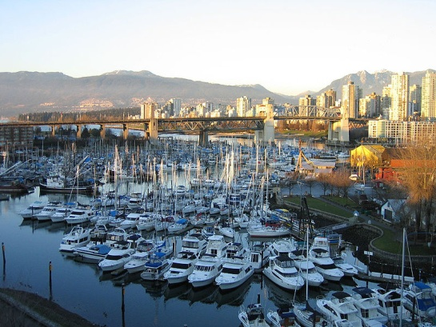
Eben Field

Citation for picture of Vancouver:

Eben Field, Jon. “False Creek 2.” 02 Jan. 2005. Wikimedia Commons. Web. 31 Oct. 2012.

<http://commons.wikimedia.org/wiki/File:False_Creek2.jpg>

