Dear Diary…
You will be assigned one of the following roles, research what their daily life was like, then write three diary entries. A day in the life of…
King | Peasant man
Noble Lord | Peasant woman
Lady of the Manor | Peasant child
Baron | Monk
Knight | Priest
Teenage noble girl | Nun
Teenage noble boy | Page
Miller | Squire
Blacksmith | Fletcher
Baker | Bailiff
Swineherd | Shepherd
Cowherd/Herdsman | Hayward
Castle Cook | Troubadour
Tanner | Thatcher

Learner Outcome: the purpose of this project is to demonstrate historical perspective; that is to demonstrate knowledge and understanding of this person’s life. What was life like for them? Research will be required using books and websites so that you may write an accurate diary entry. Your research and diary entry should include the following details:
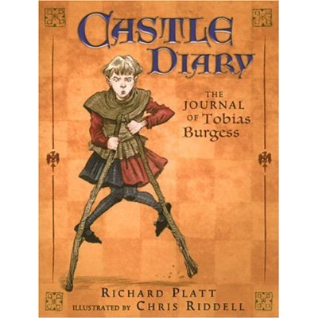
  - Each entry dated. (Time period between 1000-1200 C.E.)
- Write from at least two different seasons.
- If you are in a religious role, include a religious ceremony or holiday.
  - Where do you live?
- What do you do all day?
- How long is your work day (if you work)? What time do you wake up? Go to bed?
- Which people do you interact with?
- What are your obligations?
- What do you eat?
- What do you wear?
- What do you worry about?
- What are you happy about? What are your pastimes?
- What is the role of religion in your life?
- Include/draw a picture of yourself or any other illustrations you think are important to your character (3 field system, a manuscript, symbols, etc.)
There are THREE PARTS to this assignment:
- Works Cited: this is your list of references, properly cited in MLA 7 style. A minimum of four is required: two websites, two books (you may include your text book). This should be completed on a separate piece of paper to be handed in with your diary booklet.
- Research Process: Note-taking sheets will be provided which shows your research on the questions from the 1st page and records where you found the information. One sheet per source is required and to be handed in with your diary booklet.
- Diary Booklet:
  - Journal entries: three entries, each approximately 200-250 words (double-spaced). The entries should be written as narrative, not as a report.
    - Your first entry should include details on where and your daily routine.
    - If you are a peasant, entries should be written from at least two different seasons. Include farming practices (ie: spring – planting; fall – harvesting).
    - If you are in a religious role, include a religious holiday (ie: Easter) or a religious ceremony (marriage, death, baptism, etc.)
    - One of your entries should include your obligations.
  - Visual: be creative as possible in its presentation!
    - Include a diary jacket (ie: title page).
    - Include some drawings that demonstrate your life.
    - Use a unique font.
    - Use any other colour paper either than white, for authenticity.

Carefully review the rubric below which outlines criteria for each category.
CATEGORY | 1– Beginning | 2 - Developing | 3 - Capable | 4 - Accomplished
Works Cited in MLA 7  (detailed rubric to be provided by library) | Includes only one source. Many errors in references. | Includes 2 sources. References have many errors. | Includes 3 sources. Most references are cited correctly. | Includes a minimum of 4 sources cited - two books and two websites. References are cited correctly with only minor errors.
Research Process (Note-taking sheet) | Many of the questions are not answered and details are very limited. Source information if missing. | Some of the questions are not answered and details are limited. Some source information is missing. | Most of the questions are answered with adequate amount of detail. Source is listed on each sheet. | All relevant questions are answered with many details. Source is listed on each sheet.
Diary Content | Includes three diary entries. Many character details are inaccurate, with many questions left unanswered. Details are very limited. | Includes three short diary entries. Some character details are historically inaccurate, with quite a few questions not addressed. Details are limited. | Includes three diary entries at required length. Character details are mostly historically accurate, with most questions included. Adequate details are included, and are fairly descriptive. | Includes three diary entries at required length. Character details are historically accurate, with all questions from research record included. Many details included which are descriptive and vivid.
Visual Product | Diary does not include a title page. Few or no drawings. Normal font and paper used. | Diary includes a basic page/jacket; with few relevant drawings. Paper and font are average. | Diary includes a visually appealing title page/jacket; filled with some relevant drawings, use of unique font and paper. | Diary includes a unique title page/jacket that is visually appealing; filled with many relevant drawings, unique font and looks authentic.

