Identifying and Naming Polygons

- a) Use Pattern Blocks.
Sort the Pattern Blocks by the number of sides.
Sketch each Pattern Block in order from least to greatest number of sides.

b) Record the number of vertices for each Pattern Block.
What do you notice between the number of vertices and the number
of sides?
Can we say this about all figures and vertices?
Give an example.

Constructing Triangles

- a) Use a geoboard.
Make the smallest isosceles triangle and the biggest isosceles triangle that
you can.

b) Sketch the triangles on square dot paper using the same number of dots as you used pegs on the geoboard.
Label the triangles.

- What is the difference between an equilateral triangle, an isosceles triangle,
and a scalene triangle?

What Makes a Figure?

- Answer the riddles:
a) I have two pairs of parallel sides.
All of my sides are equal.
All of my angles are right angles.
What am I?

b) I have 4 sides.
I have at least 1 pair of of parallel sides.
What kind of quadrilateral am I?

c) None of my sides are the same length.
I have 3 sides.

- Draw a picture of each figure in the riddles above.

- Make up your own riddles. Trade them with a classmate.
Drawing Solids

- a) Name a prism that could be made using the following faces:
• squares and rectangles
• triangles and rectangles
• rectangles and hexagons

b) Draw and label an example of each prism.

- a) Name a pyramid that could be made using the following faces:
• an isosceles triangle and an equilateral triangle
• a square and an equilateral triangle

b) Draw and label an example of each pyramid.

Planes of Symmetry

- Name the faces in the following planes of symmetry:
a) a horizontal cut in a rectangular prism
b) a vertical cut in a rectangular prism
c) a vertical cut in a square pyramid
d) a vertical cut in a triangular pyramid

- Draw and label the faces you would see in each pyramid and prism.

Extra Practice Sample Answers

Identifying and Naming Polygons
1. a) 3 sides: equilateral triangle, 4 sides: trapezoid, blue rhombus, beige rhombus, square, 6 sides: regular hexagon.
b) Vertices: 3: equilateral triangle, 4: trapezoid, blue rhombus, beige rhombus, square, 6: regular hexagon.
The number of vertices and the number of sides are the same.
We can say this about all figures. For example, a five-pointed star has 10 sides and 10 vertices.

Constructing Triangles
1. a) Smallest isosceles triangle covers 4 pegs, and would stretch 1 peg either height or width and 3 pegs either height or width.
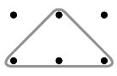

Largest isosceles triangle on a 10 peg by
10 peg geoboard would have a height 10 pegs and a base width of 10 pegs.
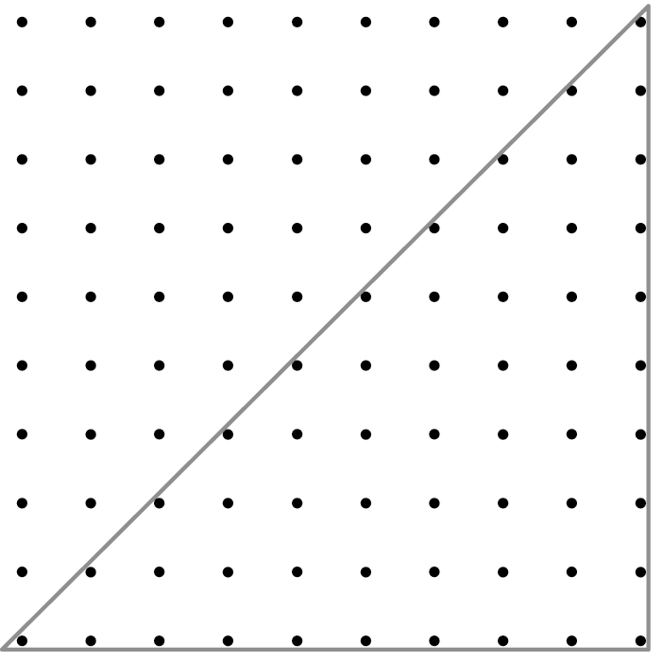

b) Sketches will vary (see above)
2. An equilateral triangle has all sides equal. An isosceles triangle has 2 sides equal. A scalene triangle has no sides equal.
What Makes a Figure?
1. a) square

b) trapezoid, parallelogram
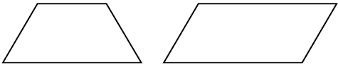

c) scalene triangle
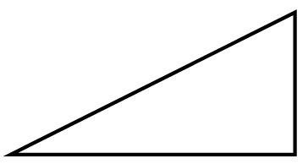

2. (See examples above)
3. Riddles will vary

Drawing Solids
- a), b)
rectangular prism
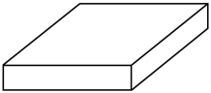

triangular prism
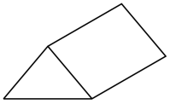

hexagonal prism
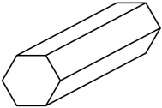

2. a), b) triangular-based pyramid
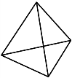

square-based pyramid
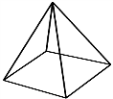

Lesson 6
1, 2. a) rectangle

b) square or rectangle

c) isosceles or equilateral triangle
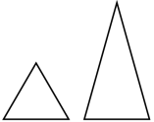

d) isosceles or equilateral triangle

