How to make a temporary home for your snail
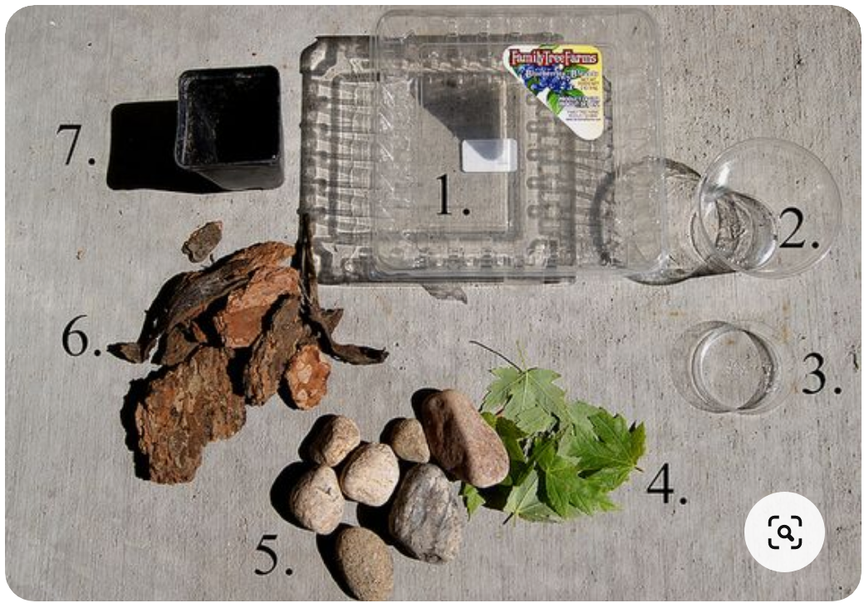
You will need:
1. A plastic produce carton- the kind that berries or lettuce come in. These have ample holes for air circulation, yet your snail won't escape! 2. A shallow saucer (a disposable plastic drinking cup trimmed down will work) 3. Fresh leaves from a nearby tree/plant. 4. Stones of various sizes. Be sure to have one will fit into your water saucer- not too big/not too small. 5. Mulch, bark or twigs. 6. Soil from your garden. 7. A small plastic plant container or yoghurt container. Be sure it's the right size that you can close the lid of your berry container! 8. A tray to place the habitat on (so that it catches any dirt/water that may spill out!)
1. Start with your clean, empty berry container. Place the water saucer, and begin to add in the soil and large pieces of bark/mulch. 2. Place a large stone in the water saucer. This will allow your snail to crawl in and out of the water. Sometimes he just hangs on the side of the rock to take a sip from the water. Without the stone, you may end up with a drowned snail! 3. Place the plant container on its side. Put some stones or mulch in the bottom to weigh it down. Snails love cool, shady places, so this will be a nice little shelter for him (or her!) Fill the container with a nice amount of stones, bark, and leaves. 4. Fill the saucer with water, and sprinkle water over everything in the habitat. You will need to freshen the water every couple of days and add some fresh leaves. Make sure your lid will close, and you are ready to put your snail in his new home! Place the habitat on the tray and find a nice cool, shady spot to keep it. Have fun watching the snail crawl all around! They are really quite fascinating!
A few interesting snail facts: Snails eat bark, fresh leaves, bits of fruit, decaying matter, and the chalk from limestone rock (this is good for their shells!) Snails like a moist, shady environment. They do not like hot and dry conditions, and they don't care for the sun. Snails sleep during the day and are most active at night. Snails belong to the mollusk animal family. They are related to oysters, clams and other shellfish. Snails are "gastropods," which is Latin for stomach ("gastro") and foot ("pod").

If you would like to build a more long term home for snails you can find some instructions here:
https://snailsandslugs.wordpress.com/2010/10/04/terrarium/

