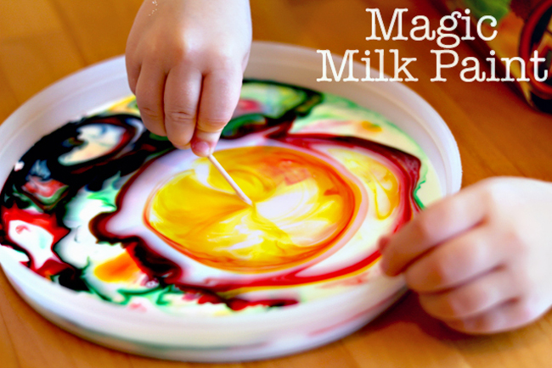

What you need:
- Whole milk
- Food colouring
- Toothpicks
- Dish soap
Put the milk in a shallow lipped bowl.
Put a few drops of food colouring (various colours) in the milk.
Dip the toothpick in the dish soap and then put it in one of the drops of food colouring and observe!
The reaction of the soap disrupting the surface tension of the milk causes the colors to radiate away from the toothpick.

