4.3 PLAYING WITH $y=x^{2}$ Name: Blk:

- Graph $y=x^{2}$ using $-3≤x≤3$
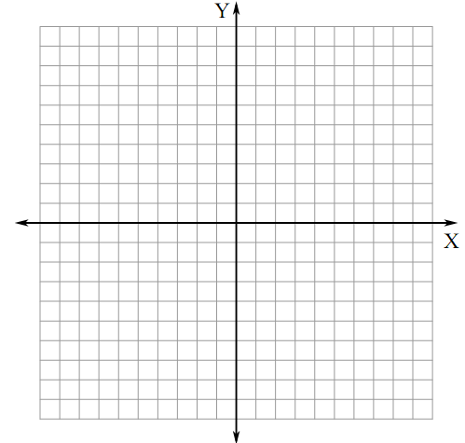
$$x$$ | $$y$$
$$-3$$
$$-2$$
$$-1$$
$$0$$
$$1$$
$$2$$
$$3$$

Notice:
- Vertex
- Graph opens

- Manipulation #1: $y=x^{2}+q$

Use a graphing calculator to graph the following functions. Sketch each of the graphs in the space provided.

$$y=x^{2}+1$$ | $$y=x^{2}+2$$ | $$y=x^{2}-1$$ | $$y=x^{2}-2$$
Notice: $±q$ moves the graph
- The graph of $y=x^{2}+q$ is the image of $y=x^{2}$ after a of $q$ units

- Manipulation #2: $y={(x-p)}^{2}$

Use a graphing calculator to graph the following functions. Sketch each of the graphs in the space provided.

$$y={(x-1)}^{2}$$ | $$y={(x-2)}^{2}$$ | $$y={(x+1)}^{2}$$ | $$y={(x+2)}^{2}$$
Notice: $±p$ moves the graph
- The graph of $y={(x-p)}^{2}$ is the image of $y=x^{2}$ after a of $p$ units
- $y={(x-p)}^{2}$ moves the graph
- $y={(x+p)}^{2}$ moves the graph

- Manipulation #3: $y={ax}^{2}$

Use a graphing calculator to graph the following functions. Sketch each of the graphs in the space provided.

$$y=2x^{2}$$ | $$y=-2x^{2}$$
$$y=\frac{1}{2}x^{2}$$ | $$y=-\frac{1}{2}x^{2}$$
Notice:
- $+a$ = graph opens
- $-a$ = graph opens
- $a>1\text{ or }a<-1$ =
- $0<a<1 \text{or}-1<a<0$ =
- The graph of $y=ax^{2}$ is the image of $y=x^{2}$ after the following transformations:
when $a>1$ =
when $0<a<1$ =
when $a<-1$ =
when $-1<a<0$ =

