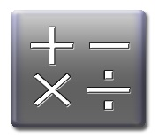
INTEGERS-REVIEW FOR GETTING BACK INTO MATH!
This Photo by Unknown Author is licensed under CC BY
REVIEWING SOME IMPORTANT SKILLS FOR OUR FIRST MATH 8 UNIT
Here are the learning intentions for our first unit. Check the boxes that you feel you are comfortable with right now!
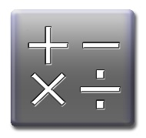
Be honest! This is to help you study what you don’t know, it is to help you!
This Photo by Unknown Author is licensed under CC BY
- I can Understand the concept of Integers
- I can Use Rules to perform operations with integers
- I can confidently Solve Problems using BEDMAS
- I can consistently and accurately use Models to add, subtract, multiply and divide integers

Name_____________________________ Blk________

INTEGERS-REVIEW FOR GETTING BACK INTO MATH!
REVIEWING SOME IMPORTANT SKILLS FOR OUR FIRST MATH 8 UNIT
Here are the learning intentions for our first unit. Check the boxes that you feel you are comfortable with right now!
Be honest! This is to help you study what you don’t know, it is to help you!
- I can Understand and identify the concept of Integers
- I can Use Rules to describe operations with integers
- I can explain relationships and use BEDMAS to solve problems.
- I can consistently and accurately use Models to add, subtract, multiply and divide integers

