Prince of Wales Mini School
4750 Haggart Street, Vancouver, BC V6L 2H8

Science Fair Handbook (2019 – 2020)
(for Grade 8 and 9 students)

“The secret of getting ahead is getting started. The secret of getting started is breaking down complex tasks into small manageable tasks, and then starting on the first one.”
Mark Twain
Read this entire handbook before starting your project!
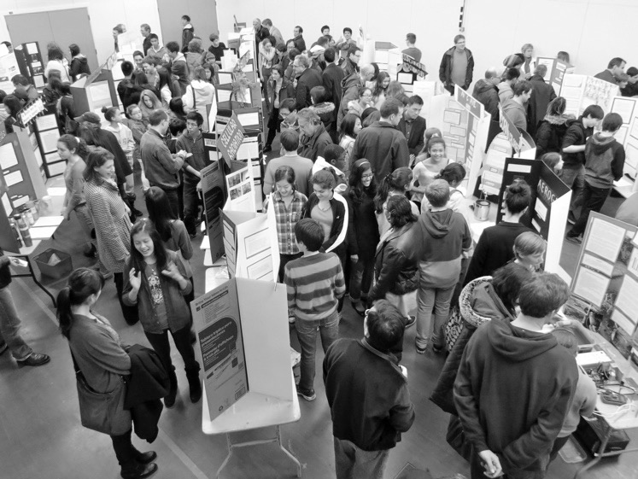

Prince of Wales Mini School Science Fair Night
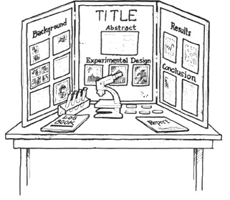

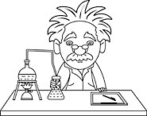
Introduction

Science Fairs assist students in learning valuable skills such as communication, critical and logical thinking, the ability to evaluate situations, a positive attitude and self-confidence, a sense of responsibility, creativity and artistic skills, and the ability to manage time.

Students work as scientists, experiencing the excitement, pleasure, frustration and collaboration connected with scientific research. A Science Fair project provides an opportunity to extend science beyond the classroom and to take an in-depth look at a topic that is of personal interest.
Timeline

Sept. & Oct. Choose a topic, research your topic, find an advisor, develop a hypothesis

October 7 Last day for Grade 8s to submit a Project Proposal sheet

October 11 Last day for Grade 9s to submit a Project Proposal sheet

November – January Conduct your experiment (once approved by the science teacher)

November – January Periodic Project Data Book checks by teacher

January 6 All experimentation must be completed by this date, to allow time for the write-up

January 27 Set-up Display Board, Project Data Book & Written Summary Report
(before 8:40 a.m.) in the Mini School Gym

January 27-31 Judging of all Presentations 8:40 a.m. – 3:00 p.m.

January 30 Presentation of projects to parents and public 7:00 – 8:00 p.m.

February 28 Vancouver District Science Fair (Langara) – selected projects
April 2-4 Greater Vancouver Regional Science Fair (UBC) – selected projects

May 9-11 Canada-Wide Science Fair (Edmonton, Alberta) – selected projects from Regionals
Grade Categories
- Junior (Grade 8)
- Intermediate (Grade 9)

Types of Projects

Experiment: An investigation undertaken to test a scientific hypothesis using experiments. Experimental variables are controlled to some extent (Grade 8 & 9 students).

Innovation / Invention: The development and evaluation of innovative devices, models or techniques, or approaches in technology, engineering, or computers (Grade 9 students only).

Study: A collection and analysis of data to reveal evidence of a fact, situation of scientific interest. It could include a study of cause and effect relationships or theoretical investigations of scientific data (Grade 9 students only).

Steps in Creating a Successful Science Fair Project

- Choose a Topic
- Narrow your ideas down to a particular branch of science
- Choose a topic that you find genuinely interesting
- Aim to be innovative
- Choose a topic that’s within your capabilities and resources
- Refer to the Judge’s Marking Sheet throughout your project

- Pick Your Project Type
- The three types of science fair projects are: experiments, innovations/inventions, and studies (Grade 8s must undertake an experiment)

- Find an Advisor
- Someone who can provide advice along the way: a senior student at P.W. Mini School; Teacher; Professor; parent; industry professional

- Read about Scientific Inquiry in your textbook. Grade 8s read p. 476 – 479. Grade 9s read p. 463 – 466.
- Use this information throughout your science fair project

- Research Your Topic In Order to Come Up With a Question
- Types of resources (books, magazines, newspapers, scientific journals, internet, people)
- Good research leads to a good project

- Develop an Objective / Purpose
- Why are you doing this project? What do you hope to find? What is the importance of your results to society?

- Ask a Question
- The Scientific Method starts when you ask a question about something that you observe. How, What, When, Who, Which, Why, or Where? In order for the Scientific Method to answer the question it must be about something that you can measure, preferably with a number.

- Conduct Background Research that Examines Your Question
- Rather than starting from scratch in putting together a plan for answering your question, you want to be a savvy scientist by using research to help you find the best way to do things and ensure that you don’t repeat mistakes from the past.

- Construct a Hypothesis
- Once you know what you want to find out, you have to go about making a prediction – an educated guess – a hypothesis. Based on past research, make an assumption about what you believe should happen. You must state your hypothesis in a way that you can easily measure, and it must also be constructed in a way that helps you answer your original question.

- Design Your Experiment
- Define your independent (manipulated) and dependent (responding) variables, your control(s), and your sample size
- Develop your materials and procedure
- Test Your Hypothesis by Conducting Your Experiment
- Your experiment tests whether your hypothesis is true or false. It is important for your experiment to be a fair test (unbiased). You conduct a fair test by making sure that you change only one factor at a time while keeping all other conditions the same. You must also repeat each component of your experiment several times.
- Keep a Project Data Book (see below for further details)
- Develop an ongoing database of results
- Take photographs

- Analyze Your Data to Construct a Discussion
- Once your experiment is complete, analyze your data to see if your hypothesis is true or false. Scientists often find that their hypothesis was false, and in such cases they will construct a new hypothesis starting the entire process of the scientific method over again. You will not need to construct a new hypothesis as part of this Science Fair Project; just report your findings even if they prove your hypothesis false.
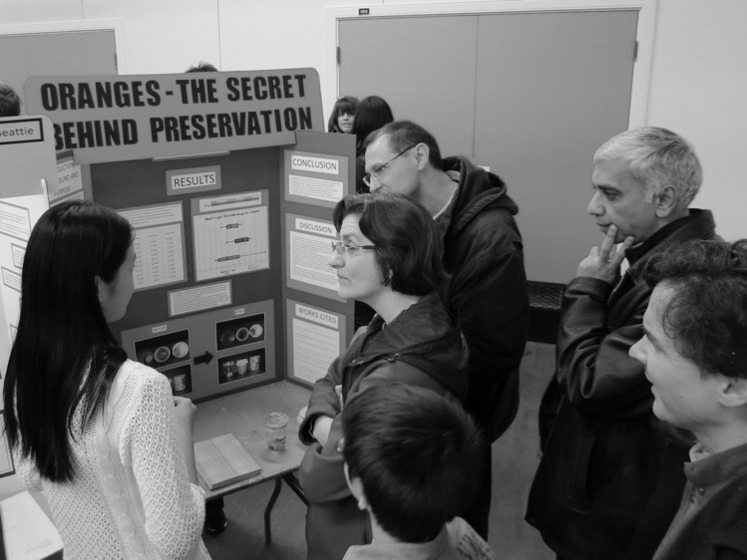
- Complete Statistical Analysis
- Do you see any patterns?
- Did you find anything interesting or exciting?
- How do your results compare with those found
By other scientists in similar studies?

- Formulate a Conclusion
- What can you conclude about your topic?
- Did your results match your hypothesis?

- Write Your Summary Report
- see below for further details

- Prepare Your Display Board
- see below for further details

- Make Your Presentation
- see below for further details

Project Components

There are five essential components to a P.W. Mini School Science Fair project:

1. Project Proposal

Refer to the Project Proposal sheet at the end of this handbook.

2. Project Data Book

A Project Data Book should contain accurate and detailed notes that demonstrate thoroughness to the judges and to assist you with your Summary Report. The Project Data Book may have an unlimited number of pages. You must write your Project Data Book on regular lined paper. It must be keep in your Science Binder (bring it to every class). There will be periodic progress checks. The Project Data Book will tell about the problem you are trying to solve, the steps you have taken. You should talk about the various experiments that were tried, the results of those experiments and the interpretations of those results. Include as many details as possible for each experiment. Perhaps what appears as a minor detail at one stage may become of importance later. It should be kept like a journal (day-by-day) and should record such details as:
- date
- names, make, model of apparatus and info about equipment
- weights, volumes of reagents used in biological or chemical experiments
- times, weights, masses, velocities, pressures, volumes pertinent to physical experiments
- precise locations of measurements, observations taken (in the fields)
- names, addresses of equipment suppliers, scientist/teacher consultants
- a continuing bibliography of books, magazines, etc. consulted
- preliminary tables, graphs, sketches
- hunches, guesses, interpretations etc. as they occur to you

3. Summary Report

P.W. Mini School follows the Canada-Wide Science Fair guidelines regarding research papers. A maximum five-page Summary Report is required plus a Title Page and no more than two extra pages for the References (maximum eight pages in total). A standard procedure called the Scientific Method must be used to investigate, analyze and answer questions posed (outlined below). This method will ensure that you have complete and accurate results. Your Summary Report must be typed on 8½” x 11” paper, one side only, single-spaced with appropriate headings and spacing between sections/paragraphs, 2.5 cm margins, left justified, 12 pt. font. It must contain the following sections:

Title Page
Centre the project title in the middle of the page. Type your name (first and last), address, school, grade, project type, and exhibit division at the bottom right of your title page.

Abstract
The abstract is a brief overview of your project, no longer than 50 words. In the abstract, you should describe what your experiment, innovation/invention, or what the study was about and give a quick conclusion of what you found.

Background
The background consists of the important information you found in your research, and how the project came to be. Usually, the background will contain a lot of facts and material from your sources. Remember to clearly cite anything that you found in another source, including quotes, statistics and results from previous experiments and studies. The information here should be relevant and important, and lead up to the purpose of your experiment.

Purpose
Every project should be designed to answer a question. Choosing that question is probably the most difficult part of the whole process. You may want to change your question, after researching your problem or examining the limitations in your experimental design and time constraints. In the purpose, talk about what exactly you hoped to find – specifics. The purpose is generally no longer than a paragraph. Why are you doing this project? What do you hope to find? What is the importance of your results to society?

Hypothesis
This is the answer to the initial question in which the student makes a prediction as to the outcome of the experiment. This is generally based on your research, including previous studies. Usually, you try to predict results that answer the questions in your purpose. This is also usually no longer than a paragraph.

Procedure
Design a process to prove or disprove the hypothesis. In a research project the student designs and carries out experiments, continually collecting information or data. In the procedure, state the materials and procedure you used to conduct your project. This procedure must follow a controlled experimental design. For an innovation, describe how you designed and built your device.

Results
From observations or experimentation, record the results in a form that others can easily understand. Use a variety of tables, charts and graphs, ensuring that there are reasons for them in your write-up. Raw data are not usually included.

Discussion
After the design of the experiment, this is perhaps the most important part of the report. The discussion section gives your interpretation of the data, including comparisons with previous studies. Explanations regarding outcomes of the investigation, some possible reasons why the results were or were not successful. Were results expected? Point out some the possible errors that occurred or things that may have effected your results. Be specific about your errors. "Human error" or careless techniques are not acceptable sources of error. Do not try to alter results which appear wrong – find an explanation and discuss.

Conclusion
In your conclusion, relate your findings to your hypothesis. Was your hypothesis correct? Why or why not? Also, how do your conclusions affect society? The conclusion is usually no longer than two paragraphs.

Future Directions / Improvements
Your findings in your science fair project may make you more curious. If that’s the case, this is the section to talk about how you could possibly continue your project and in which direction you would go. How you could improve the experimental design or data collection to do a more accurate study or experiment?
Acknowledgements
Remember all the people who helped you throughout your project? They could have been parents, friends, family, teachers – anyone! This is where you thank them for their help and support.

References
You’ve undoubtedly done a lot of research during your project. You should have also used many citations within your report. Here is where you list your citations and other references you used throughout your project.

4. Display Board

Your Display Board should highlight all key components of your project – meaning all of the main parts of the scientific process (refer to the template on the front page of this document). Keep in mind that the information on the science board should only be a summary of the information found in your more detailed written report. Displays must conform to the official maximum-size restrictions: 1.1 metres wide; 0.8 metres deep; 1.1 metres in height.

The display should include headings that stand out, clearly drawn and correctly labeled graphs and diagrams, photographs, and some of the apparatus used so that key aspects of the project can be demonstrated. Use a larger-than-normal font size for the information on your display (at least 16-point).

5. Presentation

You will be given 15 minutes to present your project. The judging team will include at least one science teacher from P.W. Secondary School and at least one Grade 12 Mini School student. Much of the information the judges obtain about your project will come from what you say to them. Communication is an extremely important aspect of all scientific work, so if you present poorly, your project will likely score poorly. Most importantly, the presentation tells the judges whether you actually understand the science behind your project, and how much of it you actually did yourself.

Template for Science Fair Display Board
Conclusion
Acknowledgements
Procedure
Results
Results
Hypothesis
Project Title
Student Name(s)

Discussion
Abstract, Background & Purpose
Safety and Ethics – Science Fair Project

Every science fair project must be carried out in a safe and ethical manner. Safety and Ethics Policies are constantly being reviewed and updated. Please refer to the following link www.youthscience.ca/node/835 for safety and ethics information. Also refer to the flow chart on the next page.

Safety – Science Fair Display

The following are not permitted to be part of a Science Fair Display unless otherwise specified:
Fire Hazards
- Operation of a flame, candle, torch, or any other heating device such as a hot plate
- Excessive packing material under the table

Electrical Hazards
- Mains plugs should be either polarized or properly grounded.
- Modifications to CSA approved electrical equipment are not permitted.
- Wet cell batteries may not be displayed (dry cell batteries such as alkalines or NiCd are permitted).
- Electronic equipment created by participants is PERMITTED as long as they have:
  - As low a voltage as possible
  - A non-combustible enclosure
  - An insulating grommet at the point where the electrical service enters the enclosure
  - Low electric current in case terminals are touched
  - Pilot light to indicate when the power is on

Biohazards
- Biological toxins
- Cell or tissue samples (including blood and blood products, except on sealed microscope slides)
- Plants or plant tissue
- Soil containing organic material
- Cultures – no Petri dishes containing media, no Ziplocs with spores, etc. Photos are a good substitute.

Images of Humans
- Displays must avoid sensational or offensive images

Animals and Animal Parts
- Live animals or micro-organisms
- PERMITTED: Items naturally shed by an animal or parts properly prepared and preserved (eg. safely contained quills, shed snake skin, feathers, tanned pelts and hides, antlers, hair samples, skeletons or skeletal parts).

Firearms, Hazardous Materials, and Equipment
- Firearms, ammunition, dangerous goods, or explosives
- Images of humans or animals injured by firearms or explosives PERMITTED: X-ray and radiation producing equipment may be displayed but NOT turned on.

Structural and Mechanical Safety
- Any structurally unsound backboard or display
- Sharp edges such as the corners of prisms, mirrors, glass, or metal plates that are not in a case
- Dangerous moving parts such as belts, gears, pulleys, and blades that are not in a guard
- Motors that do not contain safety shut-offs
- Pressurized vessels or compressed gas cylinders
- Moving exhibits (such as robots) that are using more than their allocated space

Chemical Safety
- Flammable, toxic or dangerous chemicals
- Any other chemicals on display other than water or table salt are strongly discouraged. Water, salt, and molasses can be used to simulate other materials. Write “simulated X” on the material.
- Prescription drugs or over the counter medications
- More than 1 L of liquid being displayed
Prince of Wales Mini School Science Fair

Project Proposal

Due no later than… Name: ___________________________ Grade: _____
October 7 for Grade 8 students
October 11 for Grade 9 students

Refer to the P.W. Mini School Science Fair Handbook as you answer these questions.

- What topic are you planning to investigate?

- Who is your Science Fair advisor (someone who can provide help/advice along the way)?

- What sort of resources have you found that relate to your topic?

- What is your project type? (experiment, innovation/invention, or study)

- Why are you doing this project?

- What do you hope to find?

- What is your hypothesis?

- Describe the experimental procedure that you plan to carry out in order to test your hypothesis?

- Describe any ethical or safety considerations.

- Will you need any specialized equipment? If yes, where will you find this equipment?

Parent Approval: __________________________________________ Date: _______________

Teacher Approval: ________________________________________ Date: _______________

