Chapter 5 Review Questions Name:___________________________
- Graph the following inequalities
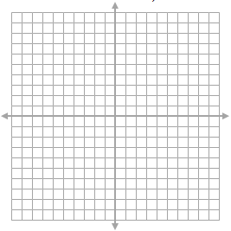
- $-2x+y>3$ b) $3x-2y+4≤0$

$c) y≤x^{2}-4x-1$ d) $y>-2x^{2}-12x-13$

- Solve the following quadratic inequalities. (Draw a rough sketch)
- $x^{2}+11x+30<0$ b) $-4x^{2}+x<-5$

c) $3x^{2}>16x-5$ d) $4x^{2}-16≥0$

- Create an inequality that has the 4. Create an inequality that has the
solution $x>3$ and$x<-4$. Show solution $-5≤x≤2.$ Show
solution in general form. solution in general form.

5. Solve the following systems graphically and algebraically.
a) $y=-{\left(x-2\right)}^{2}+4$
$y=-x+4$

$b)$$y=2{\left(x+1\right)}^{2}-6$
$y=6x-4$

c) $y=x^{2}-4x-1$
$3y=-6x+6$

d) $2y-6x=-6$
$y=-3{\left(x-2\right)}^{2}+3$

