A solution of a linear-quadratic system of equations is an ordered pair, $(x,y)$, that satisfies both equations in the system. The system may have ____________________________ solutions.

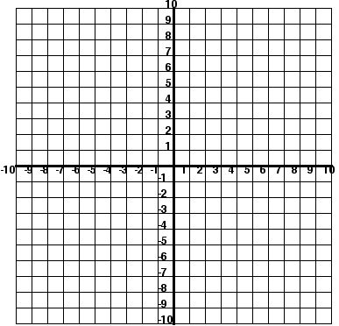

**Example 1:** Solve this system.

$y=\frac{1}{3}x^{2}-3$

$x+y=-3$

A solution of a quadratic-quadratic system of equations is an ordered pair, $(x,y)$, that satisfies both equations in the system. The system may have _____________________________ ______________________________ solutions.



**Example 2:** Solve this system

